Name

Mathematics Stage 5 Paths
Further Non-Linear Relationships

Book 1 | Transformations of exponentials, hyperbolas, and circles.  Solving equations graphically. | Version: 260728  Feedback:  https://MrDingMaths.com
Contents
Syllabus Content 2
Learning Intention Error! Bookmark not defined.

Syllabus Content
MA5-NLI-P-01 interprets and compares non-linear relationships and their transformations, both algebraically and graphically
Graph exponentials and describe their features and transformations
- Use graphing applications to graph exponential relationships of the form $y= k{\left(a\right)}^{x}+c$ and $y=k{\left(a\right)}^{-x}+c$for integer values of $k$, $a$ and $c$ (where $a>0$ and $a≠1$), and compare and describe any relevant features
Graph hyperbolas and describe their features and transformations
- Use graphing applications to graph, compare and describe hyperbolic relationships of the form $y=\frac{k}{x}$ for integer values of $k$
- Use graphing applications to graph and describe a variety of hyperbolas, including where the equation is given in the form $y=\frac{k}{x}+c$ or $y=\frac{k}{x - b}$ for integer values of $k, b$ and $c$
Graph circles and describe their features and transformations
- Derive the equation of a circle $x^{2}+y^{2}=r^{2}$ with centre $\left(0, 0\right)$ and radius $r$ using the distance formula
- Identify and describe equations that represent circles with centre at the origin and radius of the circle $r$
- Graph circles of the form $x^{2}+y^{2}=r^{2}$, where $r$ is the radius of the circle using graphing applications
- Establish the equation of the circle with centre $\left(a,b\right)$ and radius $r$, and graph equations of the form ${\left(x-a\right)}^{2}+{\left(y-b\right)}^{2}=r^{2}$
- Find the centre and radius of a circle with the equation in the form $x^{2}+y^{2}+ax+by+c=0$ by completing the square
Distinguish between different types of graphs by examining their algebraic and graphical representations and solve problems
- Identify and describe features of different types of graphs based on their equations
- Identify a possible equation from a graph and verify using graphing applications
- Find points where a line intersects with a parabola, hyperbola or circle, both graphically and algebraically
Graph and compare polynomial curves and describe their features and transformations
- Use graphing applications to graph and compare features of cubic equations of the form $y=ax^{3}+c$, where $a$ and $c$ are integers
- Use graphing applications to graph a variety of equations of the form $y={kx}^{n}$, where $n$ is an integer and $n≥2$, and describe the effect on the shape of the curve where $n$ is an odd or an even number
- Use graphing applications to graph curves of the form $y={kx}^{n}+c$ and $y=k{\left(x-b\right)}^{n}$ where $n$ is an integer and $n≥2,$ and describe the transformations from $y={kx}^{n}$

Exponential Curve Transformations

- Exponential Curve Transformations
$a>1$ exponential growth  $0<a<1$ exponential decay  Common ratio  $$y=k⋅a^{x}$$  Factor; affects $y$-intercept and reflects across $x$ axis if negative |  | $a>1$ exponential decay  $0<a<1$ exponential growth  Common ratio  $$y=k⋅a^{-x}$$
$$y=2^{x}$$ | $y=2^{-x}$ or $y={\left(\frac{1}{2}\right)}^{x}$  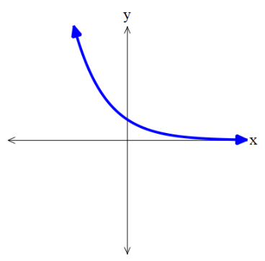 | $$y=-2^{x}$$  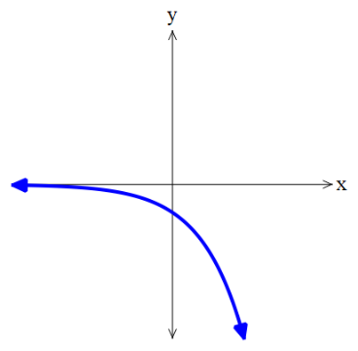  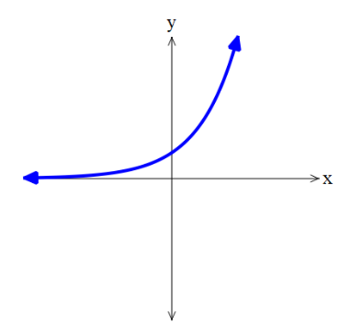 | $y=-2^{-x}$ or $y=-{\left(\frac{1}{2}\right)}^{x}$  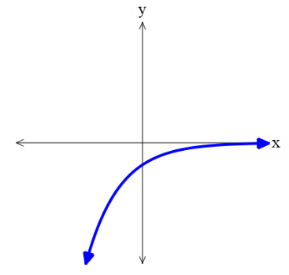

- Exponential Curve Transformations
Consider the equation of an exponential curve $y=k{(a)}^{x}+c$, where $a>0$
The parameters $a,c, k$ are numbers that affect the graph in predictable ways.
$a>1$, we call this exponential ………………  $$y=2^{x}$$ | $0<a<1$, we call this exponential …………  $$y={\left(\frac{1}{2}\right)}^{x}$$  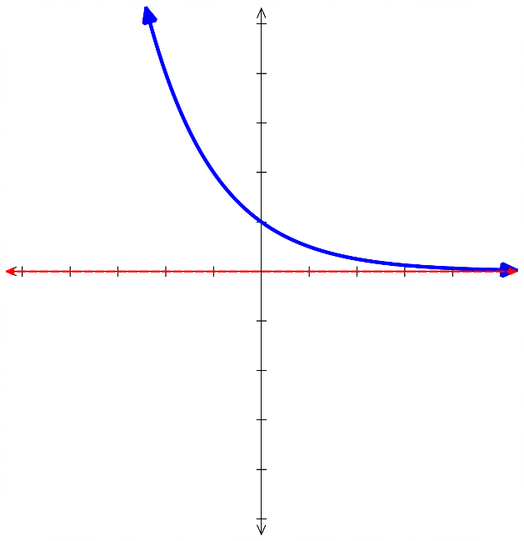  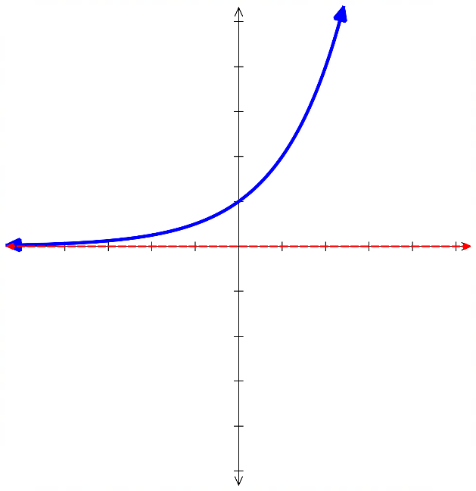
$c>0$, the curve is shifted ……………  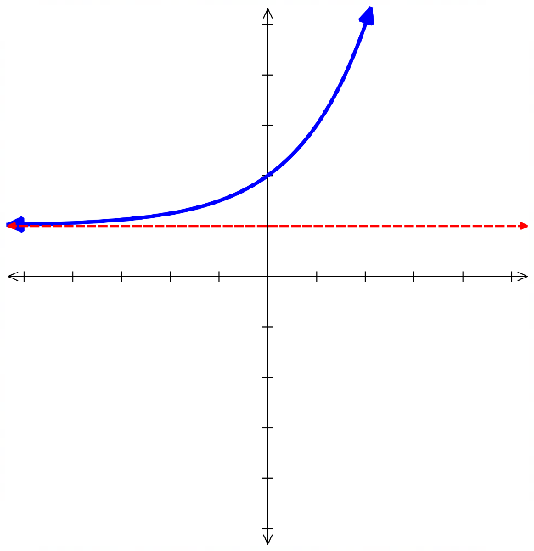  The value of $c$ is the ……………………  $$y=2^{x}+1$$ | $c<0$, the curve is shifted ……………  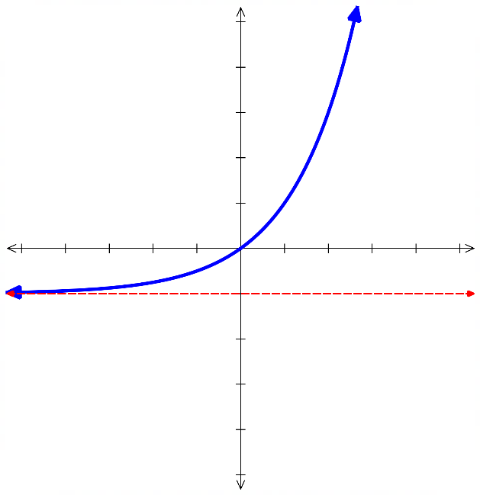  The value of $c$ is the ……………………  $$y=2^{x}-1$$
$k>0$  $$y=1\left(2^{x}\right)$$  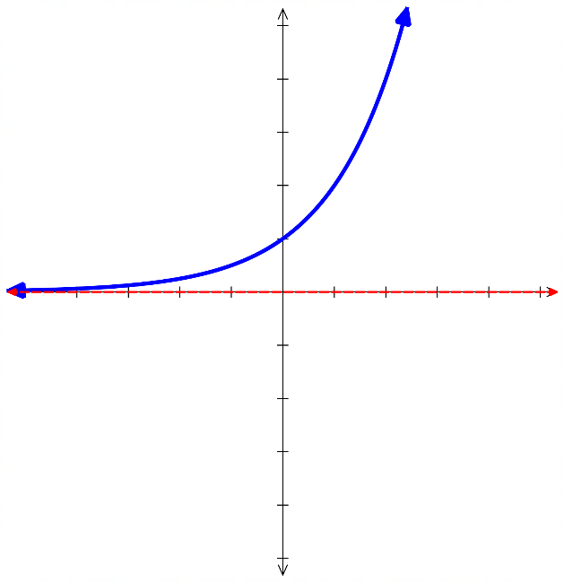 | $k<0$, reflect the graph across $x$-axis  $$y=-1 \left(2^{x}\right)$$  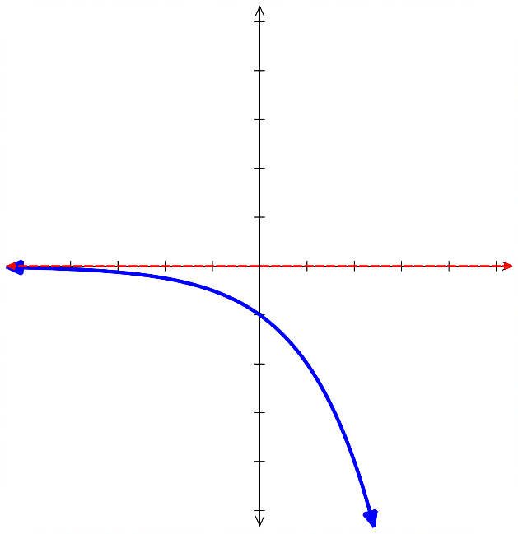
$\left|k\right|>1$, the curve changes more quickly.  $$y=3\left(2^{x}\right)$$  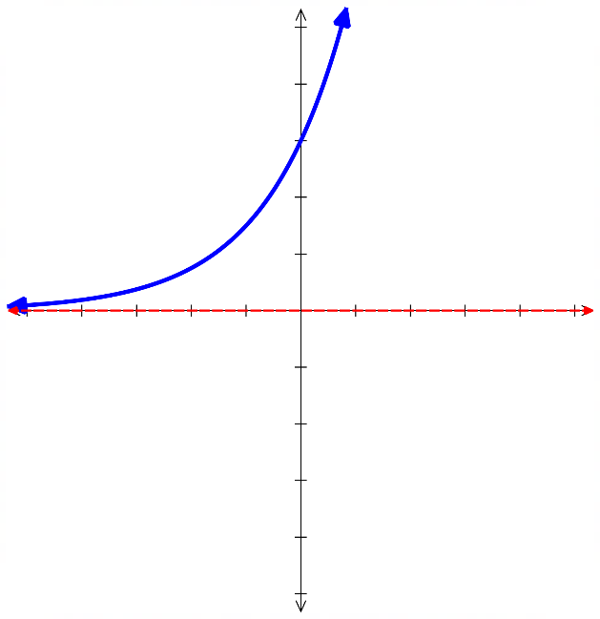 | $0<\left|k\right|<1$ the curve changes more slowly.  $$y=\frac{1}{3}\left(2^{x}\right)$$  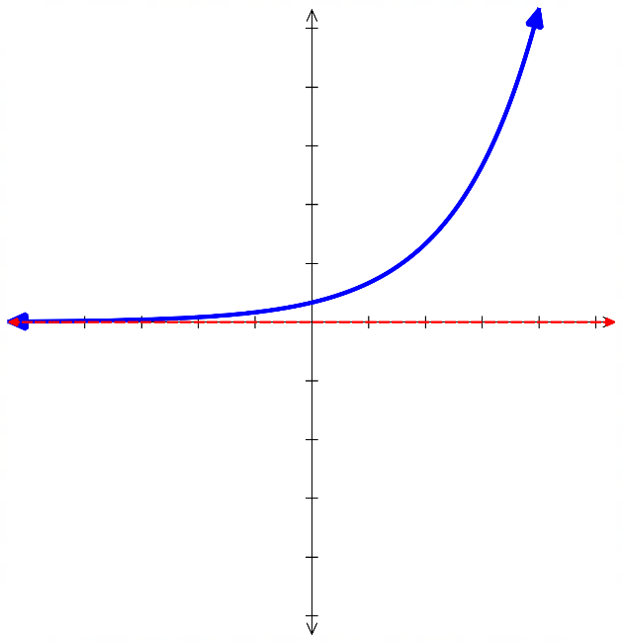

- Exponential Curve Transformations
$a>1$ exponential growth  $0<a<1$ exponential decay  Common ratio  $$y=k⋅a^{x}+c$$  Factor; affects $y$-intercept and vertical translation  reflects across $x$ axis if negative $y=c$ is asymptote | $a>1$ exponential decay  $0<a<1$ exponential growth  Common ratio  $$y=k⋅a^{-x}+c$$
To sketch exponential curves:
- Find $y$-intercept by letting $x=0$.
- Find asymptote: $y=c$.
- Plot at least one other point, such as at $x=1$.
- You do not need to find $x$-intercepts until you learn logarithms

- Example Sketch transformations of exponential curves
$y=2^{x}-4$  1. $y$-int: Let $x=0$,  $y=2^{0}-4=-3$  2. Asymptote: $y=-4$  3. When $x=1$: $y=2^{1}-4$  $y=-2$  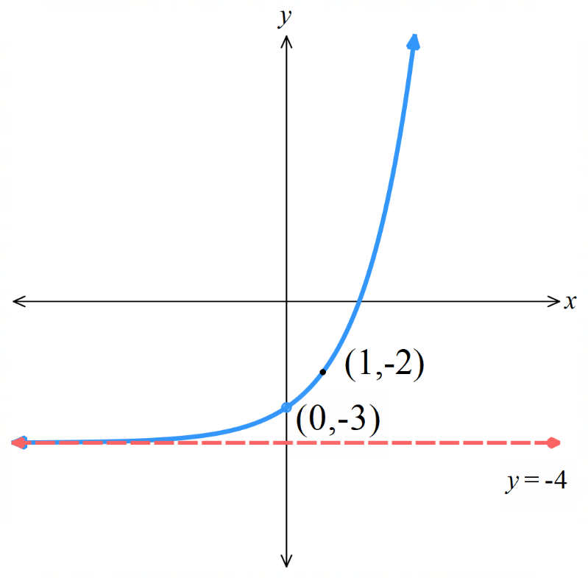  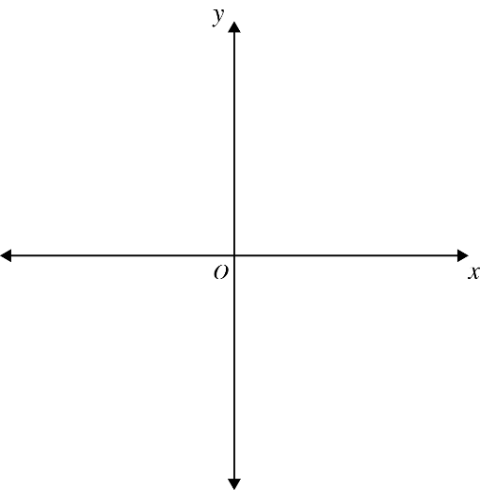 | $y=3^{-x}-5$  1. $y$-int:  2. Asymptote:  3. Another point:  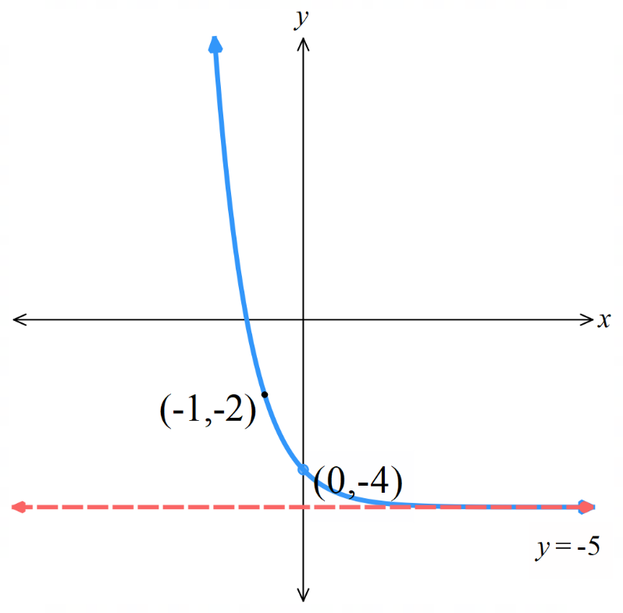

Foundation
- The graph of $y=2^{x}$ is given. Sketch these graphs on the same axis to show the transformation.
Clearly label the $y$-intercept, asymptote, and the point where $x=1$.
- $y=2^{x}+1$  $y$-int:  Asymptote:  When $x=1$:  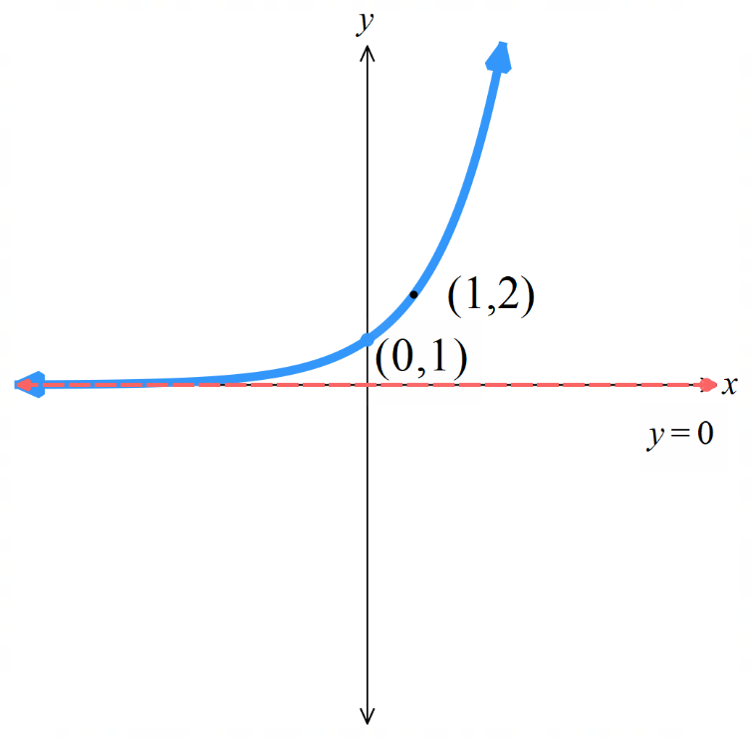 | - $y=2^{x}-3$  $y$-int:  Asymptote:  When $x=1$: | - $y=2^{x}-5$  $y$-int:  Asymptote:  When $x=1$:
- $y=3^{x}$  $y$-int:  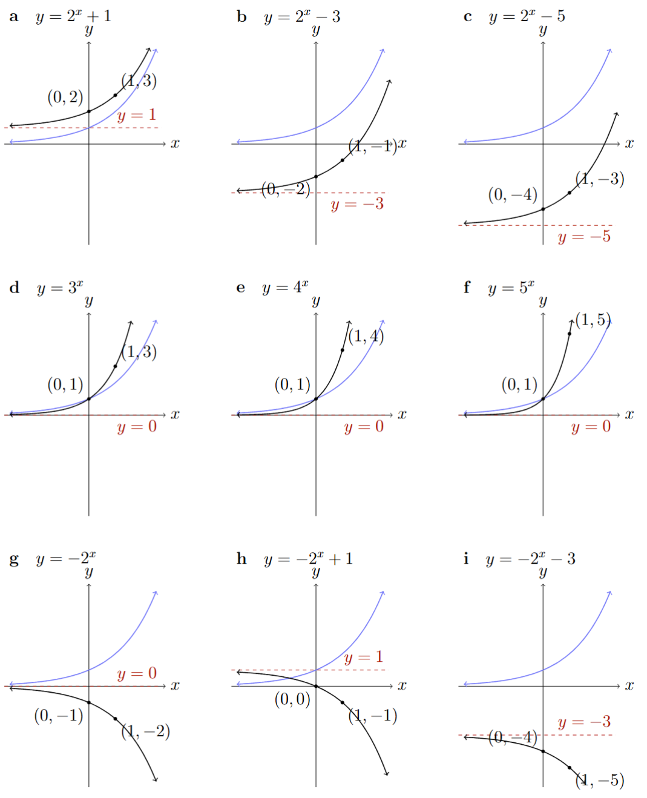  Asymptote:  When $x=1$: | - $y=4^{x}$  $y$-int:  Asymptote:  When $x=1$: | - $y=5^{x}$  $y$-int:  Asymptote:  When $x=1$:
- $y=-2^{x}$ | - $y=-2^{x}+1$ | - $y=-2^{x}-3$
- $y=3(2^{x})$ | - $y=-3(2^{x})$ | - $y=0.5(2^{x})$  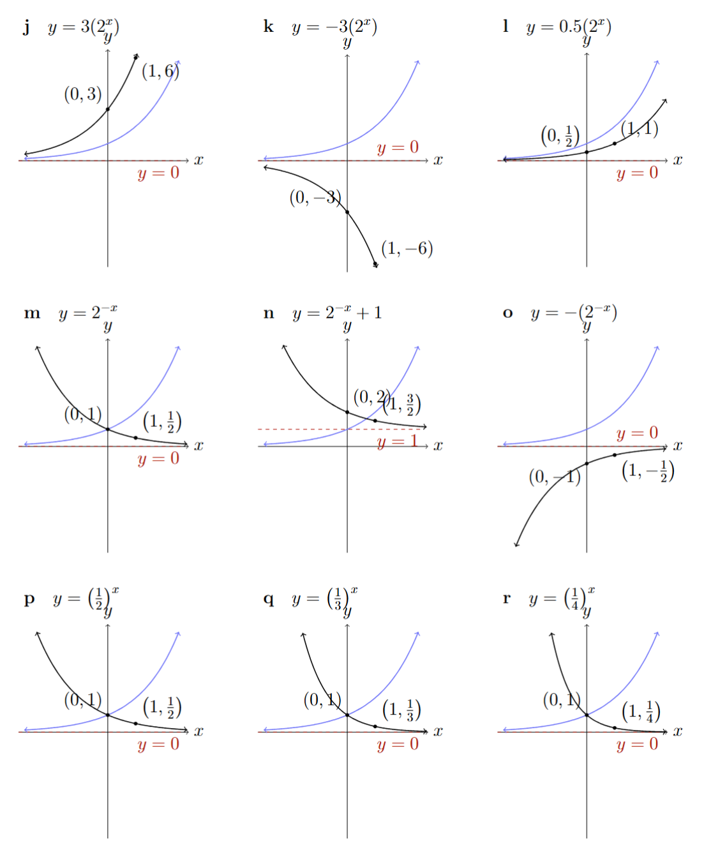
- $y=2^{-x}$ | - $y=2^{-x}+1$ | - $y=-{(2}^{-x})$
- $y={\left(\frac{1}{2}\right)}^{x}$ | - $y={\left(\frac{1}{3}\right)}^{x}$ | - $y={\left(\frac{1}{4}\right)}^{x}$

Development
- Sketch these exponential equations.
Clearly label the $y$-intercept, asymptote, and the point where $x=1$.
- $y=3^{x}+2$  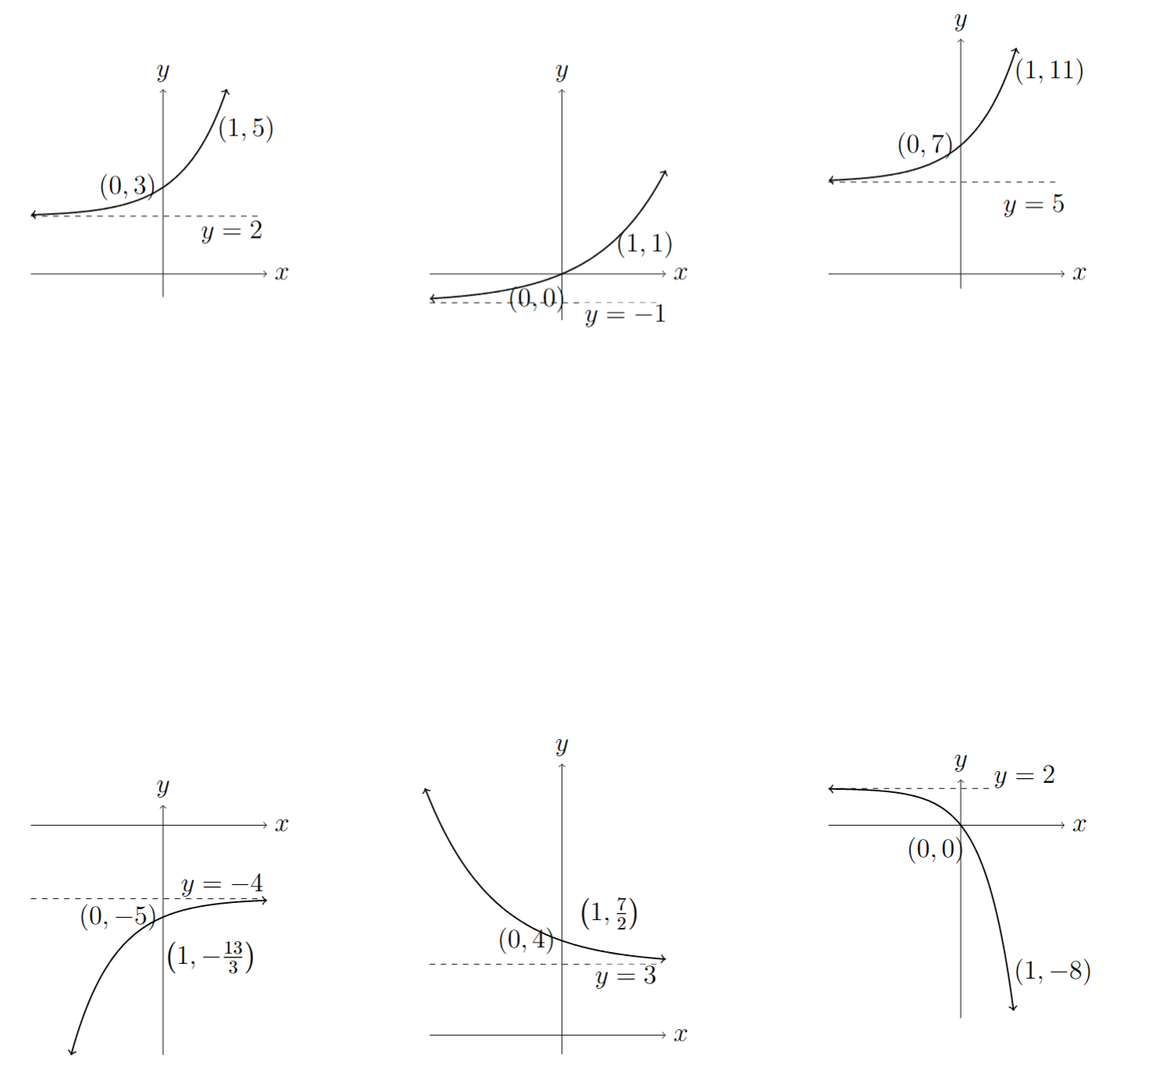 | - $y=2^{x}-1$ | - $y=2{(3}^{x})+5$
- $y=-3^{-x}-4$ | - $y=2^{-x}+3$ | - $y=-2\left(5^{x}\right)+2$

Mastery
- Match the equation to the graph.
$y=6^{x}$ $y=-6^{x}$ $y=-6^{x}-2$ $y=-6^{x}+2$ $y=6^{-x}$
$y=6^{-x}-2$ $y=6^{-x}+2$ $y=-6^{-x}$ $y=-6^{-x}-2$ $y=6^{-x}+2$

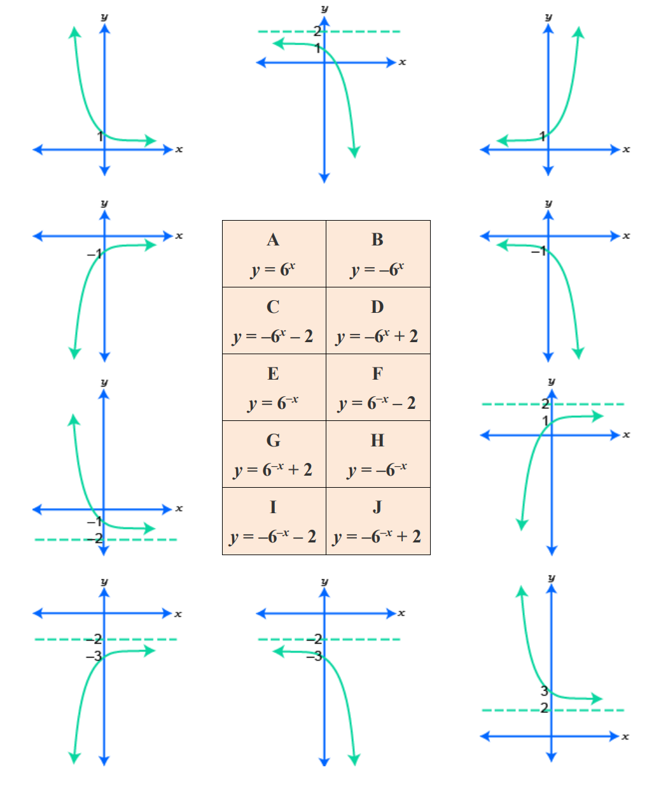  $$y=6^{-x}$$ | $$y=-6^{x}+2$$ | $$y=6^{x}$$ | $$y=-6^{-x}$$
$$y=-6^{x}$$ | $$y=6^{-x}-2$$ | $$y=-6^{-x}+2$$ | $$y=-6^{-x}-2$$
$$y=-6^{x}-2$$ | $$y=6^{-x}+2$$

Hyperbolas

- Reciprocal Relationships
Reciprocal relationships are in the form $y=$ $\frac{k}{x}$.
Their graph will not be a straight line; so the relationship is non-linear.
We can graph reciprocal relationships using these steps:
  - Construct a table of values using the equation.
  - Graph the table by using the columns as coordinates.
  - Join the points to form a smooth curve.

- Investigation Graph reciprocal relationships using a table of values
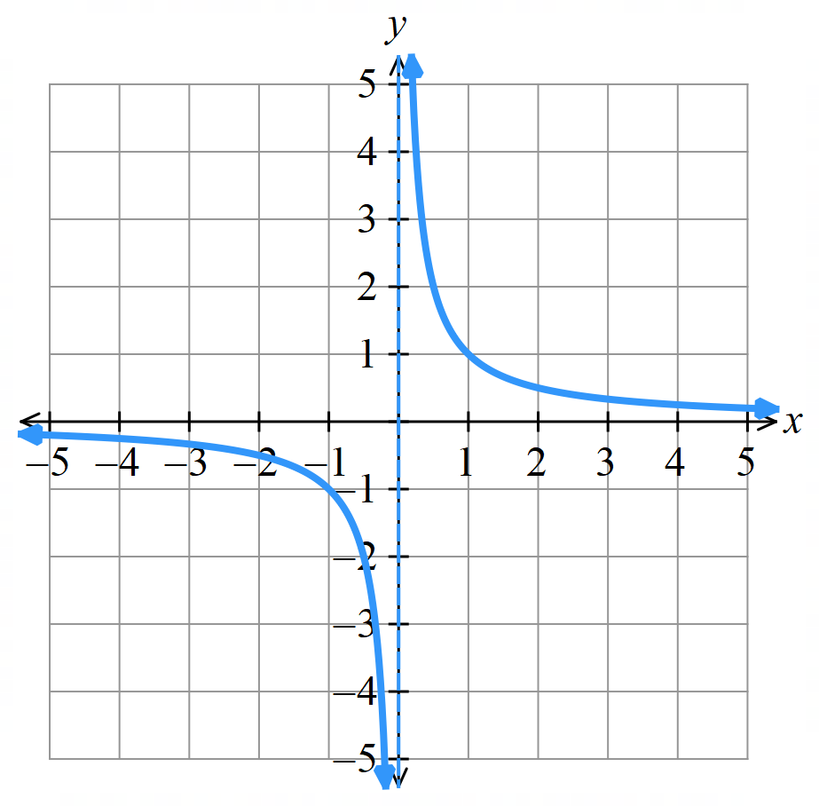
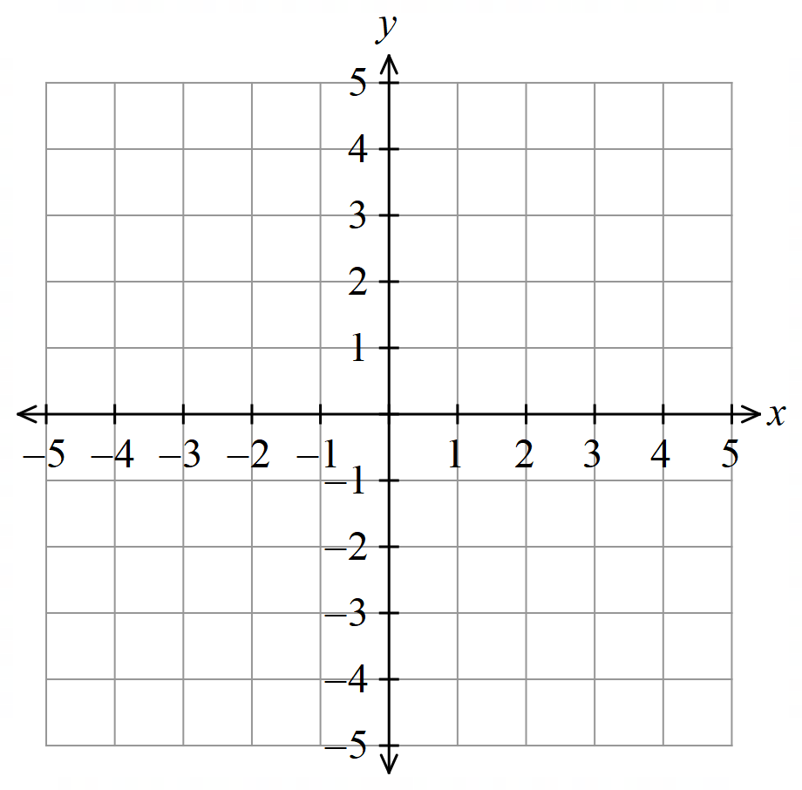
Draw the graph of $y=$ $\frac{1}{x}$
$$x$$ | $$-2$$ | $$-1$$ | $$-\frac{1}{2}$$ | $$0$$ | $$\frac{1}{2}$$ | $$1$$ | $$2$$
$$y$$

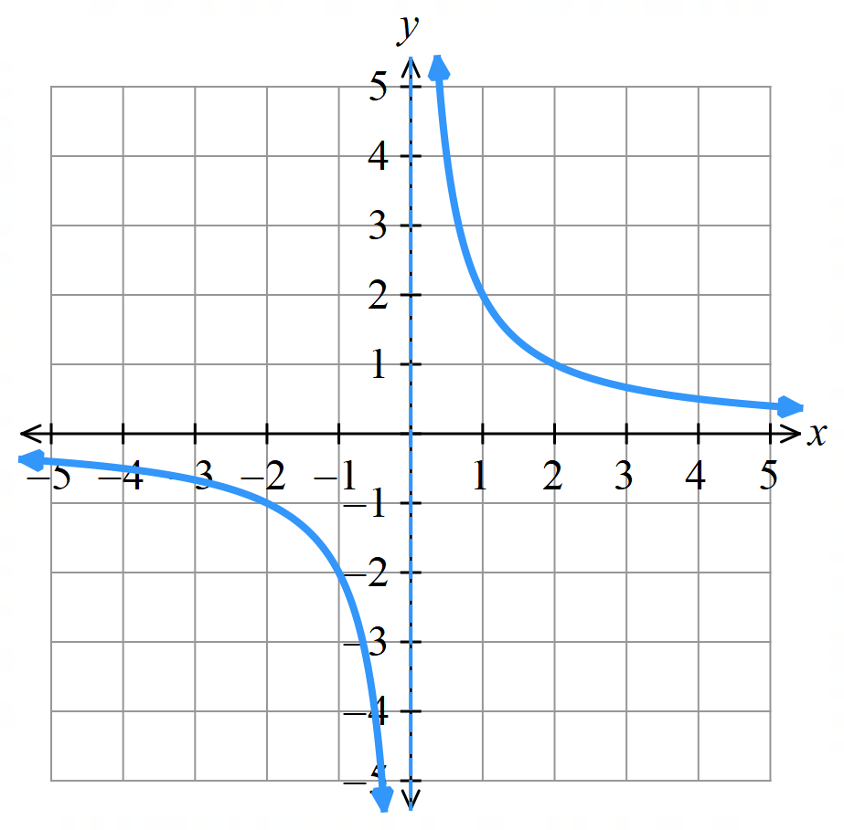
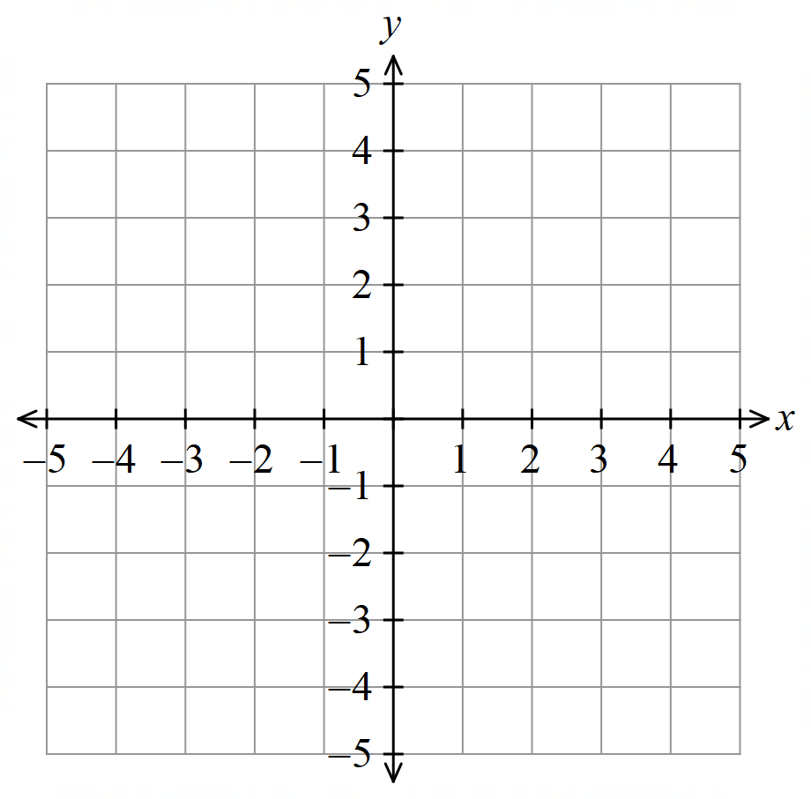
Draw the graph of $y=$ $\frac{2}{x}$

$$x$$ | $$-2$$ | $$-1$$ | $$-\frac{1}{2}$$ | $$0$$ | $$\frac{1}{2}$$ | $$1$$ | $$2$$
$$y$$

- Properties of Hyperbolas
A reciprocal relationship $y=$ $\frac{k}{x}$ has a graph in the shape of a hyperbola.
Hyperbolas have:
- Two asymptotes: lines where the graph approaches but never reaches.
- No $x$ or $y$-intercepts.
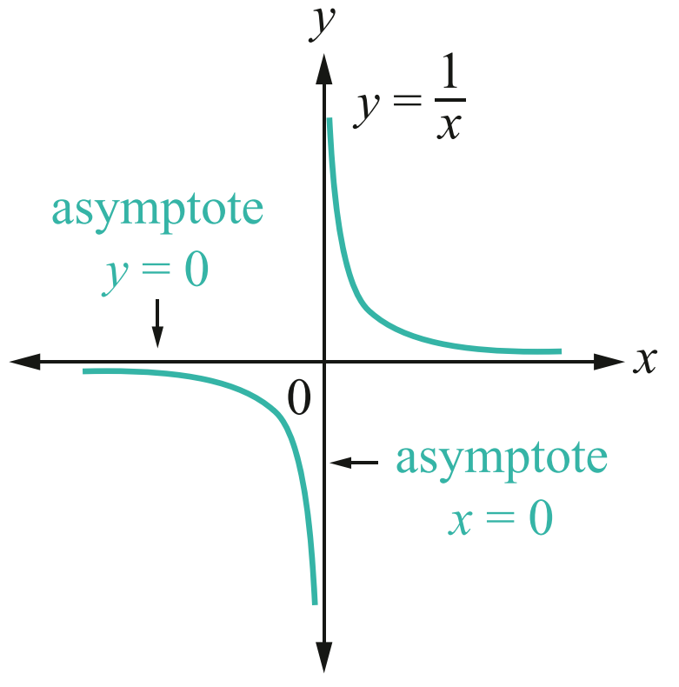
- Two symmetrical branches.

- Identify Features of hyperbolas
- $y=$ $\frac{2}{x}$  Identify the asymptotes.  Behaviour as $x→∞$:  Behaviour as $x→-∞$:  Behaviour as $x→0^{+}$:  Behaviour as $x→0^{-}$: | - $y=-$ $\frac{2}{x}$  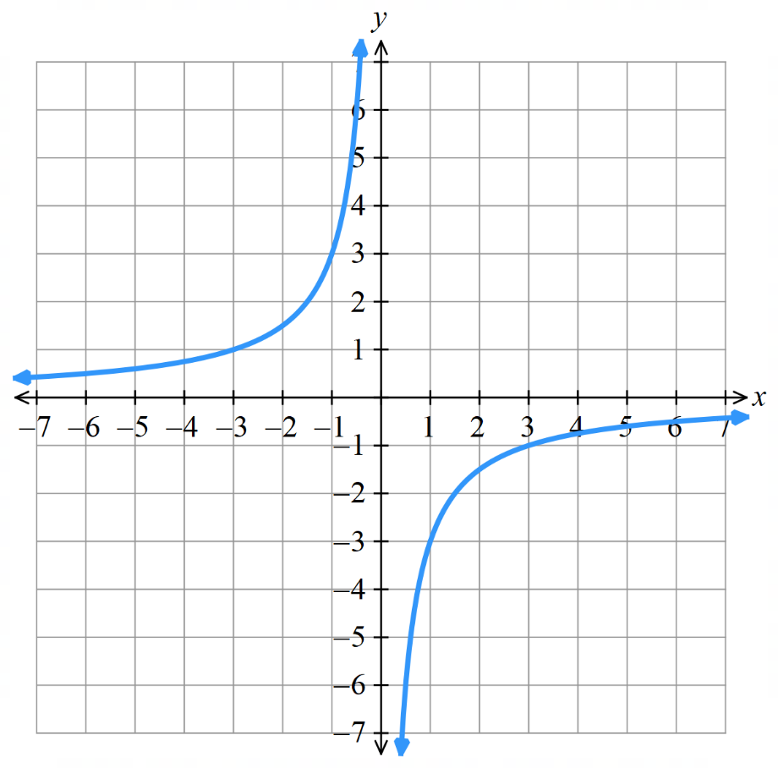  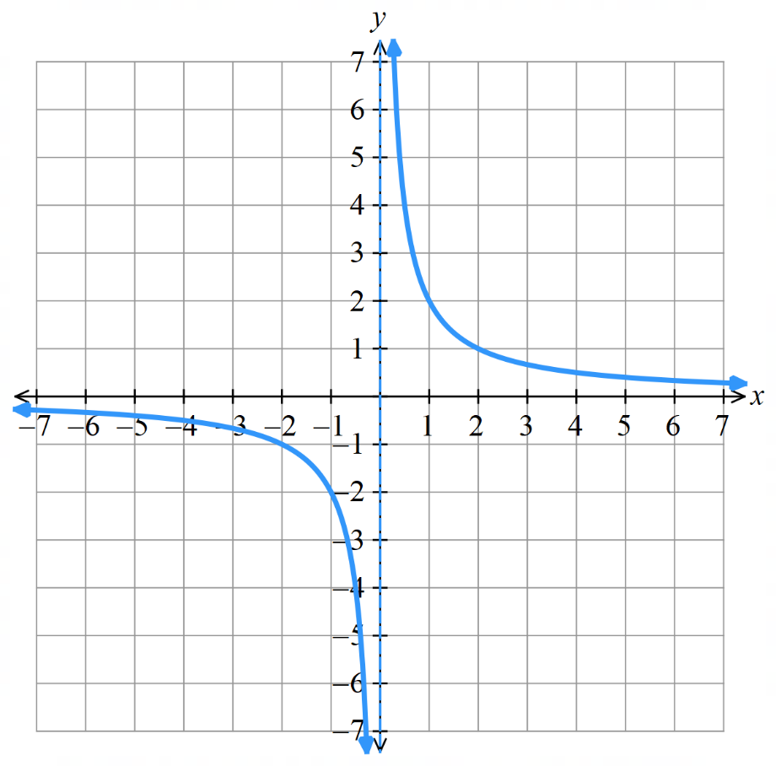  Identify the asymptotes.  Behaviour as $x→∞$:  Behaviour as $x→-∞$:  Behaviour as $x→0^{+}$:  Behaviour as $x→0^{-}$:

Foundation
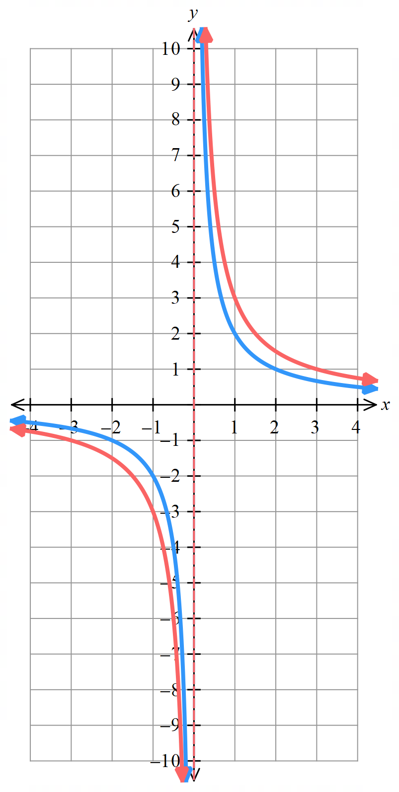
- Plot $y=$ $\frac{2}{x}$ and $y=$ $\frac{3}{x}$ on the same axis.
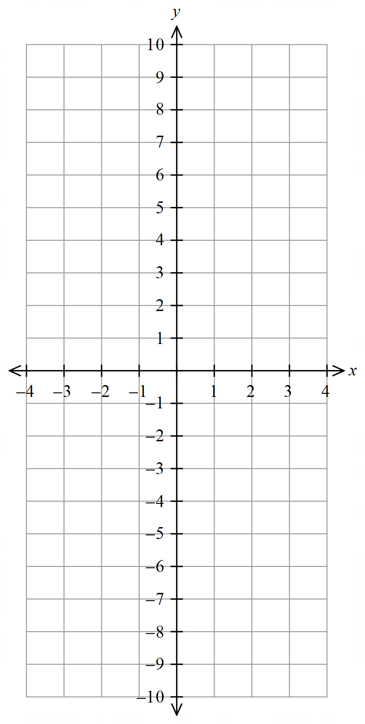
$y=$ $\frac{2}{x}$
$$x$$ | $$-2$$ | $$-1$$ | $$-\frac{1}{2}$$ | $$0$$ | $$\frac{1}{2}$$ | $$1$$ | $$2$$
$$y$$

Behaviour as $x→∞$:
Behaviour as $x→-∞$:

$y=$ $\frac{3}{x}$
$$x$$ | $$-2$$ | $$-1$$ | $$-\frac{1}{3}$$ | $$0$$ | $$\frac{1}{3}$$ | $$1$$ | $$2$$
$$y$$

Behaviour as $x→∞$:
Behaviour as $x→-∞$:
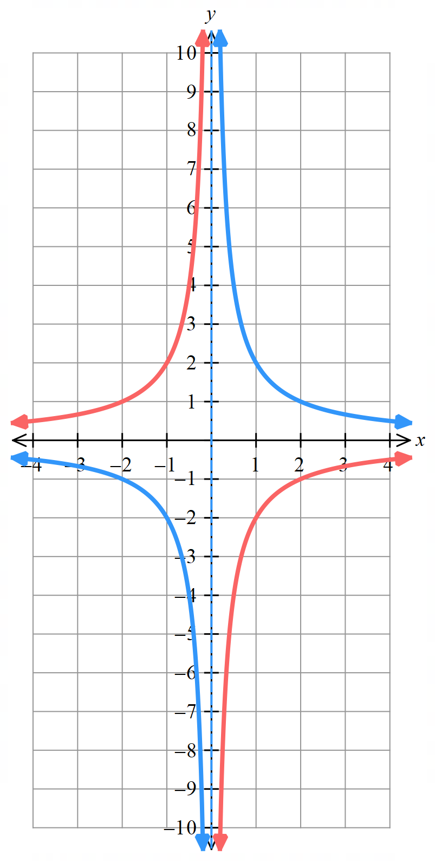
- Plot these graphs on the same axis.
$$x$$ | $$-2$$ | $$-1$$ | $$-\frac{1}{2}$$ | $$0$$ | $$\frac{1}{2}$$ | $$1$$ | $$2$$
$y=$ $\frac{2}{x}$
$y=-$ $\frac{2}{x}$
Describe their differences in terms of:

Behaviour as $x→∞$:

Behaviour as $x→-∞$:

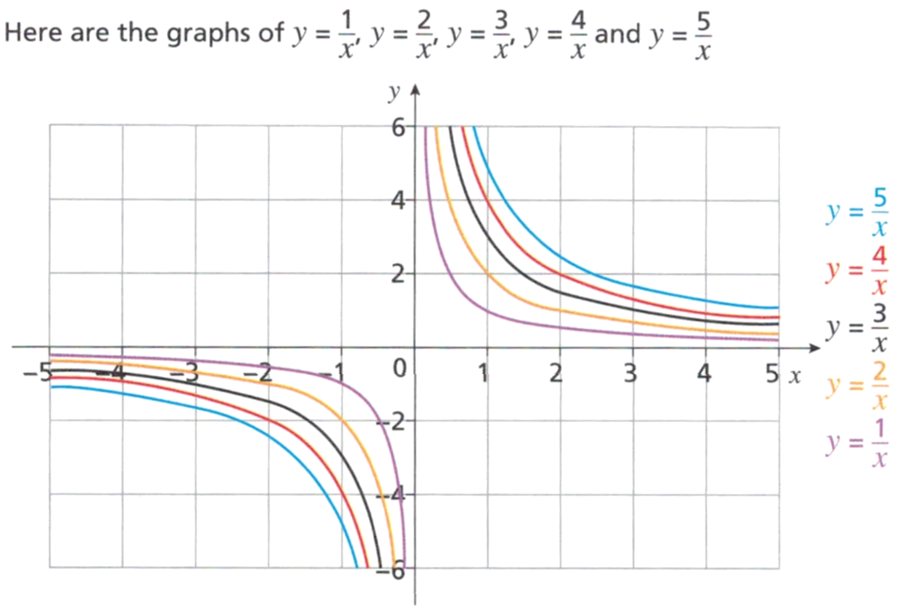

What's the same and what’s different about the graphs?
Same:  Asymptotes at $x=0$ and $y=0$, in quadrants 1 and 3. | Different:  For $y=\frac{k}{x}$, the larger the value of $k$, the further away from the axes.
- Sketch these hyperbolas, labelling the point where $x=1$ and $x=-1$.
- $y=$ $\frac{2}{x}$  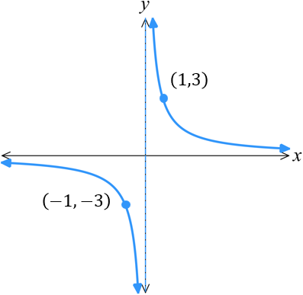  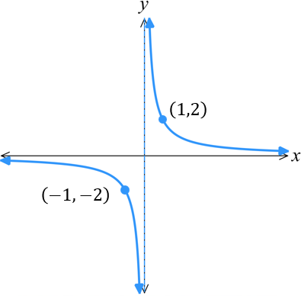  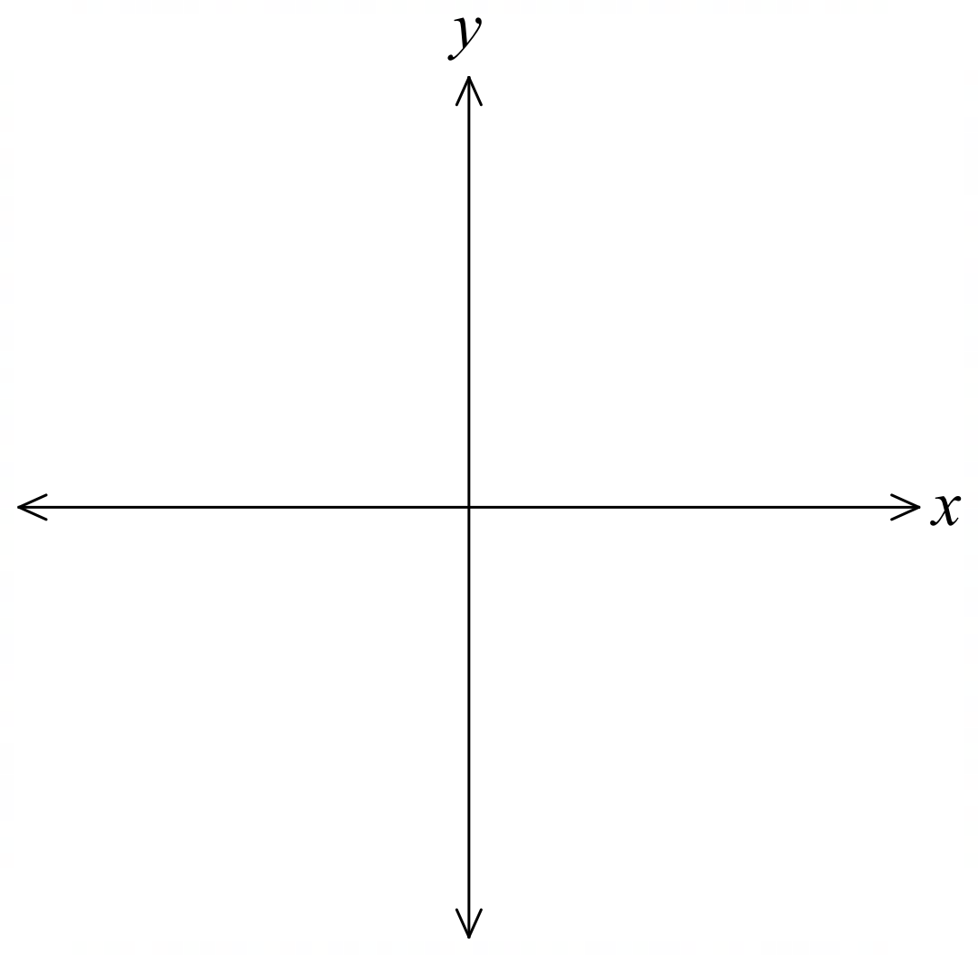 | - $y=$ $\frac{3}{x}$ | - $y=$ $\frac{7}{x}$  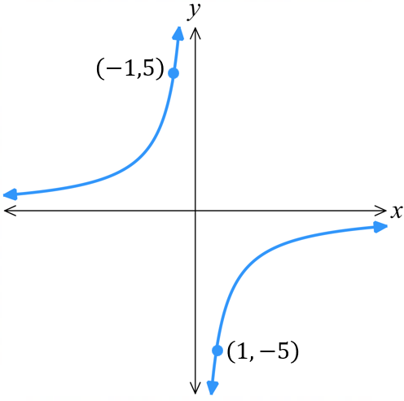  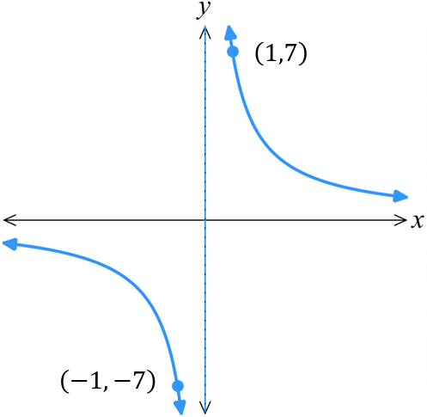
- $y=-$ $\frac{1}{x}$  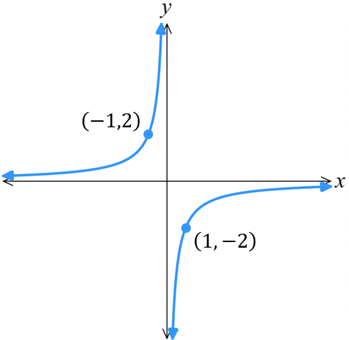  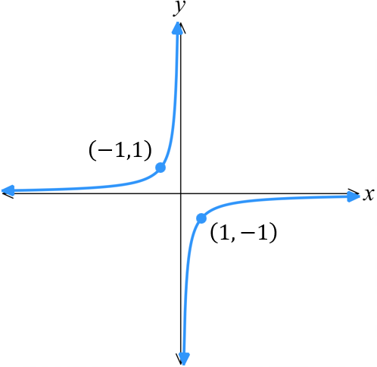 | - $y=-$ $\frac{2}{x}$ | - $y=-$ $\frac{5}{x}$

Hyperbola Transformations

- Investigation Equation and the graph of a hyperbola
- https://www.desmos.com/calculator

- Sketch these graphs  $y=$ $\frac{1}{x}$  $y=$ $\frac{2}{x}$  $y=$ $\frac{3}{x}$  $y=$ $\frac{4}{x}$  Increasing the value of $k$ s………………… or dilates the hyperbola away from the axes. | - Sketch these graphs.  $y=$ $\frac{-1}{x}$  $y=$ $\frac{-2}{x}$  $y=$ $\frac{-3}{x}$  $y=$ $\frac{-4}{x}$  A negative value of $k$ means the hyperbola is in the …………… and …………… quadrants.
- Sketch these graphs  $y=$ $\frac{1}{x}$ $+1$  $y=$ $\frac{1}{x}$ $+2$  $y=$ $\frac{1}{x}$ $+3$  $y=$ $\frac{1}{x}$ $-3$  $y=$ $\frac{1}{x}$ $-4$  The constant term shifts the hyperbola v……………………… | - Sketch these graphs  $y=$ $\frac{1}{x+1}$  $y=$ $\frac{1}{x+2}$  $y=$ $\frac{1}{x+3}$  $y=$ $\frac{1}{x-3}$  $y=$ $\frac{1}{x-4}$  The constant term with the $x$ shifts the hyperbola h………………………

- Hyperbola Transformations
Consider the equation of a hyperbola $y=$ $\frac{k}{x-b}$ $+c$, where $k$ is an integer.
The parameters $k,b, c$ are numbers that affect the graph in predictable ways.
$k$ is positive, the hyperbola is top …………… and bottom …………… relative to the asymptotes.  $$y=\frac{1}{x}$$ | $k$ is negative, the hyperbola is ……………… and ………………… relative to the asymptotes.  $$y=-\frac{1}{x}$$  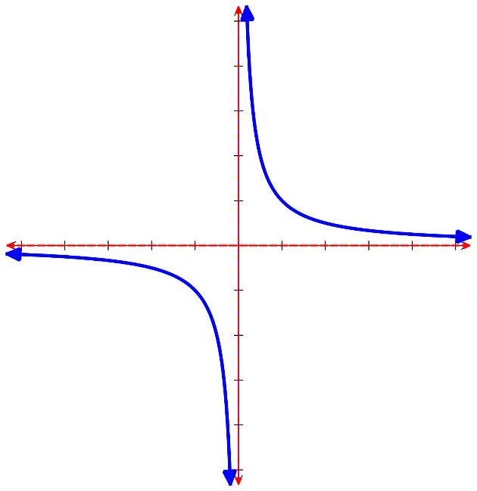  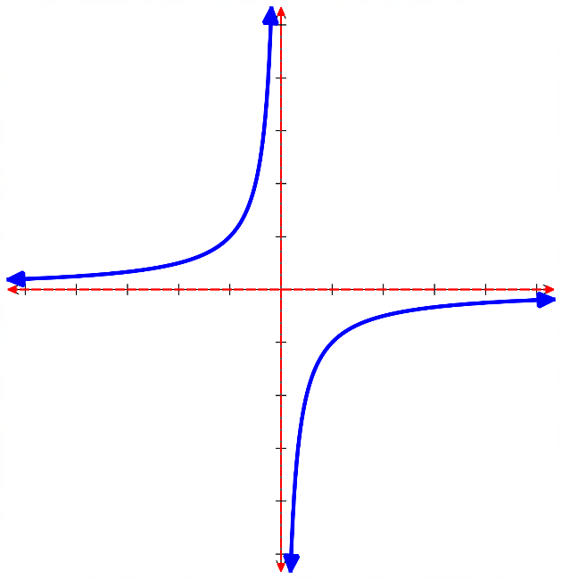
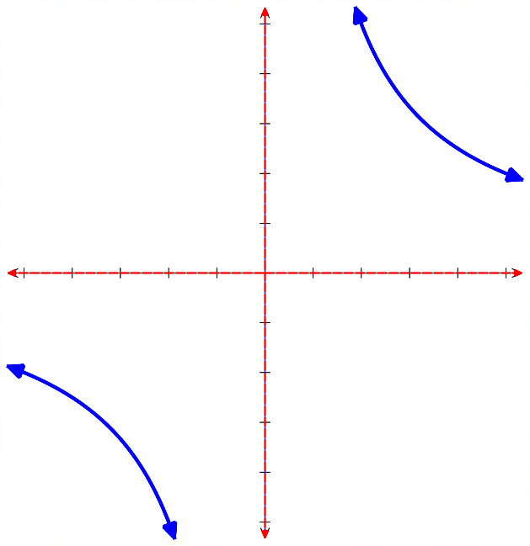
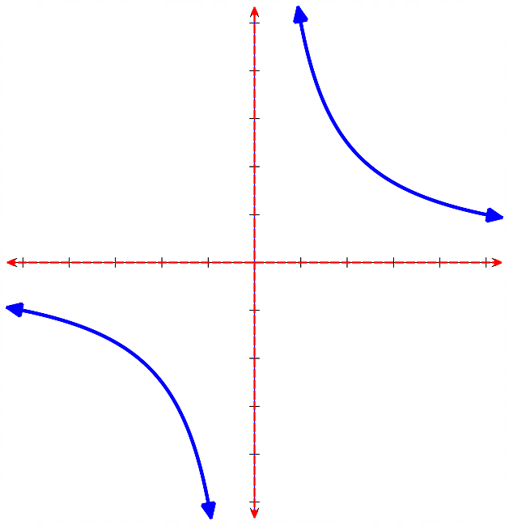
As $\left|k\right|$ increases, the hyperbola gets dilated; it stretches away from the axes.
$y=$ $\frac{5}{x}$ $y=$ $\frac{10}{x}$

$c$ shifts the curve …………………. The value of $c$ is the …………… asymptote.
$y=$ $\frac{1}{x}$ $+2$ $y=$ $\frac{1}{x}$ $-2$
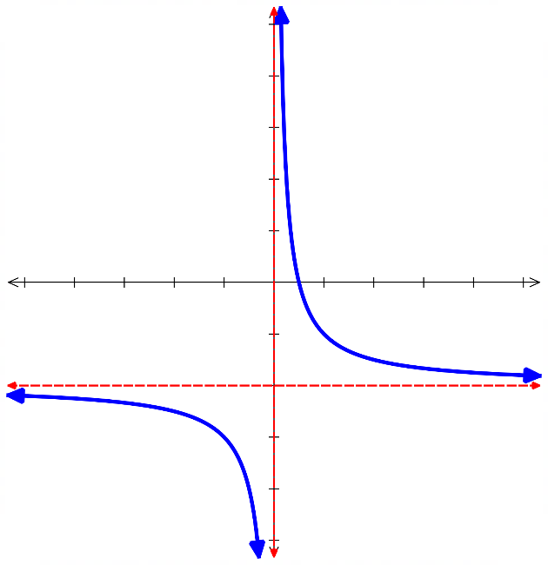
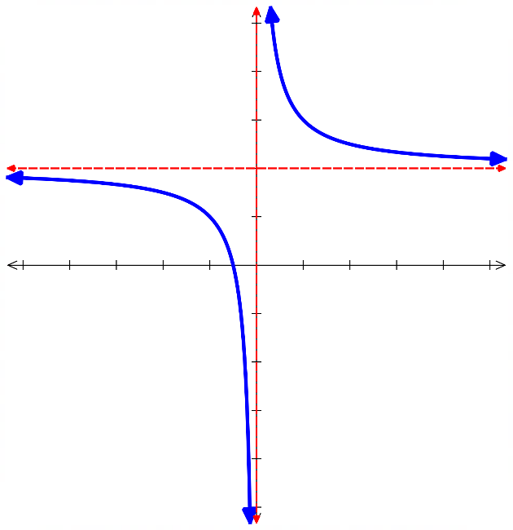

$b$ shifts the curve ………………… The value of $b$ is the …………… asymptote.
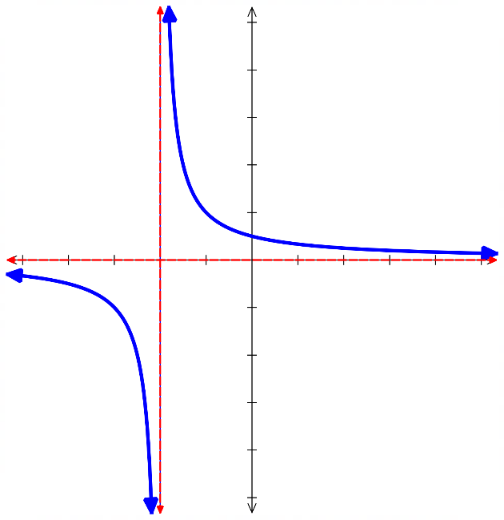
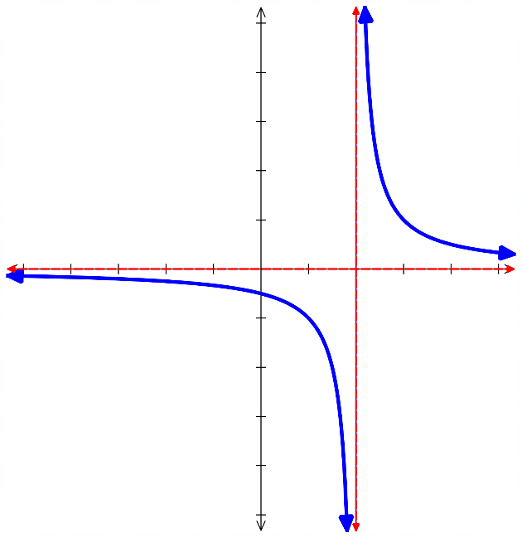
$y=$ $\frac{1}{x-2}$ $y=$ $\frac{1}{x+2}$

- Sketching Hyperbolas
Dilates, or stretches, hyperbola

$$y=\frac{k}{x-b}+c$$

Horizontal translation Vertical translation
$x=b$ is a vertical asymptote $y=c$ is a horizontal asymptote
To sketch hyperbolas:
- Find $y$-intercept, if any, by letting $x=0$.
- Find $x$-intercept, if any, by letting $y=0$.
- Find vertical asymptote at $x=b$ and horizontal asymptote at $y=c$,

- Example Sketch hyperbolas, showing intercepts and asymptotes
$y=$ $\frac{1}{x+1}$ $+2$  1. $y$-int: Let $x=0$,  $y=\frac{1}{1}+2=3$  2. $x$-int: $Let y=0$  $$0=\frac{1}{x+1}+2$$  $$-2=\frac{1}{x+1}$$  $$-2x-2=1$$  $$-2x=3$$  $$x=-\frac{3}{2}$$  3. Asymptotes: $x=-1$  $y=2$  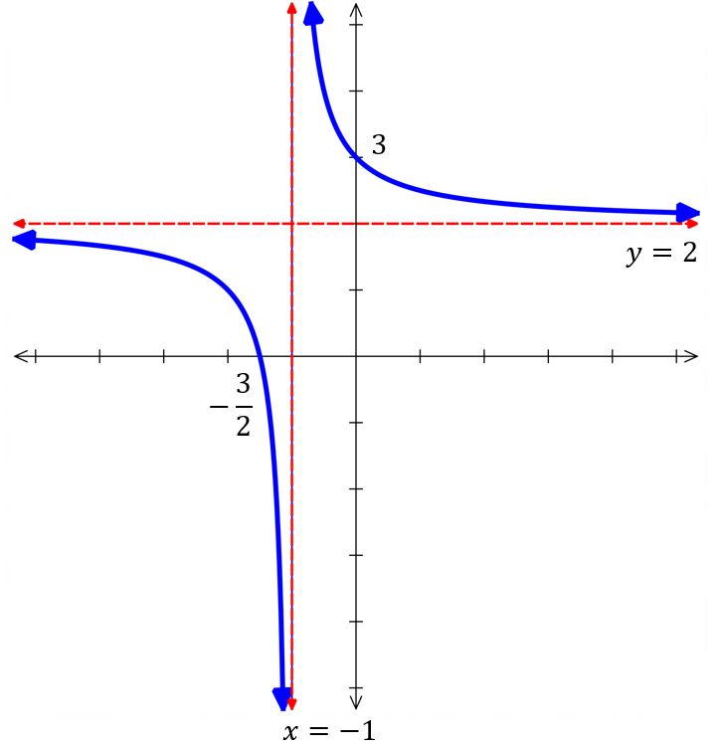 | 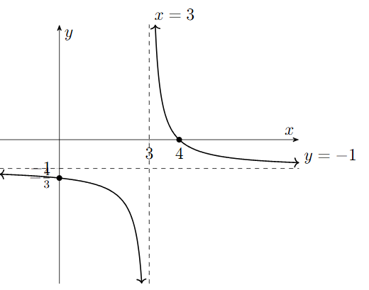  $y=$ $\frac{1}{x-3}$ $-1$

Foundation
- Describe these translations.
  - Compared with $y=$ $\frac{1}{x}$, $y=$ $\frac{1}{x-3}$ is translated right by 3
  - Compared with $y=$ $\frac{1}{x}$, $y=$ $\frac{1}{x+2}$ is translated ………………
Left 2
  - Compared with $y=$ $\frac{1}{x}$, $y=$ $\frac{1}{x}$ $+3$ is translated ………………
Up 3
  - Compared with $y=$ $\frac{1}{x}$, $y=$ $\frac{1}{x}$ $-6$ is translated ………………
Down 6
  - Compared with $y=$ $\frac{1}{x}$, $y=$ $\frac{1}{x+3}$ $-2$ is translated ………………………………
Left 3, down 2
  - Compared with $y=$ $\frac{1}{x}$, $y=$ $\frac{1}{x+5}$ $+7$ is translated ………………………………
Left 5, up 7
  - Compared with $y=$ $\frac{1}{x}$, $y=$ $\frac{1}{x-5}$ $+3$ is translated ………………………………
Right 5, up 3
  - Compared with $y=$ $\frac{1}{x}$, $y=$ $\frac{1}{x+1}$ $-9$ is translated ………………………………
Left 1, down 9

- Determine the equation of these hyperbolas in the form $y=$ $±\frac{1}{x-b}$ $+c$
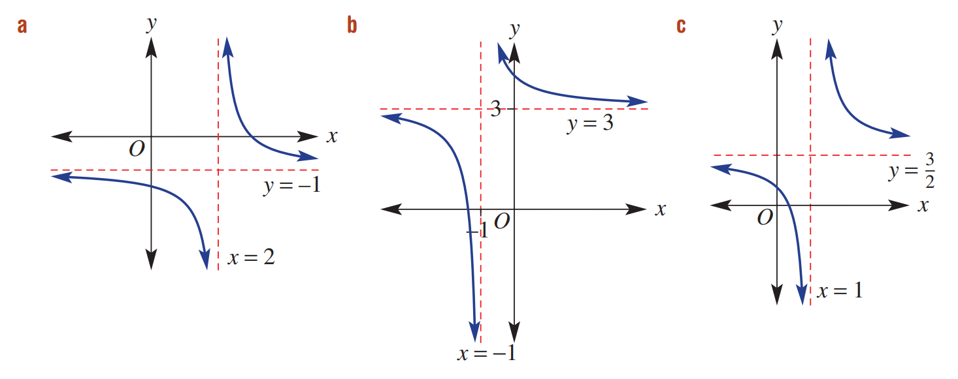  $$y=\frac{1}{x-2}-1$$ | $$y=\frac{1}{x+1}+3$$ | $$y=\frac{1}{x-1}+\frac{3}{2}$$
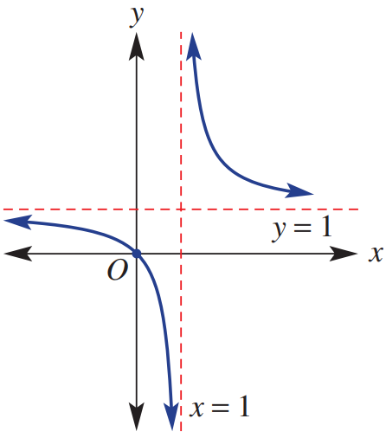  $$y=\frac{1}{x-1}+1$$ | 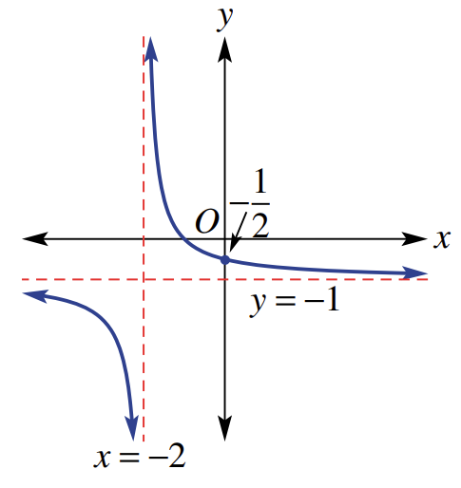  $$y=\frac{1}{x+2}-1$$ | 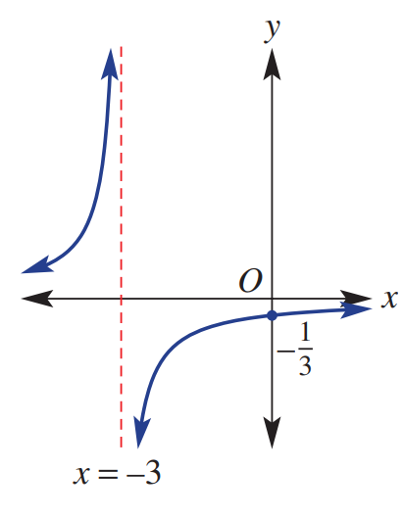  $$y=-\frac{1}{x+3}$$

Development
- Sketch these graphs on the same axis to show the transformation.
Clearly label the asymptotes and intercepts.
$$y=\frac{1}{x}+2$$  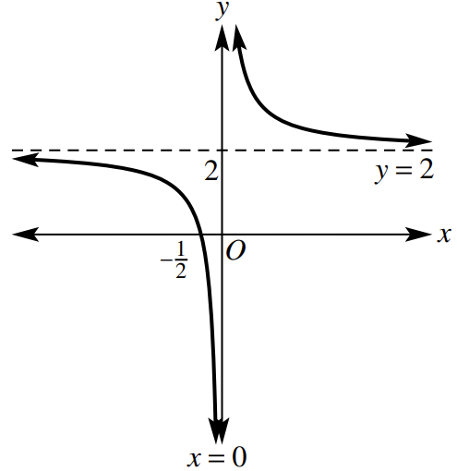 | $$y=\frac{1}{x+3}$$  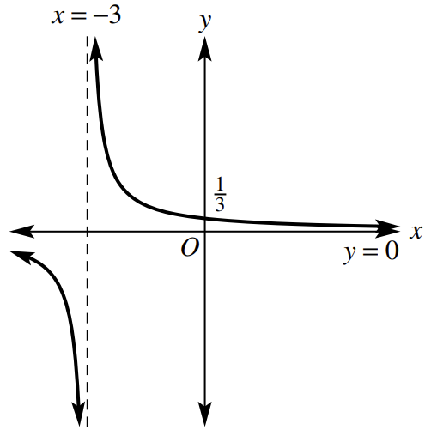 | $$y=\frac{1}{x-2}$$  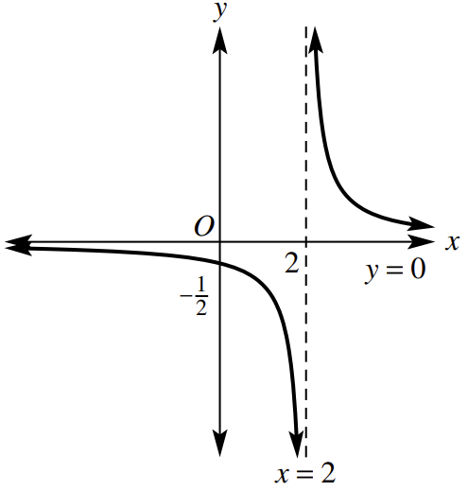 | $$y=\frac{1}{x-1}-3$$  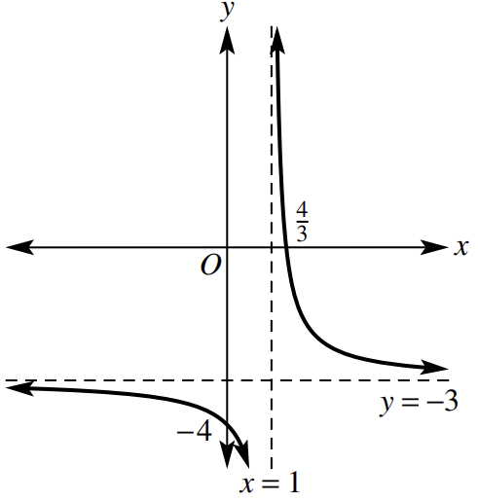
$$y=\frac{1}{x-3}+2$$  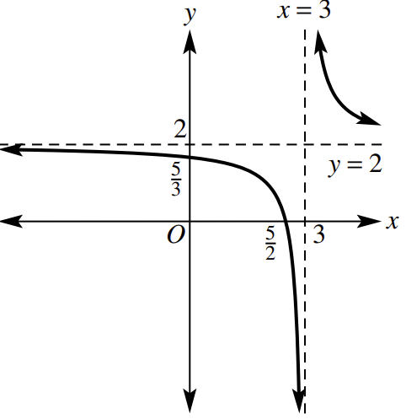 | $$y=\frac{1}{x-5}+6$$  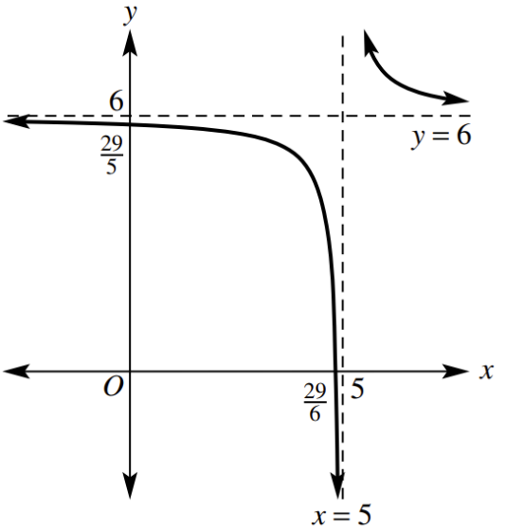 | $$y=\frac{-1}{x+1}+2$$  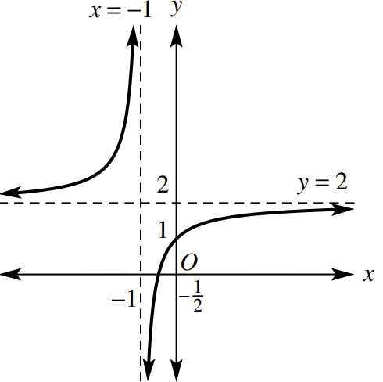 | $$y=\frac{-2}{x-3}-2$$  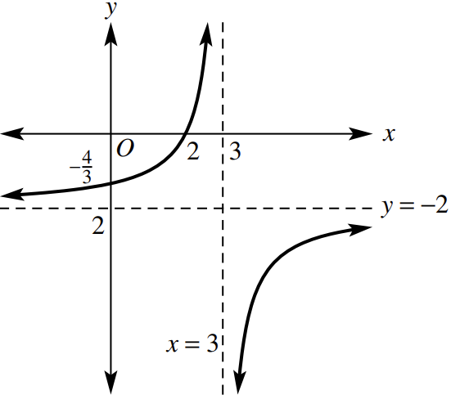

- These hyperbolas have equations in the form $y=\frac{k}{x}$.
Determine the value of $k$ by substituting in a coordinate and hence find the equation of the hyperbola.
$$y=-\frac{4}{x}$$ | 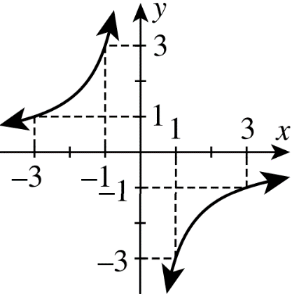  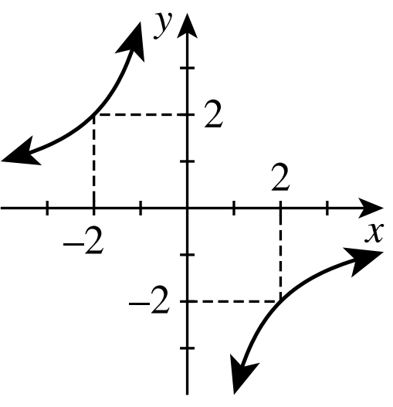  $$y=-\frac{3}{x}$$

Circles at the Origin

- Investigation Equation of a Circle
Consider the following circle with radius $r$ centred at the origin $(0,0)$
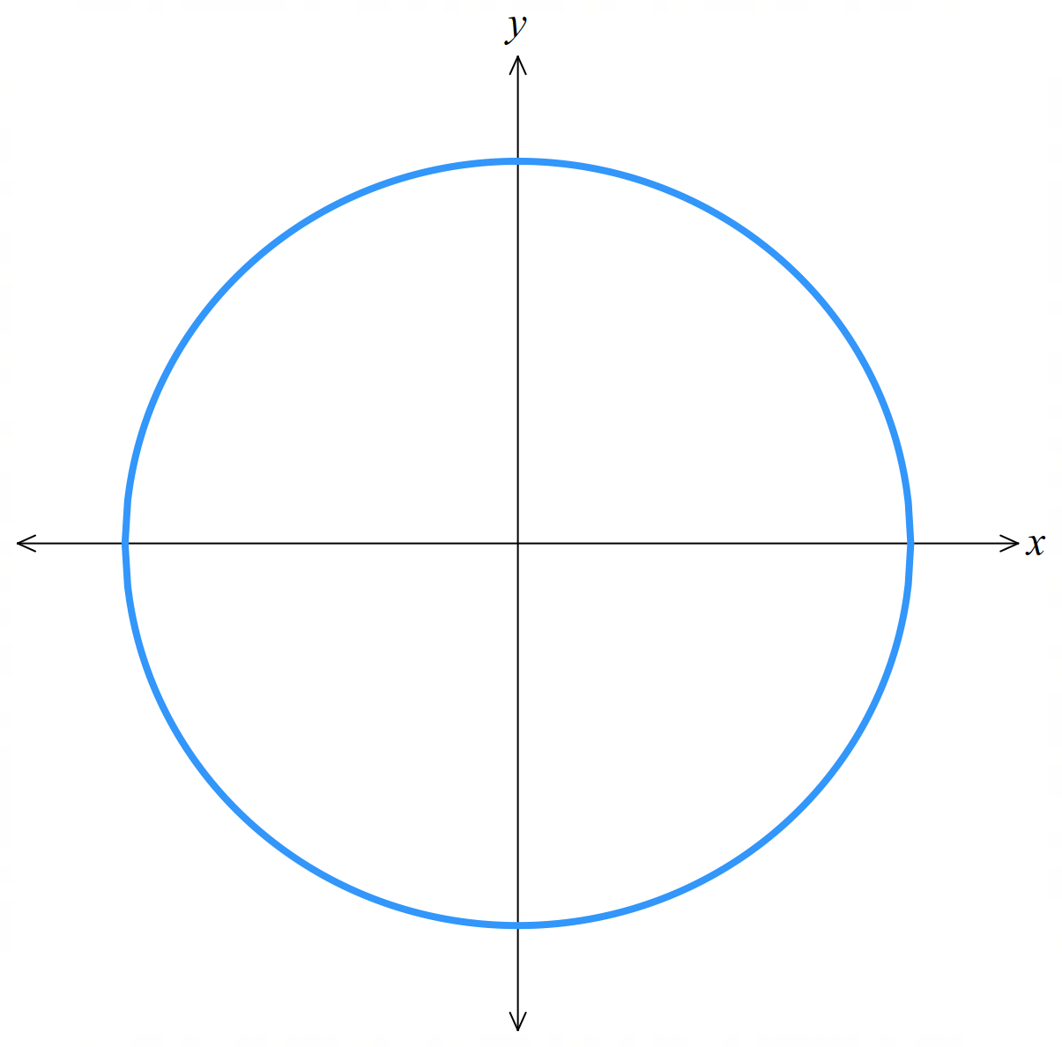

1. Choose a point on the circumference. Label this $P(x,y)$

2. Draw a line segment from the centre to the point $P$.
What is the length of this line and what is it called? …………………………………

3. Construct a right-angled triangle using the radius as the hypotenuse.
Label the lengths of the sides.

4. Write an equation relating the three sides of the right-angled triangle.
…………………………………………………………………………………………………………
This is the equation of a circle.

- Equation of a Circle Centred at the Origin
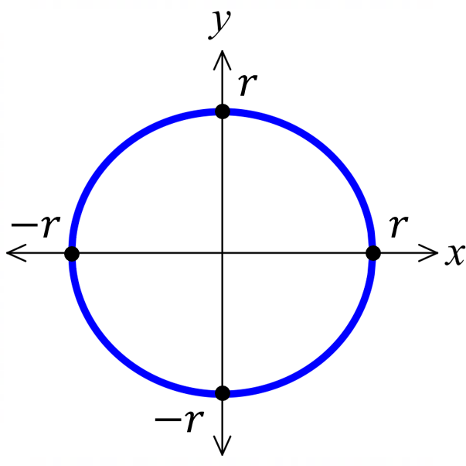

$$x^{2}+y^{2}=r^{2}$$
radius $r$

- Sketch the graph of a circle centred at the origin
Sketch $x^{2}+y^{2}=16$  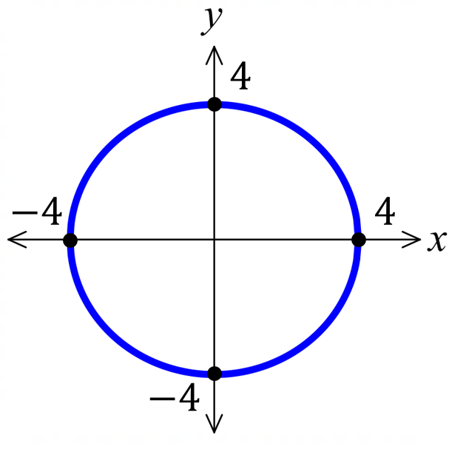 |  | Sketch $x^{2}+y^{2}=$ $\frac{4}{9}$  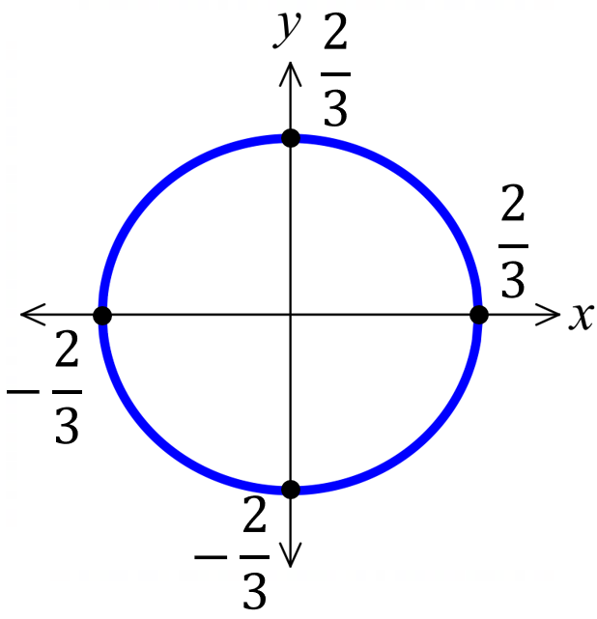
Sketch these circles
- $x^{2}+y^{2}=36$ | - $x^{2}+y^{2}=37$ |  | - $x^{2}+y^{2}=$ $\frac{1}{4}$
- $x^{2}+y^{2}=$ $\frac{9}{4}$ | - $x^{2}+y^{2}=144$ |  | - $x^{2}+y^{2}=7^{2}$

Foundation
- Identify the radius of the circles with these equations:
- $x^{2}+y^{2}=36$  6 | - $x^{2}+y^{2}=81$  9 | - $x^{2}+y^{2}=144$  12
- $x^{2}+y^{2}=5$  $$\sqrt{5}$$ | - $x^{2}+y^{2}=12$  $$2\sqrt{3}$$ | - $x^{2}+y^{2}=\frac{1}{4}$  $$\frac{1}{2}$$
- Write the equation of a circle with centre at the origin and radius of:
- $4$  $$x^{2}+y^{2}=16$$ | - $7$  $$x^{2}+y^{2}=49$$ | - $100$  $$x^{2}+y^{2}=10000$$
- $\sqrt{6}$  $$x^{2}+y^{2}=6$$ | - $\sqrt{10}$  $$x^{2}+y^{2}=10$$ | - $1.1$  $$x^{2}+y^{2}=1.21$$

- Sketch these circles showing the centre and all intercepts.
- $x^{2}+y^{2}=49$  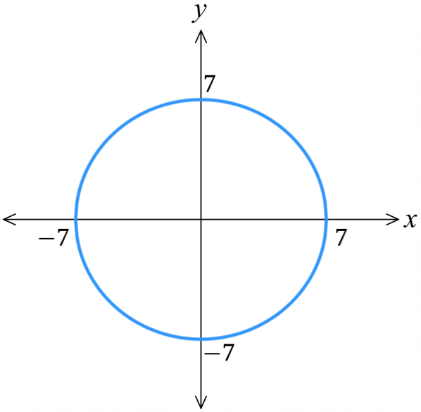 | - $x^{2}+y^{2}=$ $\frac{1}{9}$  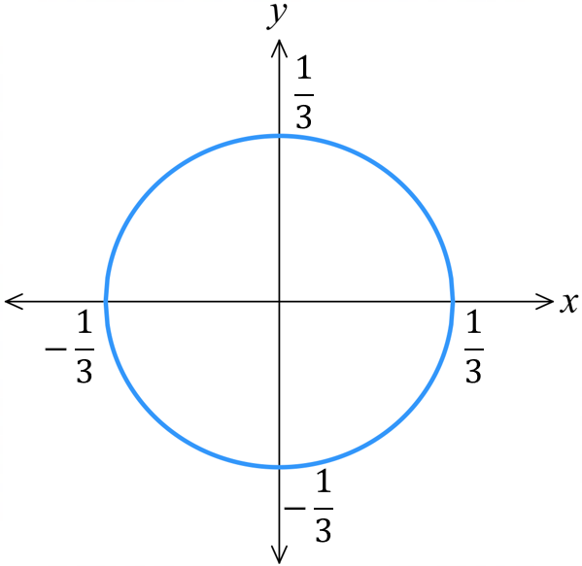  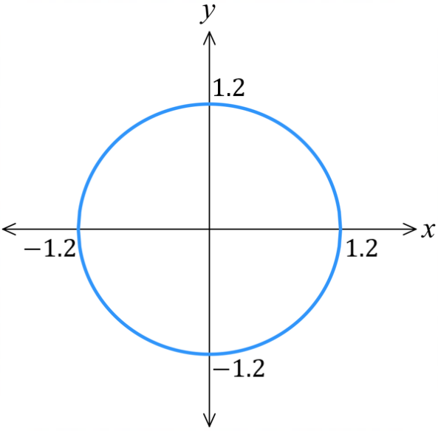  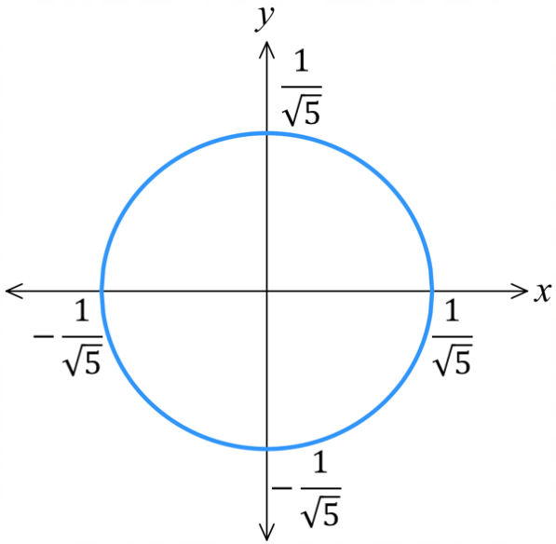 | - $x^{2}+y^{2}=1.44$
- $x^{2}+y^{2}=$ $\frac{9}{4}$  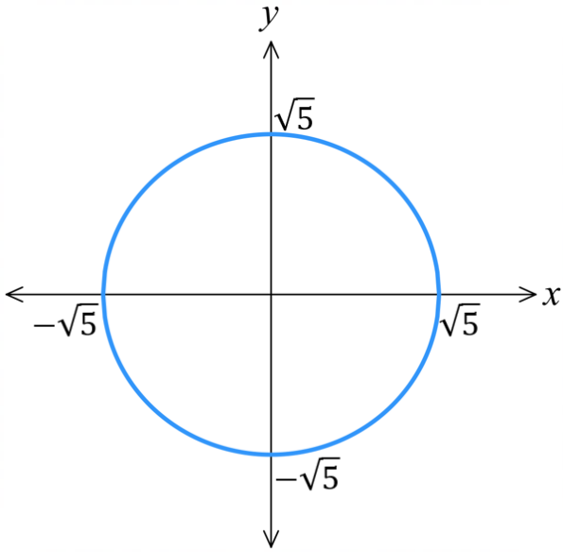  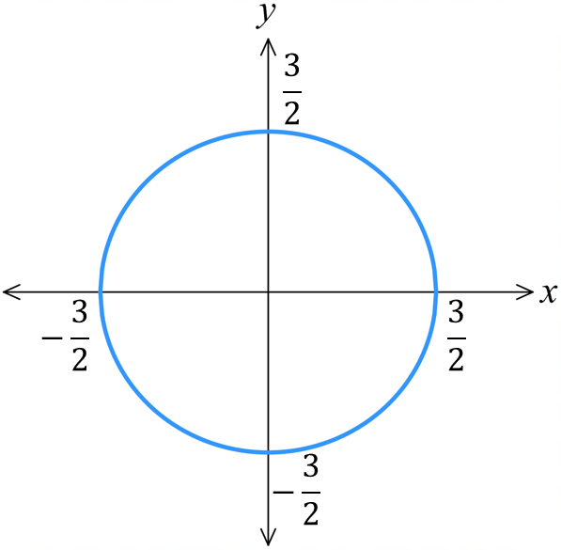 | - $x^{2}+y^{2}=5$ | - $x^{2}+y^{2}=$ $\frac{1}{5}$

Development
- Determine the equation of each circle. They are all centred at the origin.
$$x^{2}+y^{2}=4$$ | 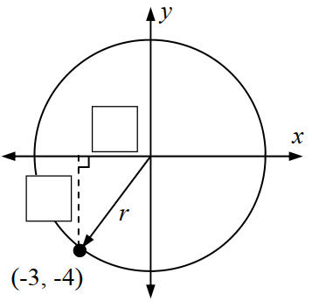  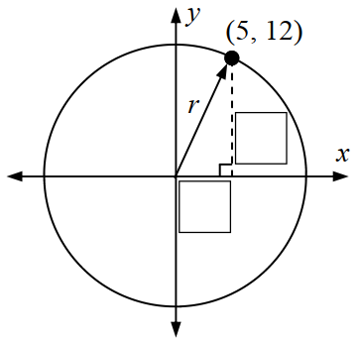  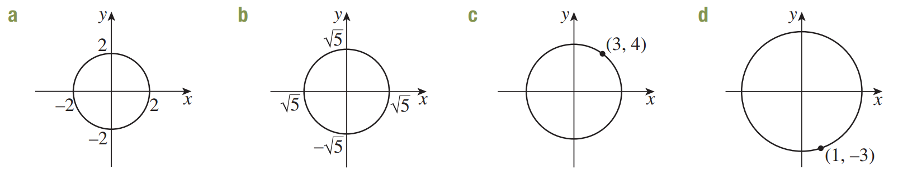  $$x^{2}+y^{2}=5$$
$$x^{2}+y^{2}=169$$ | $$x^{2}+y^{2}=25$$
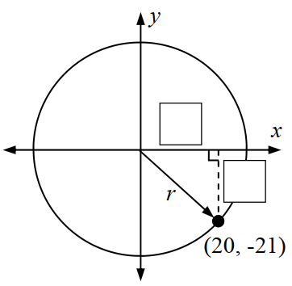  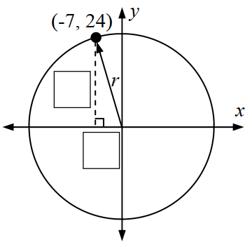  $$x^{2}+y^{2}=625$$ | $$x^{2}+y^{2}=841$$
$$x^{2}+y^{2}=25$$ | $$x^{2}+y^{2}=10$$

Mastery
- A circle with centre $O\left(0, 0\right)$ passes through $A\left(5, 12\right)$.
  - What is its radius?

$$13$$
  - Therefore, what is its equation?

$$x^{2}+y^{2}=169$$
- Consider the four points $A\left(1, 4\right), B\left(2, \sqrt{13}\right), C\left(3, 2\sqrt{2}\right) and D\left(4, 1\right)$
  - Find the distance of each point from the origin O.

$\sqrt{17}$
  - Hence explain why the four points lie on a circle with centre the origin and state the equation of the circle.

Each point is equidistant from the origin, so it lies on a circle centred at the origin.
$$x^{2}+y^{2}=17$$
  - What is the radius, diameter, circumference and area of this circle?

$r=\sqrt{17}$, $d=2\sqrt{17}$, $C=2π\sqrt{17}$, $A=17π$

- Show, using substitution, that $E\left(-12, -5\right)$ lies on the circle centred at the origin with radius 13.

$$x^{2}+y^{2}=169$$
$${\left(-12\right)}^{2}+{\left(-5\right)}^{2}=144+25=169$$
- Consider points $A\left(-5,0\right), B\left(5,0\right),$and $C\left(3,4\right)$.
  - Show that the points all lie on the circle $x^{2}+y^{2}=25$.

Using distance formula, distance from origin of all 3 points is $5$
  - Show that $AC⊥BC$.
$$m_{AC}=\frac{1}{2}, m_{BC}=-2$$
Since the gradients of AC and BC are negative reciprocals, they are perpendicular.

Circle Transformations

- General Equation of a Circle
centre $\left(a,b\right)$

$${\left(x-a\right)}^{2}+{\left(y-b\right)}^{2}=r^{2}$$
radius $r$

- Identify Centre and radius from equation of a circle
$${\left(x-3\right)}^{2}+{\left(y-4\right)}^{2}=25$$  Centre $\left(3,4\right)$, Radius 5 | $${\left(x-4\right)}^{2}+{\left(y+3\right)}^{2}=36$$  Centre $\left(4,-3\right)$, Radius 6
Identify the centre and radius of these circles
- ${\left(x-3\right)}^{2}+{\left(y+4\right)}^{2}=16$  Centre ………… Radius ………… | - ${\left(x+3\right)}^{2}+y^{2}=25$  Centre ………… Radius …………
- ${\left(x+2\right)}^{2}+{\left(y-50\right)}^{2}=100$  Centre ………… Radius ………… | - ${\left(x+19\right)}^{2}+{\left(y+\frac{1}{2}\right)}^{2}=50$  Centre ………… Radius …………
Find the equation of the circle for:
- Centre: $\left(3,9\right)$, radius 4 | - Centre: $\left(-1,\frac{3}{4}\right),$ radius $\sqrt{13}$

- Sketching a Translated Circle
centre $\left(a,b\right)$

$${\left(x-a\right)}^{2}+{\left(y-b\right)}^{2}=r^{2}$$
radius $r$
1. Identify centre and radius.
2. Draw a quick sketch, using the radius to determine if it crosses the axes.
3. Find $x$ and $y$ intercepts, if any.

- Example Sketch the graph of a circle not centred at the origin
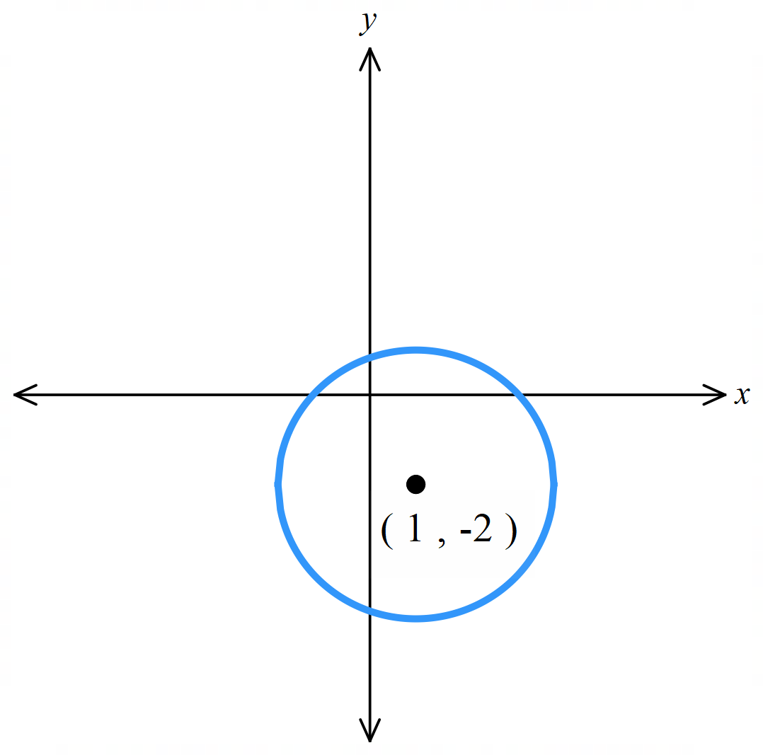
Sketch ${\left(x-1\right)}^{2}+{\left(y+2\right)}^{2}=9$.
Centre $\left(1,-2\right)$ radius 3.
The circle will cross the axes because the radius is 3.
$x$ intercepts let $y=0$  $${\left(x-1\right)}^{2}+{\left(0+2\right)}^{2}=9 \\ {\left(x-1\right)}^{2}=5 \\ x=1±\sqrt{5}$$ | $y$ intercepts let $x=0$  $${\left(0-1\right)}^{2}+{\left(y+2\right)}^{2}=9 \\ {\left(y+2\right)}^{2}=8 \\ y=-2±2\sqrt{2}$$

- Guided Practice
Sketch, and find the intercepts, if any.
- ${(x-1)}^{2}+y^{2}=1$  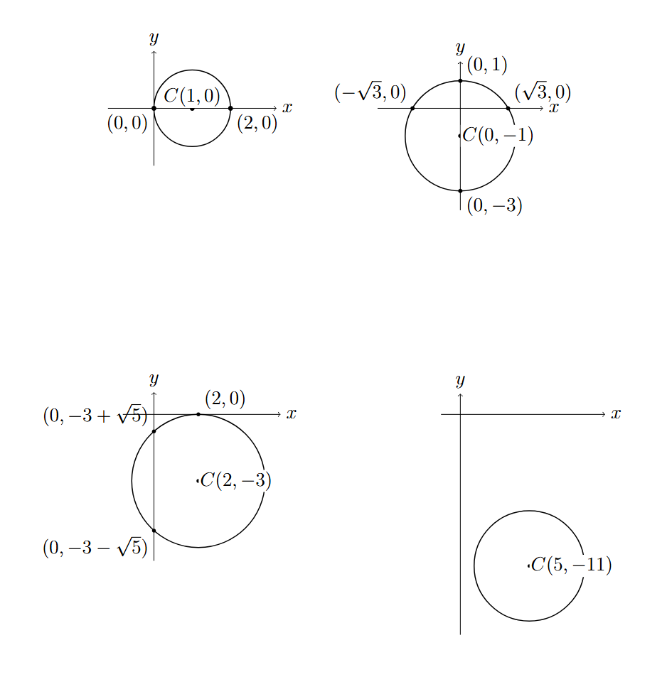 | - $x^{2}+{(y+1)}^{2}=4$
- ${(x-2)}^{2}+{(y+3)}^{2}=9$ | - ${\left(x-5\right)}^{2}+{\left(y+11\right)}^{2}=16$

Foundation
- Choose the word left, right, up or down to complete each sentence.
  - Compared to $x^{2}+y^{2}=r^{2},$ ${\left(x-1\right)}^{2}+y^{2}=r^{2}$is translated …………… by 1 unit.
right
  - Compared to $x^{2}+y^{2}=r^{2},$ ${\left(x+3\right)}^{2}+y^{2}=r^{2}$ is translated ……………………………
Left by 3 units
  - Compared to $x^{2}+y^{2}=r^{2},$ $x^{2}+{(y+3)}^{2}=r^{2}$ is translated ……………………………
Down by 3 units
  - Compared to $x^{2}+y^{2}=r^{2},$ $x^{2}+{(y-2)}^{2}=r^{2}$ is translated ……………………………
Up by 2 units
  - Compared to $x^{2}+y^{2}=r^{2},$ ${(x+2)}^{2}+{(y-1)}^{2}=r^{2}$ is translated
…………………………………………………………………
Left by 2, up by 1
  - Compared to $x^{2}+y^{2}=r^{2},$ ${(x+5)}^{2}+{(y+3)}^{2}=r^{2}$ is translated
…………………………………………………………………
Left by 5, down by 3
  - Compared to $x^{2}+y^{2}=r^{2},$ ${(x-4)}^{2}+{(y+2)}^{2}=r^{2}$ is translated
…………………………………………………………………
Right by 4, down by 2

- Write the equation of the circle with:
- centre $(-1,5)$, radius 4  $${\left(x+1\right)}^{2}+{\left(y-5\right)}^{2}=16$$ | - centre $\left(3,-5\right),$radius $\sqrt{7}$  $${\left(x-3\right)}^{2}+{\left(y+5\right)}^{2}=7$$ | - $\left(8,11\right),$radius $2\sqrt{5}$  $${\left(x-8\right)}^{2}+{\left(y-11\right)}^{2}=20$$

Foundation
- Sketch the following circles.
Label the coordinates of the centre and intercepts, if any. Check your sketch using DESMOS.
- ${\left(x-1\right)}^{2}+y^{2}=1$  Centre: (1,0)  $x$-intercepts:$x=0, 2$  $y$-intercepts:$y=0$ | - ${\left(x+1\right)}^{2}+y^{2}=9$  Centre: (−1,0)  $x$-intercepts:$x=-4, 2$  $y$-intercepts:$y=±2\sqrt{2}$ | - $x^{2}+{\left(y-4\right)}^{2}=36$  Centre: (0,4)  $x$-intercepts:$x=±2\sqrt{5}$  $y$-intercepts: $-2, 10$
- ${\left(x-3\right)}^{2}+{\left(y+1\right)}^{2}=1$  Centre: (3,−1)  $x$-intercepts:$x=3$  $y$-intercepts: none | - ${\left(x+2\right)}^{2}+{\left(y-3\right)}^{2}=4$  Centre: (−2,3)  $x$-intercepts: none  $y$-intercepts:3 | - ${\left(x-1\right)}^{2}+{\left(y+3\right)}^{2}=25$  Centre: (1,−3)  $x$-intercepts:$x=-3, 5$  $y$-intercepts:$y=-3±2\sqrt{6}$
- ${\left(x+3\right)}^{2}+{\left(y-2\right)}^{2}=25$  Centre: (−3,2)  $x$-intercepts:$x=-3±\sqrt{21}$  $y$-intercepts:$y=-2, 6$ | - ${\left(x+2\right)}^{2}+{\left(y-1\right)}^{2}=9$  Centre: (−2,1)  $x$-intercepts:$x=-2±2\sqrt{2}$  $y$-intercepts:$y=1±\sqrt{5}$ | - ${\left(x-2\right)}^{2}+{\left(y-5\right)}^{2}=64$  Centre: (2,5)  $x$-intercepts:$x=2±\sqrt{39}$  $y$-intercepts:$y=5±2\sqrt{15}$
- A circle with centre $B\left(4, 5\right)$ passes through the origin. What is its equation?

$${\left(x-4\right)}^{2}+{\left(y-5\right)}^{2}=41$$
- Determine the equation of each circle, using Pythagoras if necessary to find the radius.
$${\left(x-2\right)}^{2}+{\left(y-3\right)}^{2}=1$$ | 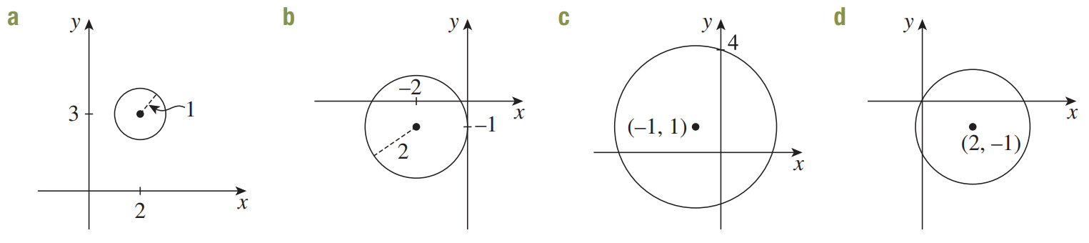  $${\left(x+2\right)}^{2}+{\left(y+1\right)}^{2}=4$$
$${\left(x+1\right)}^{2}+{\left(y-1\right)}^{2}=10$$ | $${\left(x-2\right)}^{2}+{\left(y+1\right)}^{2}=5$$

Development
- Find the equation of a circle with centre $(5,-2)$ passing through $\left(-1,1\right)$.

Distance between the centre and the point is $\sqrt{45}$, so the radius is $\sqrt{45}$.
$${\left(x-5\right)}^{2}+{\left(y+2\right)}^{2}=45$$
- A circle has centre $(4,-3)$ and one of the $x$-intercepts is at $(-\sqrt{7}+4, 0)$.
Determine the equation of the circle.

Distance between the centre and the intercept is $4$, so the radius is 4.
$${\left(x-4\right)}^{2}+{\left(y+3\right)}^{2}=16$$
- The interval joining the points $A\left(3,-1\right)$ and $B\left(-7,5\right)$ is a diameter of a circle.
  - Find the midpoint of $AB$.

$$\left(-2,2\right)$$
  - Explain why the midpoint of $AB$ is the centre of the circle.

The diameter connects two points on the circumference, passing through the centre.
Therefore, the midpoint of the diameter is the centre of the circle.
  - Find the length of the radius.

$$\sqrt{34}$$
  - Hence state the equation of the circle.

$${\left(x+2\right)}^{2}+{\left(y-2\right)}^{2}=34$$

- Find the centre of the circle with diameter $CD$, where $C=\left(2, 1\right)$ and $D=\left(8, -7\right)$.

$$\left(5,-3\right)$$
- Find the equation of a circle with diameter $KL$, where $K\left(5,7\right)$ and $L\left(-9,3\right)$

$${\left(x+2\right)}^{2}+{\left(y-5\right)}^{2}=53$$
- Find the possible equations of a circle with radius $AB$.
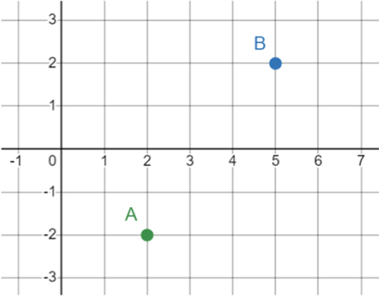

Circle with centre at A:
$${\left(x-2\right)}^{2}+{\left(y+2\right)}^{2}=25$$
Circle with centre at B:
$${\left(x-5\right)}^{2}+{\left(y-2\right)}^{2}=25$$

Completing the Square for a Circle

- Completing the Square to Find the Centre and Radius
Some questions require you to complete the square for the $x$and $y$ terms to write in the form
$${\left(x-a\right)}^{2}+{\left(y-b\right)}^{2}=r^{2}$$

- Example Sketch the graph of a circle by completing the square
$x^{2}+2x+y^{2}-6y-6=0$
$x^{2}+2x+1-1+y^{2}-6y+9-9-6=0$
$(x^{2}+2x+1)-1+(y^{2}-6y+9)-9-6=0$
${\left(x+1\right)}^{2}+{\left(y-3\right)}^{2}-16=0$
${\left(x+1\right)}^{2}+{\left(y-3\right)}^{2}=16$
Centre: $\left(-1,3\right)$, radius 4

- Guided Practice
Find the centre and radius by completing the square first.
- $x^{2}-4x+y^{2}=0$  $$\left(2,0\right) r=2$$ | - $x^{2}+6x+y^{2}-8y=0$  $$\left(-3,4\right) r=5$$
- $x^{2}+y^{2}-10x+12y=12=0$  $$\left(5,-6\right) r=7$$ | - $4x^{2}+4y^{2}-12x+20y-7=0$  $$\left(\frac{3}{2}, -\frac{5}{2}\right) r=\frac{\sqrt{41}}{2}$$

Foundation
- Determine the centre and radius of these circles by completing the square, if necessary.
- ${\left(x+1\right)}^{2}+y^{2}=4$  Centre: $\left(-1,0\right)$ Radius: 2 | - ${\left(x-1\right)}^{2}+{\left(y-2\right)}^{2}=1$  Centre: $\left(1,2\right)$ Radius: 1
- $x^{2}-10x+y^{2}=-16$  Centre: $\left(5,0\right)$ Radius: 3 | - $x^{2}+y^{2}+14x=33$  Centre: $\left(-7,0\right)$ Radius: $\sqrt{82}$
- $x^{2}-2x+y^{2}-4y-4=0$  Centre: $\left(1,2\right)$ Radius: 3 | - $x^{2}+6x+y^{2}-8y=0$  Centre: $\left(-3,4\right)$ Radius: 5
- $x^{2}-10x+y^{2}+8y+32=0$  Centre: $\left(5,-4\right)$ Radius: 3 | - $x^{2}+14x+14+y^{2}-2y=0$  Centre: $\left(-7,1\right)$ Radius: 6
- $x^{2}+4x+y^{2}-2y+1=0$  Centre: $\left(-2,1\right)$ Radius: 2 | - $x^{2}-6x+y^{2}-4y-3=0$  Centre: $\left(3,2\right)$ Radius: 4

  - Complete the square for $x^{2}+4x+y^{2}-6y+15=0$.

$${\left(x+2\right)}^{2}+{\left(y-3\right)}^{2}=-2$$
  - Explain why this is not an equation of a circle.

The radius cannot be negative.

Development
- Complete the square to sketch these circles. Show the centre, radius, and intercepts.
- $x^{2}-2x+y^{2}=0$  Centre: (1,0)  Radius: 1  $x$-intercepts:$x=0, 2$  $y$-intercepts:$y=0$ | - $x^{2}+6x+y^{2}=0$  Centre: (–3,0)  Radius: 3  $x$-intercepts:$x=-6, 0$  $y$-intercepts:$y=0$
- $x^{2}+4x+y^{2}-2y+1=0$  Centre: (–2,1)  Radius: 2  $x$-intercepts:$x=-2±\sqrt{3}$  $y$-intercepts:$y=1$ | - $x^{2}+8x+y^{2}+10y+5=0$  Centre: (–4,–5)  Radius: 6  $x$-intercepts:$x=-4±\sqrt{11}$  $y$-intercepts:$y=-5±2\sqrt{5}$
- $x^{2}-6x+y^{2}-4y-3=0$  Centre: (3,2)  Radius: 4  $x$-intercepts:$x=3±2\sqrt{3}$  $y$-intercepts:$y=2±\sqrt{7}$ | - $x^{2}-2x+y^{2} +6y-5=0$  Centre: (1,–3)  Radius: $\sqrt{15}$  $x$-intercepts:$x=1±\sqrt{6}$  $y$-intercepts:$y=-3±\sqrt{14}$

Mastery
- For what values of $k$ would the graph of $x^{2}+6x+y^{2}+k=0$ not exist?

By CTS, ${\left(x+3\right)}^{2}+y^{2}=9-k$
For circle to not exist, $9-k<0$
$$∴k>9$$
- A naval ship is at coordinates $P$ and equipped with a radar scanner that can detect objects inside the circle $x^{2}+y^{2}-80x-40y=500,$ where radius is measured in kilometres.
  - Find the coordinates of $P$.

By CTS, ${\left(x-40\right)}^{2}+{\left(y-20\right)}^{2}=2500$
$P$ is the centre of the circle, at $\left(40,20\right)$
  - Another ship is at $Q\left(60,-20\right)$ and can detect objects within a radius of 40 km.
    - Will ship $Q$ be able to detect $P$?

Distance between PQ is $\sqrt{2000}≈44.7$ km. Since Q has a radar range of 40 km, no.
    - Will ship $P$ be able to detect $Q$?

P’s radar has a range of 50 km, so yes.

- Consider the points $A\left(1,3\right)$, $B\left(3,9\right)$ and let $P\left(x,y\right)$ be a point.
  - Find an expression for the gradients of $PA$ and $PB$.

$$m_{PA}=\frac{y-3}{x-1}, m_{PB}=\frac{y-9}{x-3}$$
  - Suppose $∠APB=90°$. Show that $x^{2}-4x+y^{2}-12y+30=0$.

$$m_{PA}×m_{PB}=-1$$
$$\frac{y-3}{x-1}×\frac{y-9}{x-3}=-1$$
$$\frac{\left(y-3\right)\left(y-9\right)}{\left(x-1\right)\left(x-3\right)}=-1$$
$$\left(y-3\right)\left(y-9\right)=-\left(x-1\right)\left(x-3\right)$$
$$y^{2}-12y+27=-x^{2}+4x-3$$
$$x^{2}-4x+y^{2}-12y+30=0$$
  - By completing the square, show that this is the equation of a circle centred at $\left(2,6\right)$ with radius $\sqrt{10}$.

  - How is the point $P$ related to the circle? A sketch using DESMOS may help.
https://www.desmos.com/geometry/opfcwyddok

We have proved that if we draw any point $P$ and connect it to both A and B such that it forms a right angle at $∠APB$,
the point $P$ must lie on a circle centred at the midpoint of AB with radius $\sqrt{10}$.
This is related to the circle theorem “The angle at the circumference in a semicircle is $90°$”

Points of Intersection of a Parabola and a Line

- Review
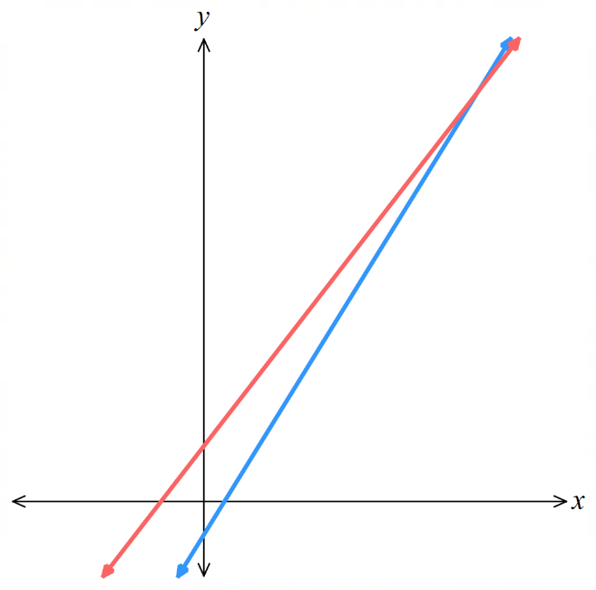
- Recall finding points of intersection of two lines
- $y=2x+1$ and $y=-4x+7$  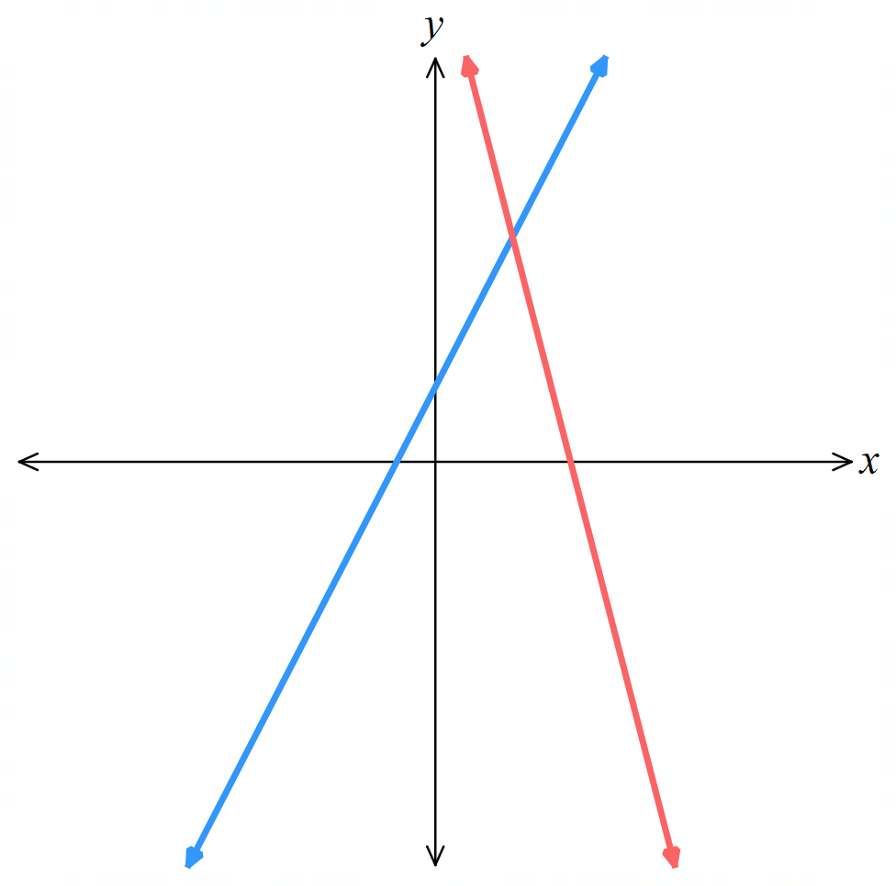 | - $y=5x-3$ and $y=4x+5$

- Solve non-linear simultaneous equations
- Solve $y=x-1$ and $y=x^{2}-3$  $x=2, y=1$  $$x=-1, y=-2$$ | - Solve  $y=x^{2}-3x+7$ and $y=2x+3$  $$x=1,y=5$$  $$x=4, y=11$$

- Finding the points of Intersection of a Parabola and a Line
When you have two graphs: $y=ax^{2}+bx+c$ and $y=mx+d$. The point of intersection lies on both curves, so is the simultaneous solution to the equations.
1. Set the two $y$ values to be equal $y_{1}=y_{2}$
2. Solve for $x$ by rearranging the resulting quadratic equation.
3. Solve for $y$.

- Example Find points of intersection of a parabola and a line
Find the points of intersection of $y=x^{2}+4x+4$ and $y=16.$

1. $x^{2}+4x+4=16$
2. $x^{2}+4x-12=0$
$\left(x+6\right)\left(x-2\right)=0$
$x=-6 or 2$

3. when $x=-6$, $y=16$
when $x=2$, $y=16$
so, points of intersection are $\left(-6,16\right)$ and $(2,16)$

- Guided Practice
Find the points of intersection of:
- $y=x^{2}+6x+9$ and $y=25$
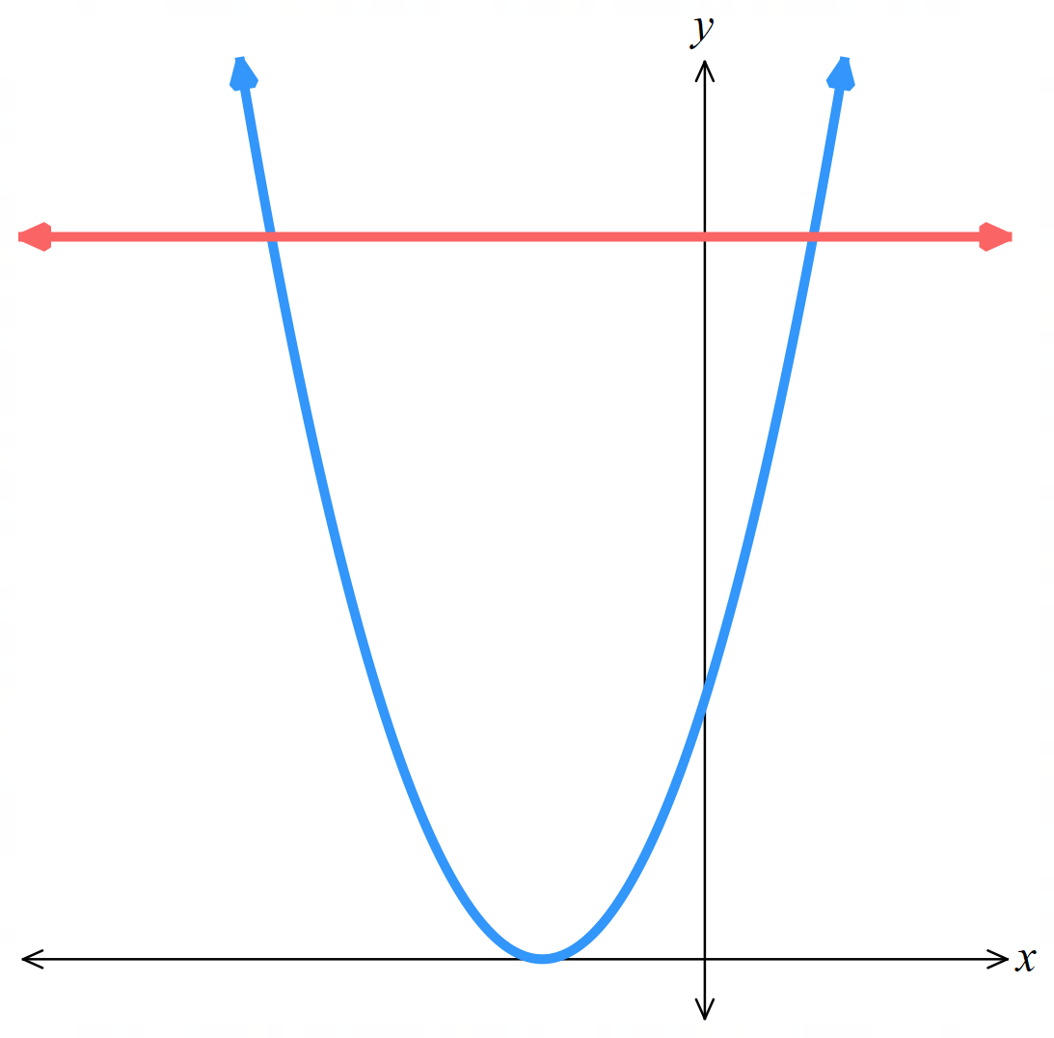

$\left(-8,25\right)$ and $\left(2,25\right)$
- $y=x^{2}+6x+9$ and $y=2x+9$
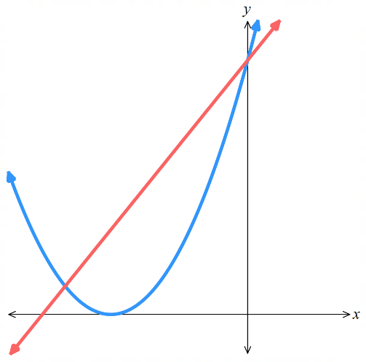

$\left(-4,1\right)$ and $\left(0,9\right)$
- $y=2x^{2}-5x-3$ and $y=3x+7$
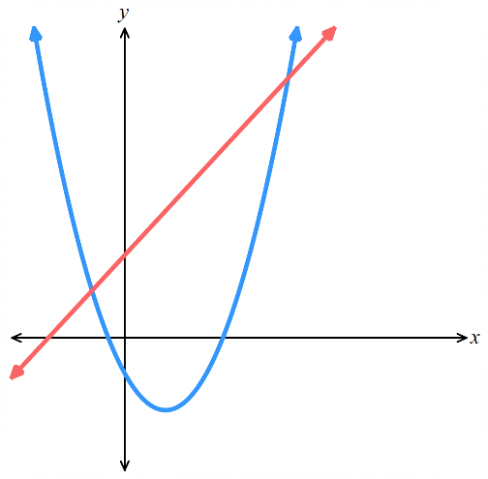

$\left(-1,4\right)$ and $\left(5,22\right)$

- The Discriminant and Points of Intersection
A parabola intersects a straight line at zero, one, or two points.
The discriminant of the resulting equation after setting the two equations equal reveals the number of points of intersection.
$$Δ=0$$  1 intersection point  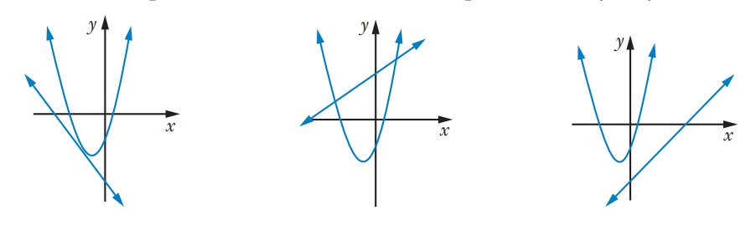  the line is tangent to the parabola | $$Δ>0$$  Two intersection points | $$Δ<0$$  No intersection points

- Investigation The discriminant and points of intersection
Consider the two graphs of $y=x^{2}-2x+1$ and $y=-2x+1.$
The graph shows that there is only one point of intersection.
Show that $Δ=0$ and then find the point of intersection.
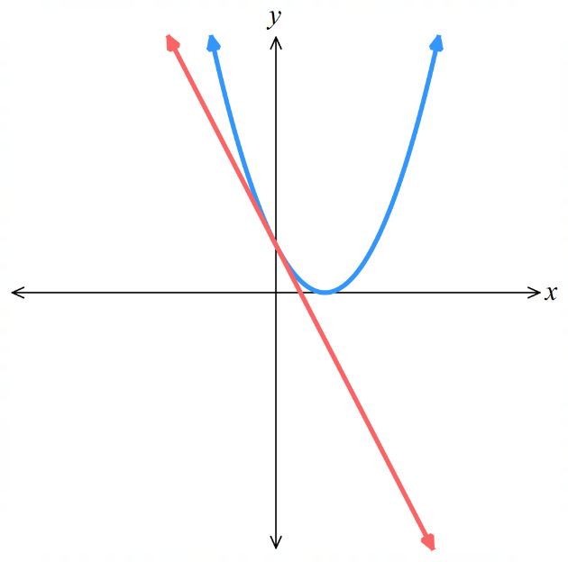

Consider the two graphs of $y=-2x^{2}+5x+3$ and $y=3x+7$.
The graph shows no points of intersection.
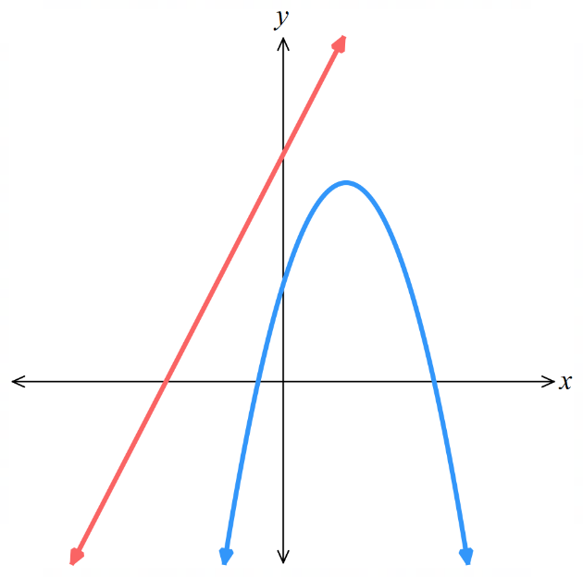
Find the value of $Δ$ and confirm this is true.

Foundation
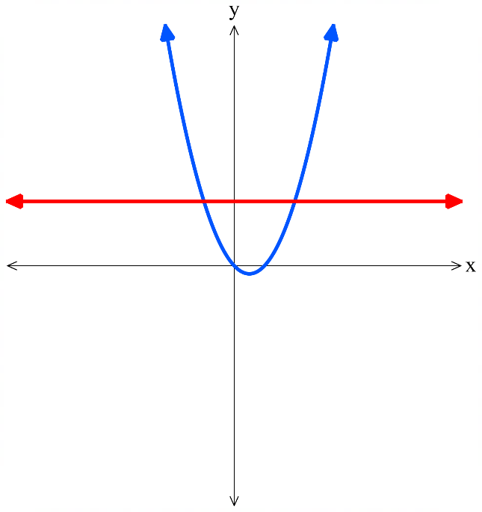
- The graphs of $y=x^{2}-x$ and $y=2$ are shown. Solve the two equations simultaneously for $x$.
Equate:
$x^{2}-x=2$
Rearrange:

Solve for $x$:

$\left(-1,2\right)$ and $\left(2,2\right)$
Do your solutions roughly match what is shown on the graph? ……………
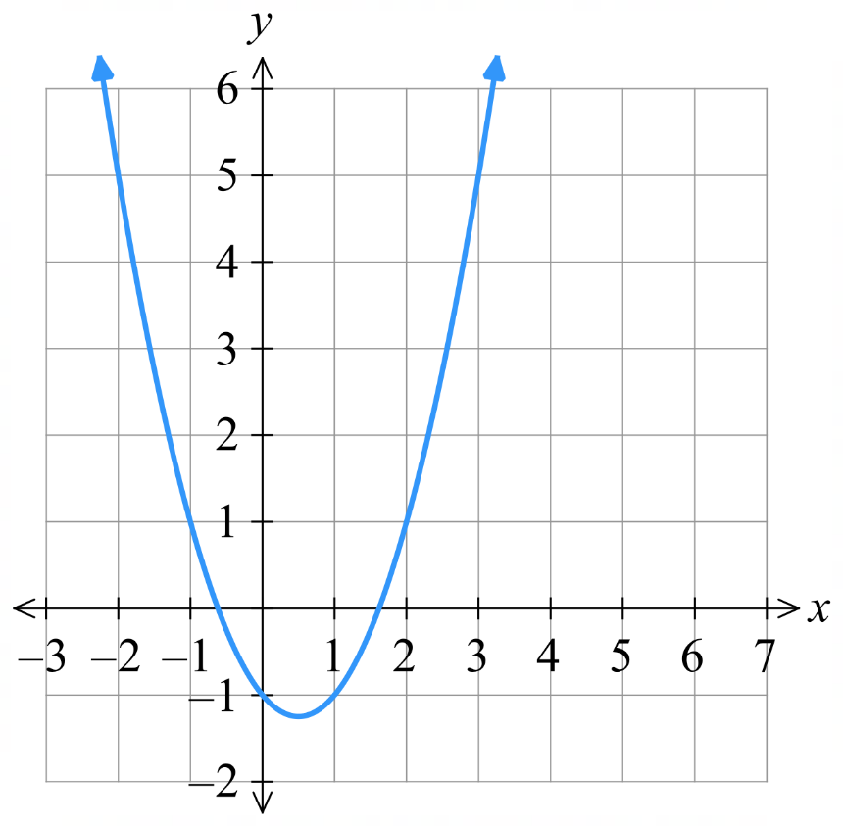
yes
- The graph of a parabola $y=x^{2}-x-1$ is shown.
  - Sketch the line $y=x+2$ on this graph.
  - Use the grid to find the points of intersection.
…………………………………………………
  - Find the points of intersection algebraically:
$x^{2}-x-1=x+2$

$\left(-1,1\right)$ and $\left(3,5\right)$
- What would be the value of the discriminant $Δ=b^{2}-4ac$ from solving the following equations simultaneously? Answer with $Δ<0$, $Δ=0$, or $Δ>0$.
$$Δ<0$$ | $$Δ>0$$ | 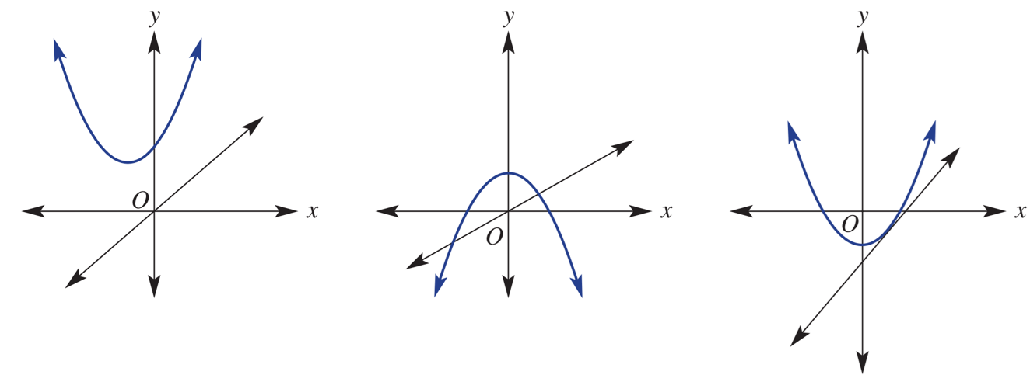  $$Δ=0$$

Development
- Find the points of intersection for these lines and parabolas.
- $y=x^{2}+x$ and $y=6$  $\left(-3,6\right)$ and $\left(2,6\right)$ | - $y=x^{2}-3x$ and $x=1$  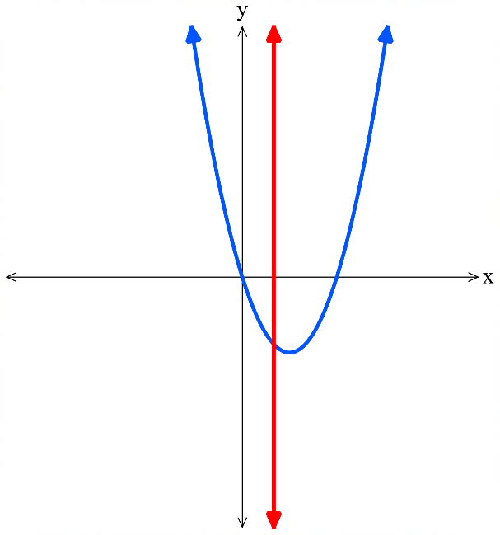  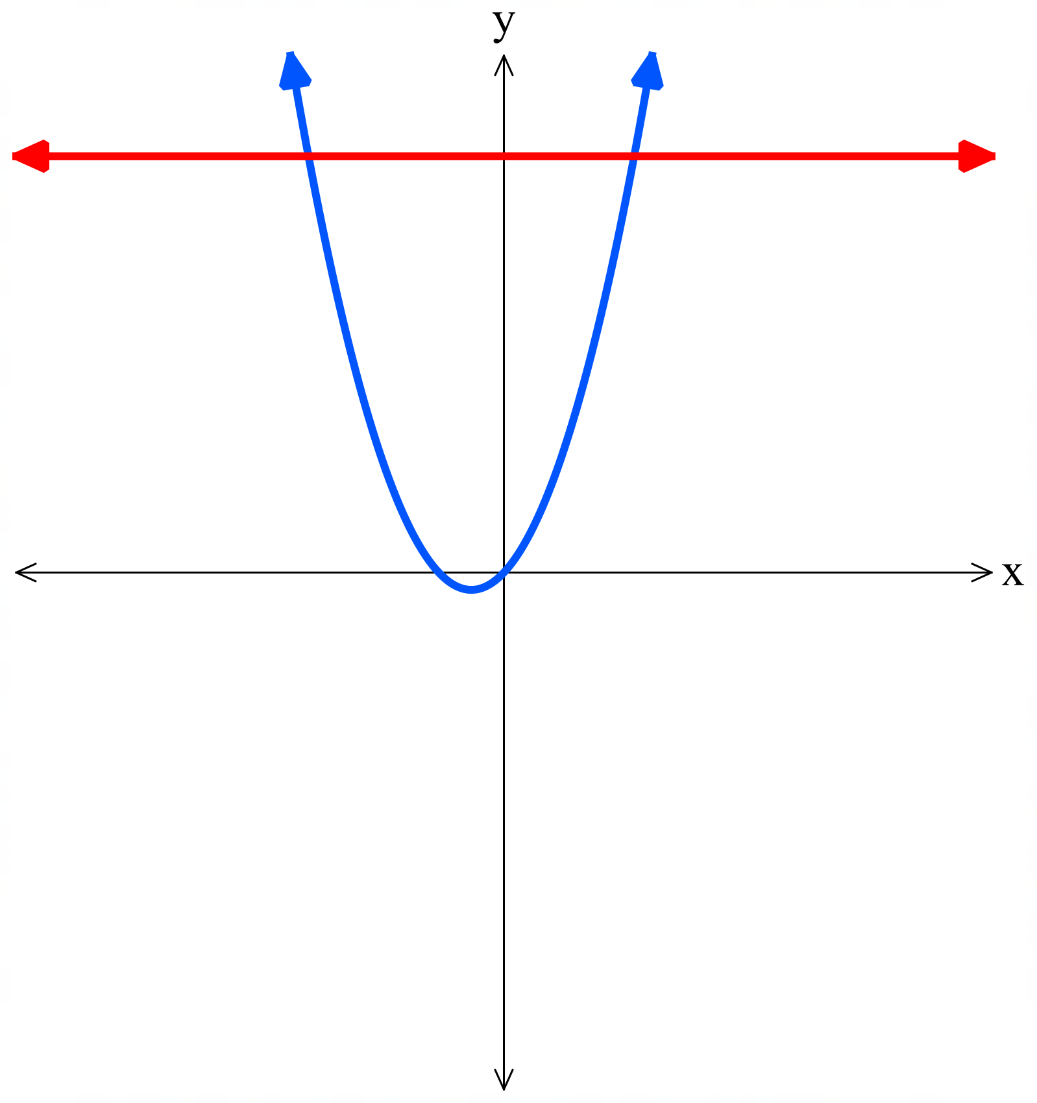  $$\left(1,-2\right)$$
- $y=x^{2}$ and $y=3x$  $(0,0)$ and $\left(3,9\right)$ | - $y=x^{2}-3x+5$ and $y=-x+4$  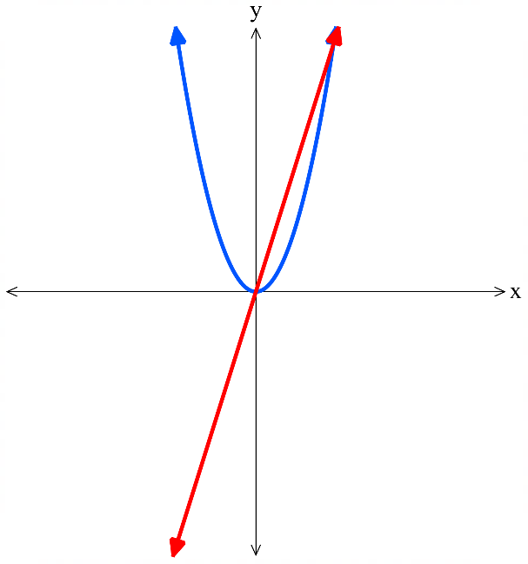  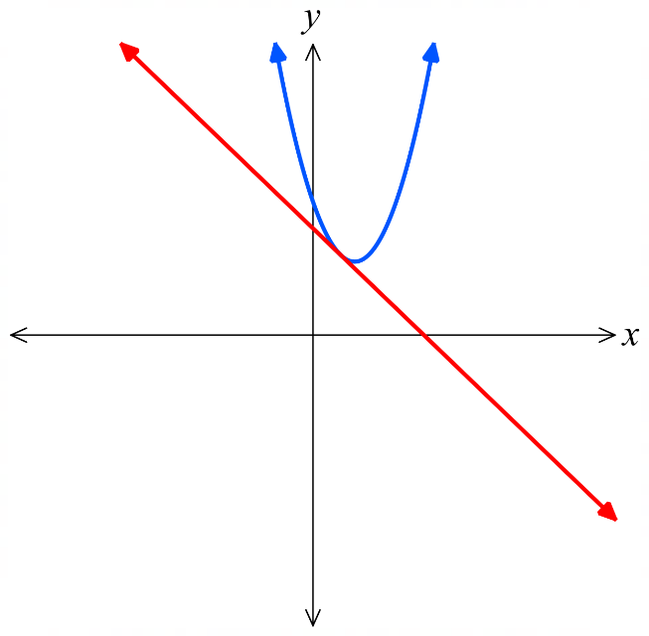  $$\left(1,3\right)$$
- $y=x^{2}-2x-4$ and $y=-2x+5$  $\left(-3,11\right)$ and $\left(3,-1\right)$ | - $y=-x^{2}-4x+3$ and $y=2x+12$  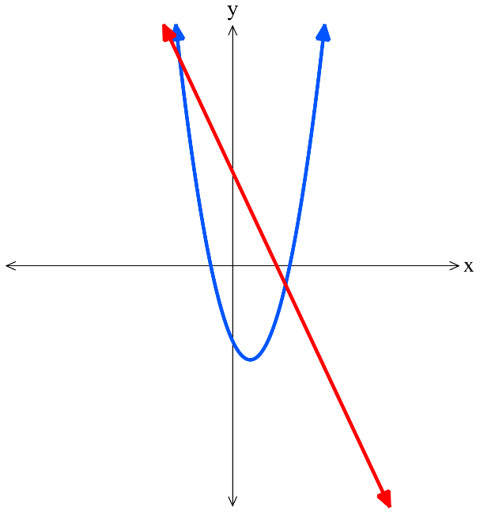  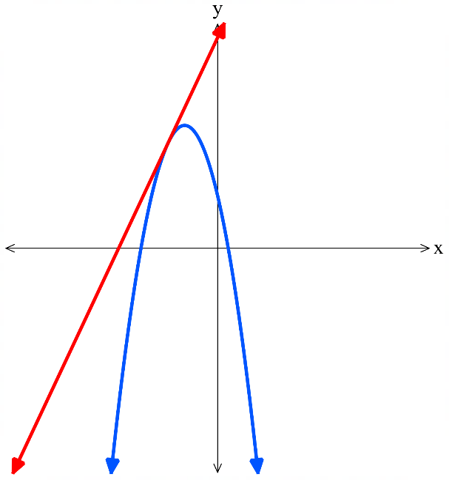  $$\left(-3,6\right)$$
- Solve the following simultaneous equations, making use of the quadratic formula.
Leave answers in exact surd form. Check your answer using DESMOS.
- Find the point of intersection of  $y=2x^{2}+3x+6$ and $y=x+4$  No point of intersection. | - Find the point of intersection of  $y=x^{2}+2x-5$ and $y=x$  $$\left(\frac{-1-\sqrt{21}}{2},\frac{-1-\sqrt{21}}{2}\right) and \left(\frac{-1+\sqrt{21}}{2},\frac{-1+\sqrt{21}}{2}\right)$$

- A member of an indoor cricket team, playing a match in a gymnasium, hits a ball that follows a path given by $y=-0.1x^{2}+2x+1$ , where $y$ is the height above ground, in metres, and $x$ is the horizontal distance travelled by the ball. The ceiling of the gymnasium is 10.6 metres high.
Determine whether the ball will intersect with the ceiling.

Set up equation $10.6=-0.1x^{2}+2x+1$
Yes, as $Δ>0$.

  - Use the discriminant to show that the line $y=2x+1$ does not intersect the parabola
$y=x^{2}+3$.

$Δ=-4$, so no solutions.
  - Determine for which values of $k$ the line $y=2x+k$ intersects the parabola
$y=x^{2}+3.$

$2x+k=x^{2}+3$
$x^{2}-2x+3-k=0$

$Δ=4-4\left(1\right)\left(3-k\right)$
$=4-12+4k$
$=4k-8$

$4k-8≥0$
$k≥2$

Mastery
- The line $y = mx$ is a tangent to the parabola $y=x^{2}-2x+4$
(i.e the line touches the parabola at just one point).
  - Find the possible values of $m$.
Set up equation $mx=x^{2}-2x+4$
$$x^{2}+\left(-2-m\right)x+4=0$$

Tangent means 1 intersection point. $b^{2}-4ac=0$
$${\left(-2-m\right)}^{2}-4\left(1\right)\left(4\right)=0$$
$$m^{2}+4m-12=0$$
$$\left(m+6\right)\left(m-2\right)=0$$
$$m=2 or-6$$
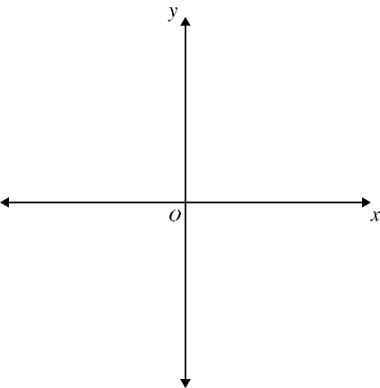
  - Explain why there are two possible values of $m$.
A diagram may help (use DESMOS to sketch $y=x^{2}-2x+4$ and $y=mx$).

There are two ways to draw a line that is tangent to $y=x^{2}-2x+4$,
one with gradient $-6$ and the other with gradient $2$
  - If the value of m is changed so that the line now intersects the parabola in two places, what is the set of possible values of m?

$$Δ>0$$
$$\left(m+6\right)\left(m-2\right)>0$$
By sketching the parabola $y=\left(x+6\right)\left(x-2\right)$ and solving the inequality, $m<-6, m>2$
- The line $y=mx-4$ is tangent to the parabola $y=x^{2}-2x+5$. Find the values of $m$.

$4$ or $-8$
- Find the values of $p$ for which $y=px-3p-5$ is tangent to $x^{2}=8y$.

$p=$ $\frac{5}{2}$ or $p=-1$

Points of Intersection of Two Curves

- Finding the Points of Intersection of Any Two Graphs
For any two graphs,
1. Solve simultaneously to find the $x$-coordinate(s) of the point of intersection.
2. Find the $y$-coordinate(s).

- Example Find points of intersection of a line and a hyperbola
Find the points of intersection of the line $y=4x$ and the hyperbola $y=$ $\frac{1}{x}$
1. Solve for $x$.  $4x=$ $\frac{1}{x}$  $4x^{2}=1$  $$x^{2}=\frac{1}{4}$$  $$x=±\frac{1}{2}$$ | 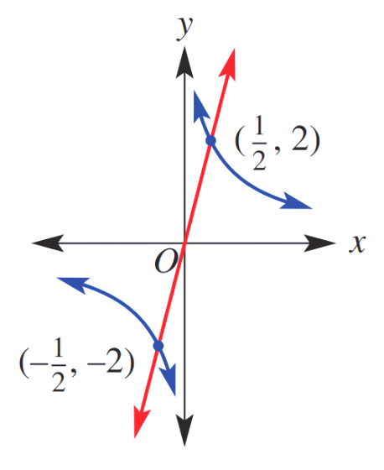  2. Find $y$ values.  Substitute $x$ into $(1)$ to find $y$ values:  When $x=$ $\frac{1}{2}$ $y=4$ $\left(\frac{1}{2}\right)$ $=2$  When $x=$ $\frac{-1}{2}$ $y=4$ $\left(\frac{-1}{2}\right)$ $=-2$  $$∴\left(\frac{1}{2}, 2\right) and \left(-\frac{1}{2},-2\right)$$

- Guided Practice
Find the point of intersection of these graphs.
- $y=-\frac{2}{x}$ and $y=-2x$
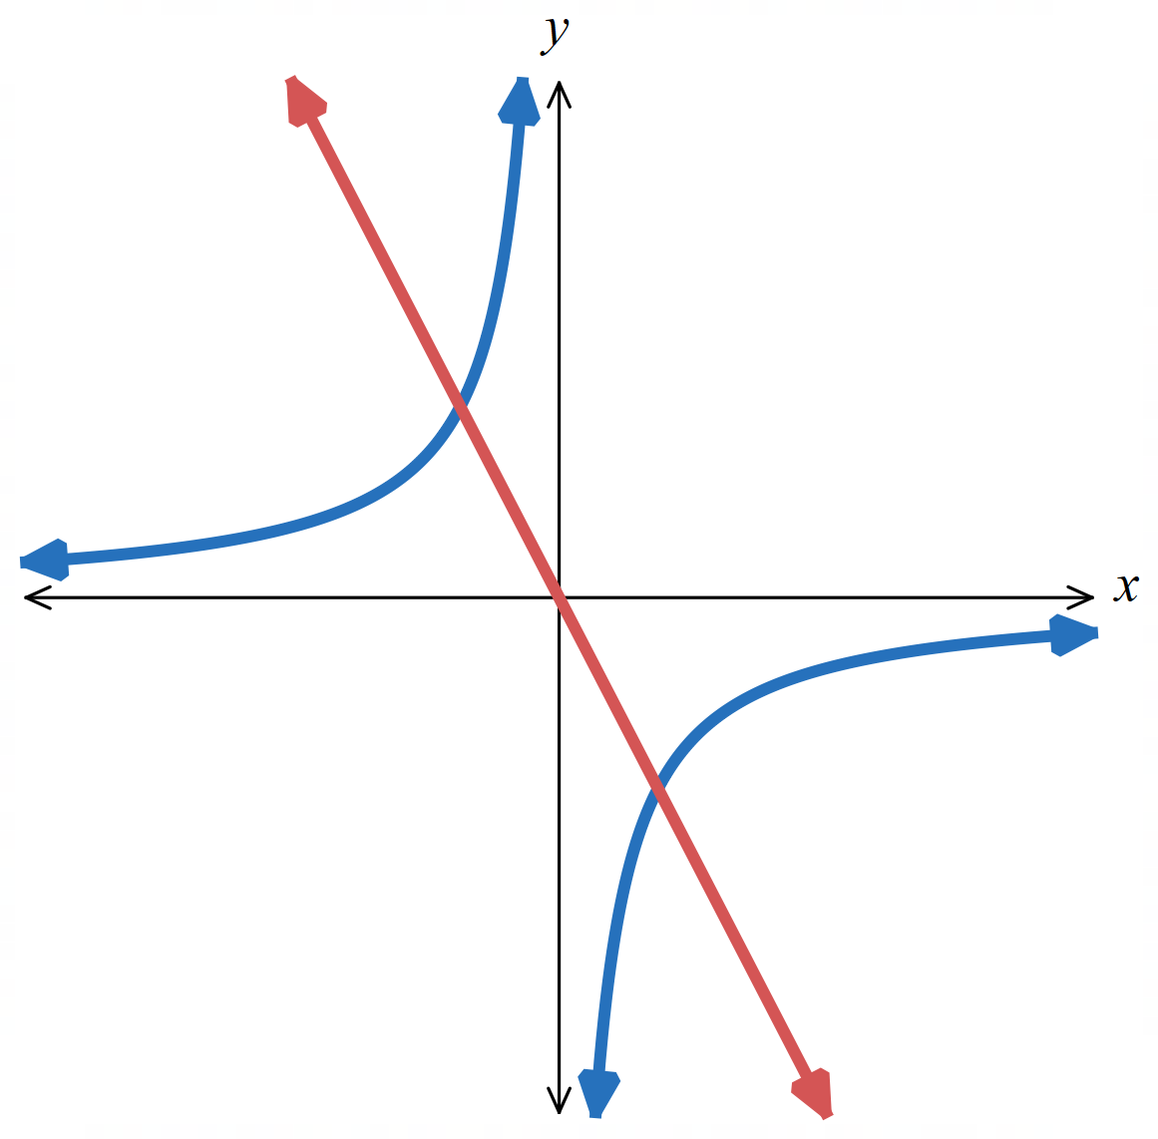

$\left(-1,2\right)$ and $\left(1,-2\right)$
- $y=$ $\frac{1}{x}$ and $y=2x$
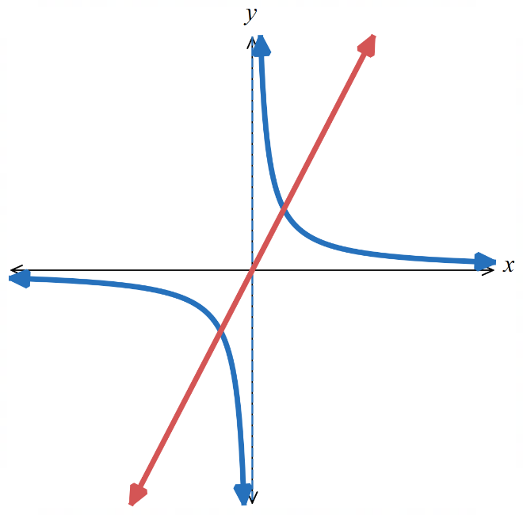

$$\left(-\frac{1}{\sqrt{2}}, -\sqrt{2} \right) and \left(\frac{1}{\sqrt{2}}, \sqrt{2} \right)$$
- Example Find points of intersection of a line and a circle
Find the points of intersection of the line $y=2x$ and the circle $y^{2}+x^{2}=4$
1. Solve simultaneously  $y=2x$ (1)  $y^{2}+x^{2}=4$ (2)  Sub (1) into (2)  ${\left(2x\right)}^{2}+x^{2}=4$  $5x^{2}=4$  $$x^{2}=\frac{4}{5}$$  $$x=±\frac{2}{\sqrt{5}}$$ | 3. Find $y$ values.  Substitute into $(1)$ to find $y$ values:  When $x=$ $\frac{2}{\sqrt{5}}$ $y=2$ $\left(\frac{2}{\sqrt{5}}\right)$ $=$ $\frac{4}{\sqrt{5}}$  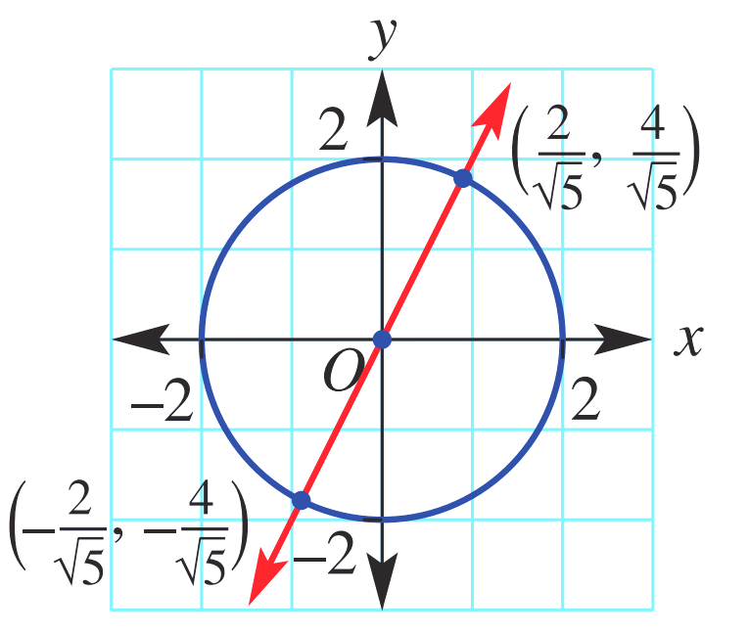  When $x=$ $\frac{-2}{\sqrt{5}}$ $y=2$ $\left(\frac{-2}{\sqrt{5}}\right)$ $=$ $\frac{-4}{\sqrt{5}}$  $∴\left(\frac{2}{\sqrt{5}},\frac{4}{\sqrt{5}}\right)$ and $\left(\frac{-2}{\sqrt{5}},\frac{-4}{\sqrt{5}}\right)$

- Guided Practice
Find the point of intersection of these graphs.
- $y=-x+1$ and
$x^{2}+y^{2}=5$
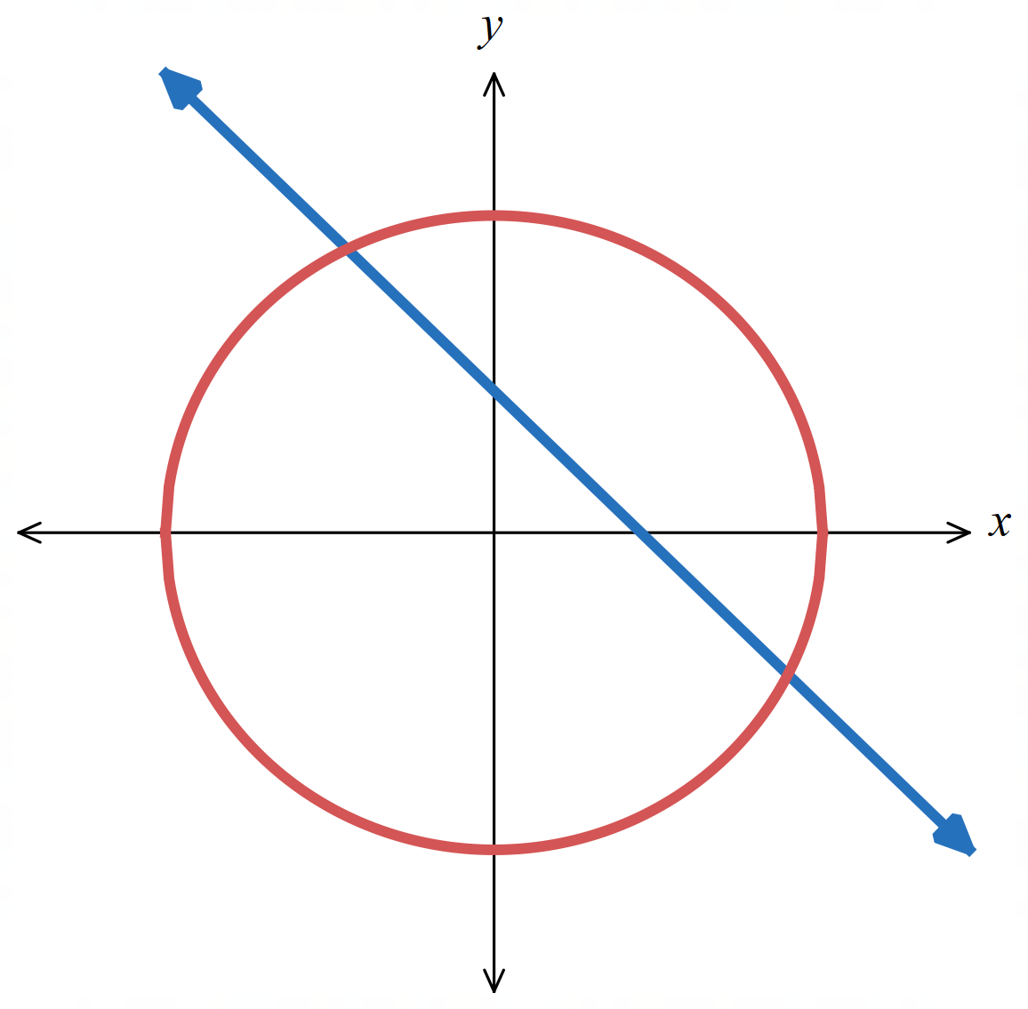

$\left(-1,2\right)$ and $\left(2,-1\right)$
- $x^{2}+y^{2}=16$ and
$y=4x$
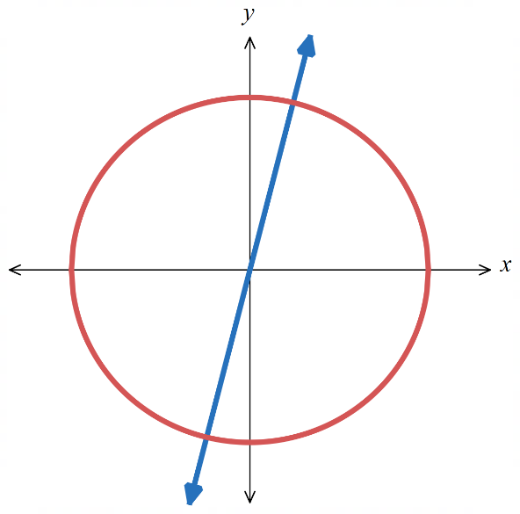

$$\left(-\frac{4}{\sqrt{17}},-\frac{16}{\sqrt{17}}\right) and \left(\frac{4}{\sqrt{17}},\frac{16}{\sqrt{17}}\right)$$

Foundation
- Find the point of intersection of these graphs. You will need to rearrange before equating.
- $y=x^{2}$ and $x=$ $\frac{y}{2}$  $\left(0,0\right)$ and $\left(2,4\right)$ | - $y+4x^{2}+x-6=0$ and $y-3x=7$  $$\left(-0.5,5.5\right)$$
- $y=x^{2}+3x-1$ and $3y=$ $x-3$  $$\left(-\frac{8}{3}, -\frac{17}{9}\right) and \left(0,-1\right)$$ | - $y-7={\left(x-2\right)}^{2}$ and $y+x=9$  $\left(1,8\right)$ and $\left(2,7\right)$
- $xy=1$ and $y=x-1$  $$\left(\frac{1-\sqrt{5}}{2},\frac{-1-\sqrt{5}}{2}\right) and \left(\frac{1+\sqrt{5}}{2},\frac{\sqrt{5}-1}{2}\right)$$ | - $x^{2}+y^{2}=4$ and $2y+x=0$  $$\left(\frac{-4}{\sqrt{5}},\frac{2}{\sqrt{5}}\right) and\left(\frac{4}{\sqrt{5}},-\frac{2}{\sqrt{5}}\right)$$

Development
- Find the point of intersection for these functions.
A sketch has been provided to help you interpret your answer.
- $y=x^{2}-2$  $y=-x^{2}+6x-6.5$  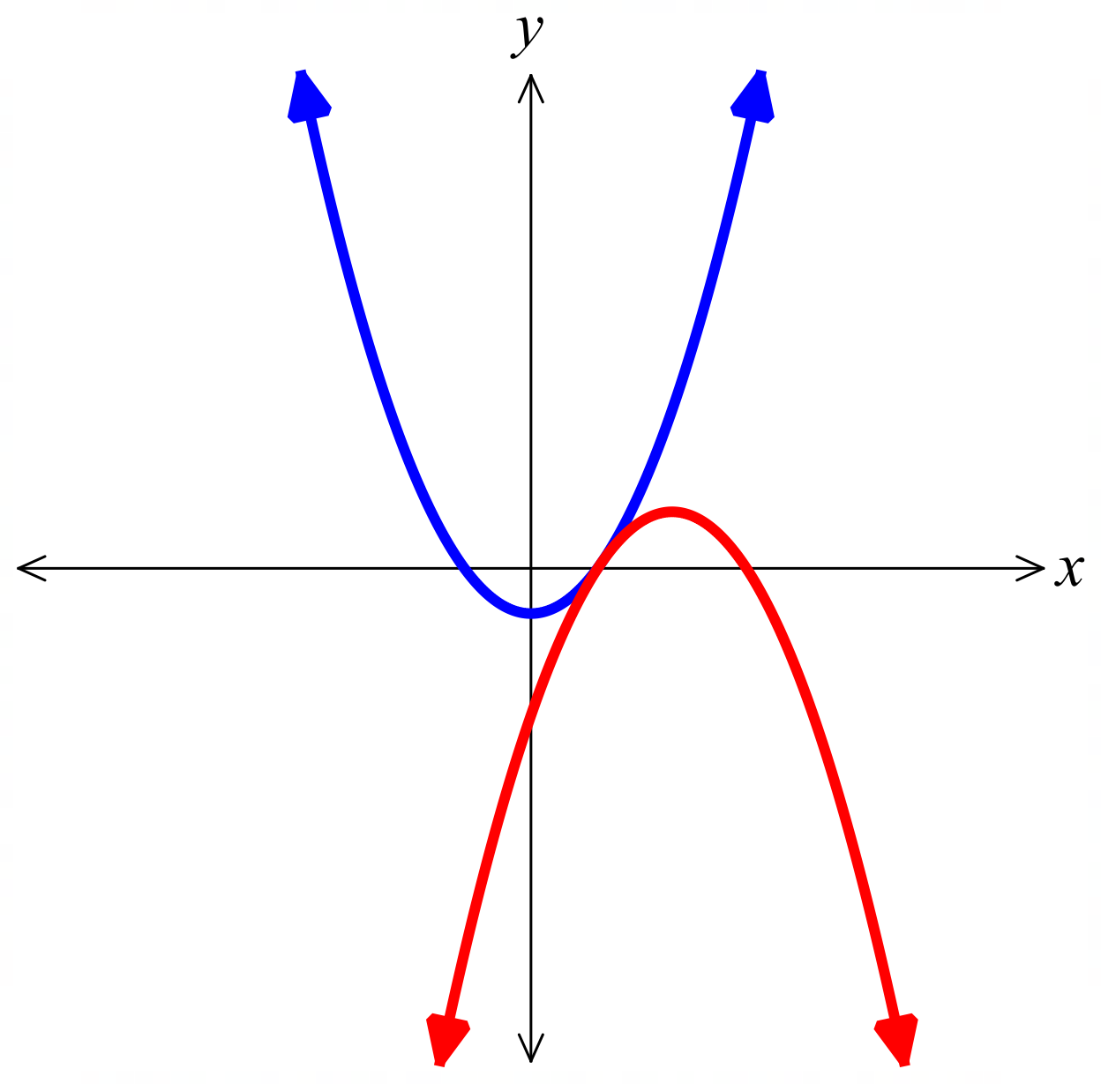  (1.5, 0.25) | - $y=x^{2}-2x+2$  $y=-x^{2}+8x+1$  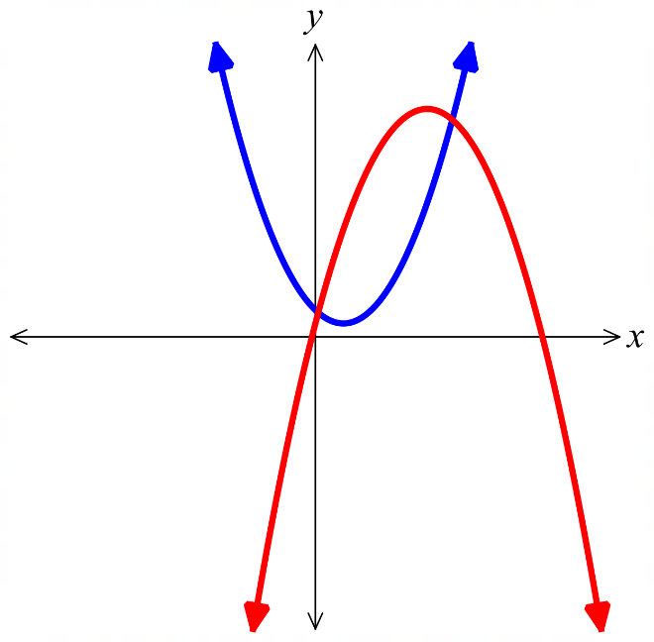  $$\left(\frac{5-\sqrt{23}}{2},9-\frac{3\sqrt{23}}{2}\right) and \left(\frac{5+\sqrt{23}}{2},9+\frac{3\sqrt{23}}{2}\right)$$
- $y=x^{2}+7$  $y=-x^{2}+6x-9$  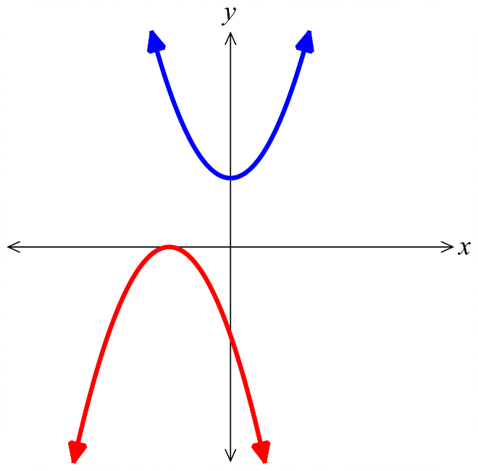  You will end up with a quadratic where $Δ<0$,  no points of intersection | - $y=x^{2}$  $y=$ $\frac{8}{x}$  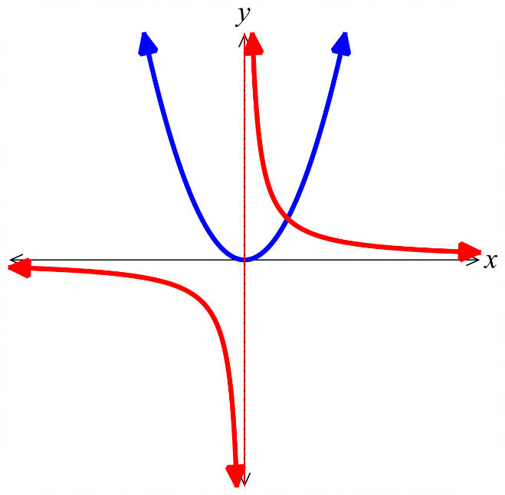  (2,4)

- The diagram shows the graph of $y=x^{3}+4x^{2}-2$ for $-3≤x≤1.5$.
By drawing a suitable straight line, solve the equation $x^{3}+4x^{2}-2=2x$ for $-3≤x≤1.5$.
Give your answer as estimates to 2 d.p.
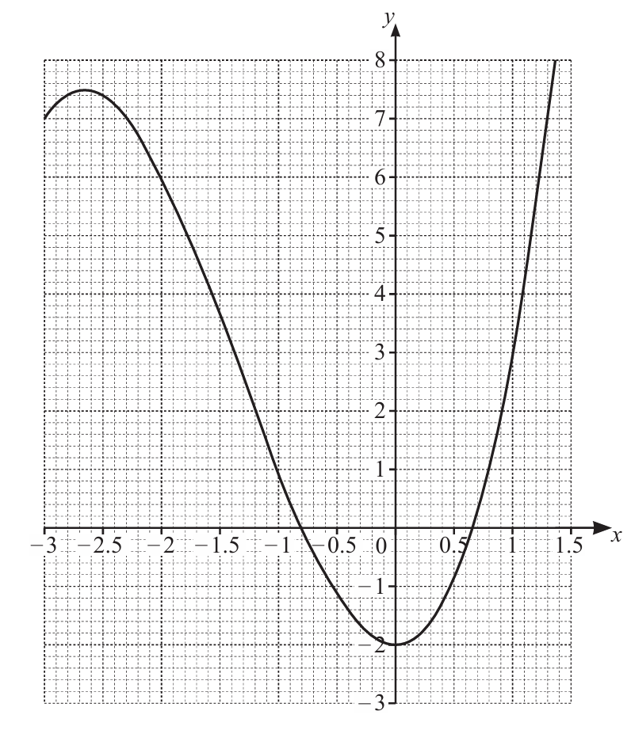

Sketch the line $y=2x$ on the same axis.
The $x$-coordinates of the points of intersection are the solution.
$x≈-0.52$and $0.88$

- The table shows some values for $y=5x^{2}-x^{3}-4$
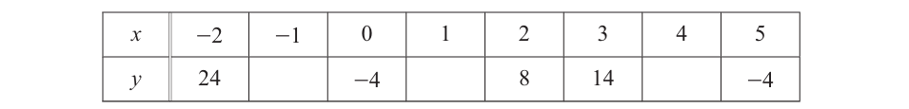
  - Complete the table.
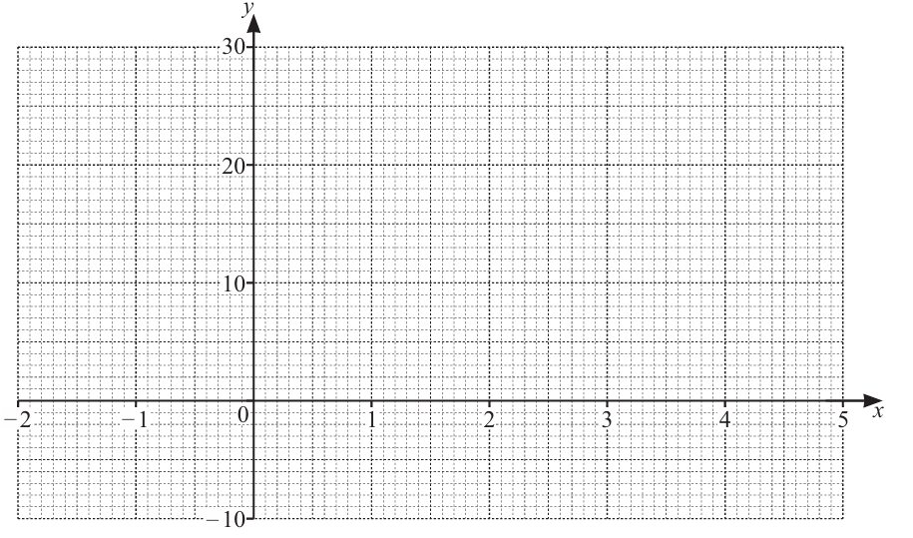
  - Sketch the graph for $-2≤x≤5$.
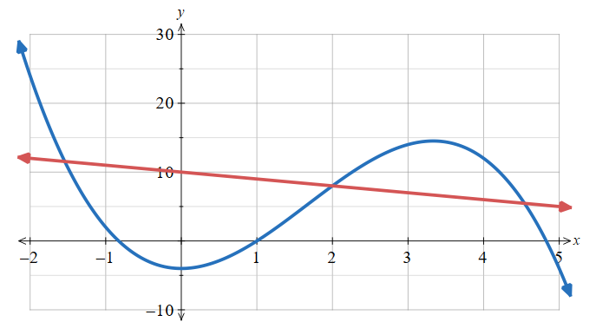

  - By drawing a suitable straight line on the grid, solve the equation $x^{3}-5x^{2}-x+14=0$
This is equivalent to solving $5x^{2}-x^{3}-4=10-x$
Draw the line $y=10-x$ and read off the points of intersection
$$x≈-1,5, 2, 4.5$$

- The table shows some values for $y=2^{x}-3$
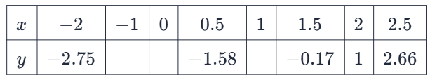
  - Complete the table.

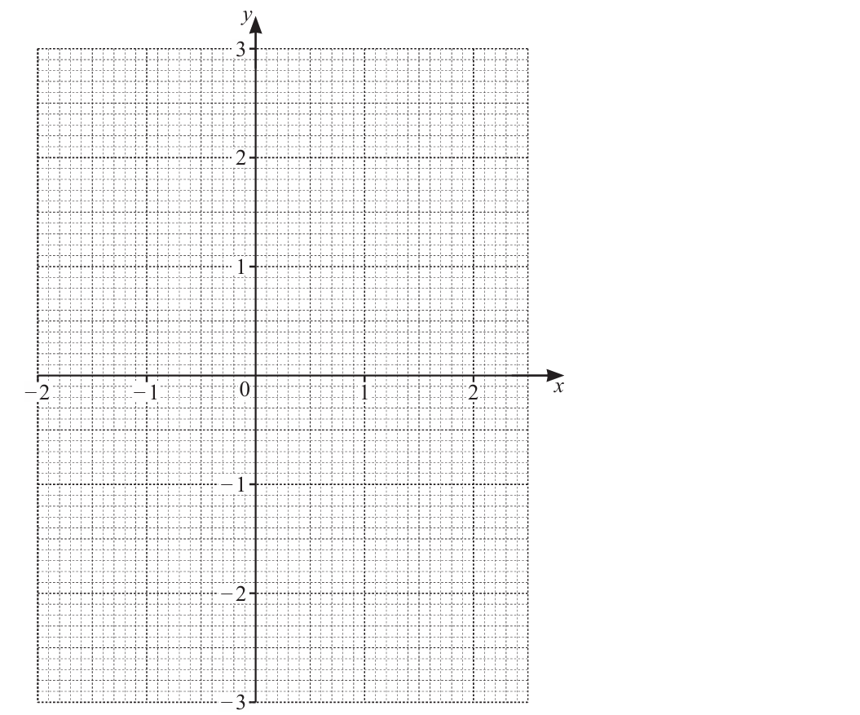
  - On the grid, sketch the graph $y=2^{x}-3$ for $-2≤x≤2.5$.
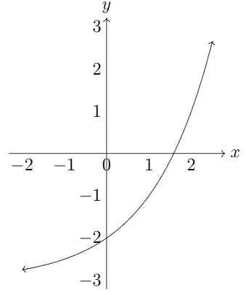

  - Use your graph to solve $2^{x}-3=2$.
Draw a horizontal line $y=2$ and read off points of intersection
$$x≈2.3$$
  - By drawing a suitable straight line, solve $2^{x}-x-1.5=0$.
This is equivalent to solving $2^{x}-3=x-1.5$
Sketch $y=x-1.5$ and read off $x$ values of points of intersection
$x=-1$ and $≈1.66$

Mastery
- Show that $y=-2x+5$ is tangent to the circle $x^{2}+y^{2}=5$.

Equate to find points of intersection:
$$x^{2}+{\left(-2x+5\right)}^{2}=5$$
$$x^{2}+4x^{2}-20x+25=5$$
$$5x^{2}-20x+20=0$$
$$Δ=b^{2}-4ac={\left(-20\right)}^{2}-4\left(5\right)\left(20\right)=0$$
$∴$ there is 1 point of intersection, hence the line is tangent to the circle.
- Show that $3x+y=6$ is tangent to the circle $x^{2}+y^{2}+4x+16y+28=0$.

Same method as above.
$$x^{2}+{\left(-3x+6\right)}^{2}+4x+16\left(-3x+6\right)+28=0$$
This simplifies to: $x^{2}-8x+16=0$
$$Δ=b^{2}-4ac={\left(-8\right)}^{2}-4\left(1\right)\left(16\right)=0$$
- The line $2x-y+3=0$ intersects the circle $x^{2}+y^{2}-4x+6y-12=0$ at two points, $D$ and $E$.
  - Find the coordinates of $D$ and $E$.

Rearrange equation of line: $y=2x+3$
Sub into equation of circle
$$x^{2}+{\left(2x+3\right)}^{2}-4x+6\left(2x+3\right)-12=0$$
This simplifies to $5x^{2}+20x+15=0$
$$∴\left(x+1\right)\left(x+3\right)=0$$
The points of intersection are $\left(-1, 1\right), \left(-3, -3\right)$
  - Hence find the length of the line segment joining $DE$.

$$DE=\sqrt{{\left(x_{2}-x_{1}\right)}^{2}+{\left(y_{2}-y_{1}\right)}^{2}}$$
$=\sqrt{2^{2}+4^{2}}=2\sqrt{5}$ units

- For the circle $x^{2}+y^{2}=4$ and line $y=mx+4$ , determine the exact values of the gradient, $m$, so that the line:
  - is a tangent to the circle (intersects the circle once)

set up equation $x^{2}+{\left(mx+4\right)}^{2}=4$
$$Δ=16m^{2}-48$$
Let $Δ=0$
$$m=±\sqrt{3}$$
  - intersects the circle at two points

$$Δ>0$$
$$16m^{2}-48>0$$
$$m<-\sqrt{3} or m>\sqrt{3}$$
  - does not intersect the circle

$$-\sqrt{3}<m<\sqrt{3}$$

  - Try to find the coordinates of the points of intersection of $y=$ $\frac{1}{x}$ and $y=-x+1$.
What do you notice?
$$-x+1=\frac{1}{x}$$
$$-x^{2}+x=1$$
$$x^{2}-x+1=0$$
There are no points of intersection; $Δ={\left(-1\right)}^{2}-4\left(1\right)\left(1\right)=-3<0$.
  - Sketch the two graphs on the same axis to visualise the scenario.

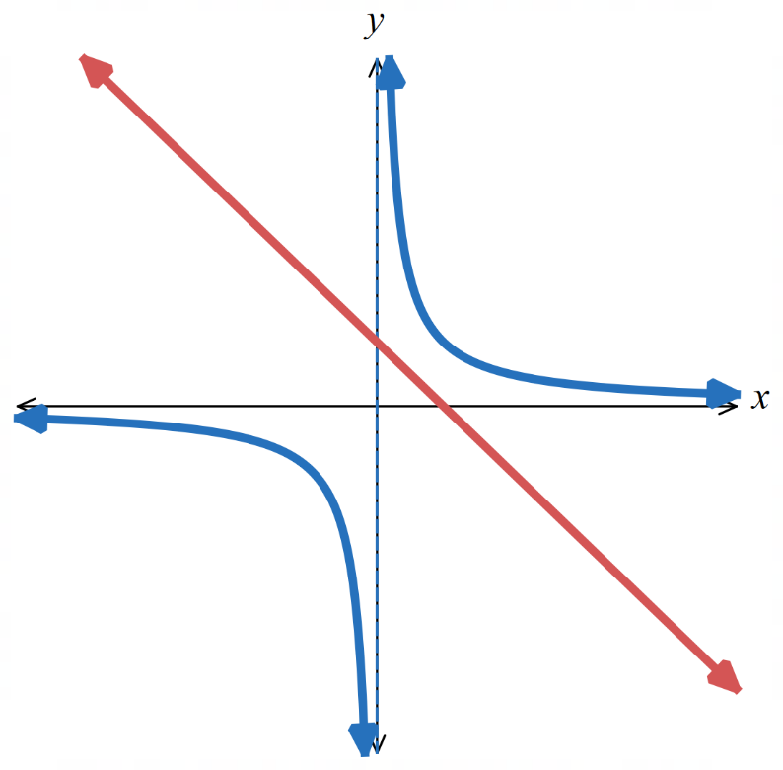

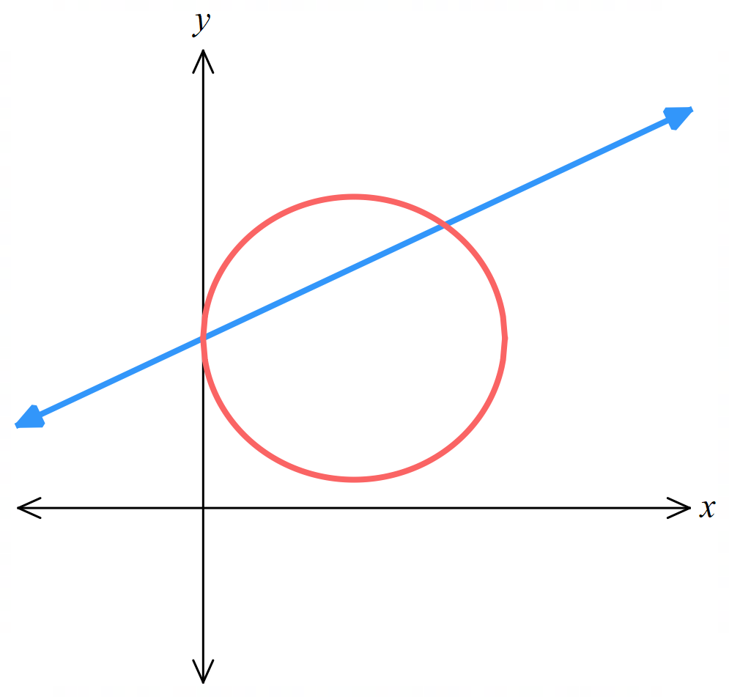
- The line $2y-x=12$ intersects the circle $x^{2}+y^{2}-10x-12y+36=0$ at the points $A$ and $B$.
A sketch is given, it would be useful to add to it as you go through parts a to d.
  - Find the coordinates of $A$ and $B$.

Using same method as previous question,
$\left(0,6\right)$ and $\left(8,10 \right)$
  - Find the equation of the perpendicular bisector of $AB$.
The perpendicular bisector of AB is the perpendicular line passing through the midpoint of AB.

Midpoint of AB: $\left(\frac{0+8}{2},\frac{6+10}{2}\right)$ $=\left(4, 8\right)$
Gradient of AB: $m=$ $\frac{10-6}{8-0}$ $=\frac{1}{2}$
$∴$ gradient of perpendicular bisector is $-2$
Using $m=-2$ and $\left(4,8\right):$ $y-y_{1}=m\left(x-x_{1}\right)$
$$y-8=-2\left(x-4\right)$$
$$y=-2x+16$$
  - The perpendicular bisector of $AB$ intersects the circle at the points $P$ and $Q$.
Find the exact coordinates of $P$ and $Q$.

Using same method as part a, $\left(5+\sqrt{5}, 6-2\sqrt{5}\right)$ and $\left(5-\sqrt{5},6+2\sqrt{5}\right)$
  - Explain why APBQ is a kite and hence find its area.
The diagonals meet at right angles, and $PA=PB$ and $QA=QB$, so it satisfies the definition of a kite.
Using distance formula:
Length of AB is: $4\sqrt{5}$
Length of PQ is: $10$
$$A=\frac{xy}{2}=\frac{4\sqrt{5}\left(10\right)}{2}=20\sqrt{5}$$

- Mr Ding used ChatGPT to generate an exam question:
‘Find the points of intersection between $y=2^{x}$ and $y=x^{2}+1$’
He checked on DESMOS and saw two ‘nice’ points of intersection at $\left(0,1\right)$ and $\left(1,2\right)$.
However, his students would not be able to find these points algebraically. Explain why.

It is not possible to solve $2^{x}=x^{2}+1$ using any standard algebraic techniques.
- [Auxiliary circle of a hyperbola]
The equation ${\left(x+y\right)}^{2}+{\left(x-y\right)}^{2}=a^{2}$ is an equation representing a circle.
  - By expanding then completing the square, find the radius of a circle in this form,
in terms of $a$.

$r=$ $\frac{a}{\sqrt{2}}$
  - What kind of curve is ${\left(x+y\right)}^{2}-{\left(x-y\right)}^{2}=a^{2}$? (hint: expand and simplify)

Hyperbola with equation $y=$ $\frac{a^{2}}{4x}$
  - Use DESMOS to sketch ${\left(x+y\right)}^{2}+{\left(x-y\right)}^{2}=a^{2}$ and ${\left(x+y\right)}^{2}-{\left(x-y\right)}^{2}=a^{2}$.
Create a slider for $a$ and experiment with values of $a$.
https://www.desmos.com/calculator/luwgidnzzy
What do you think the coordinates of the point of intersection are?

The points of intersection are $\left(±\frac{a}{2}, ±\frac{a}{2}\right)$
  - Verify this algebraically.

Start by expanding out each equation, after fully simplifying you should have $2x^{2}+2y^{2}=a^{2}$ and $4xy=a^{2}$
Substitute $y=$ $\frac{a^{2}}{4x}$ into the first equation to get $32x^{4}-16a^{2}x^{2}+2a^{4}=0$
Divide by the common factor and recognise as a perfect square: ${\left(4x^{2}-a^{2}\right)}^{2}=0$
Solve to get $x=±$ $\frac{a}{2}$
Substitute into a previous equation and solve for $y$: $y=±$ $\frac{a}{2}$

Cubic Curves and Transformations

- Cubic Curves
A cubic function has an equation where $x$ has a highest power of 3.
The most basic form is $y=kx^{3}$
The basic cubic curve has a point of inflection, where the concavity changes.
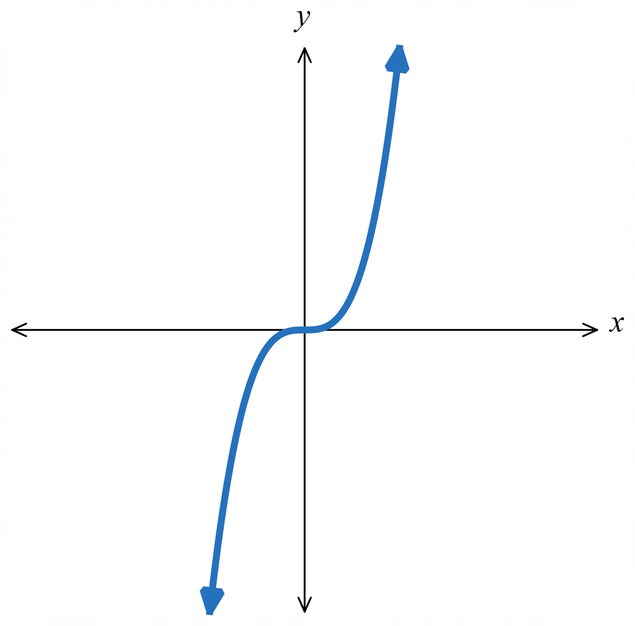

Point of inflection
This curve changes from concave down to concave up

- Investigation Graph cubic relationships using a table of values
Draw the graph of $y=x^{3}-2$  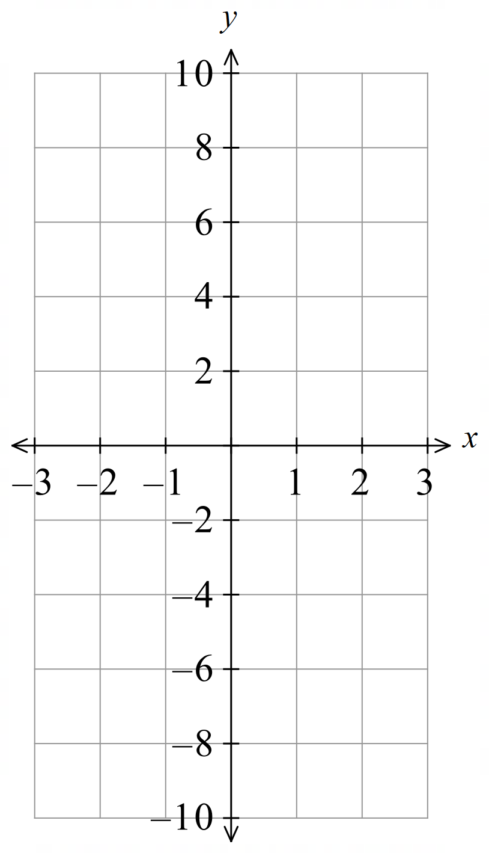  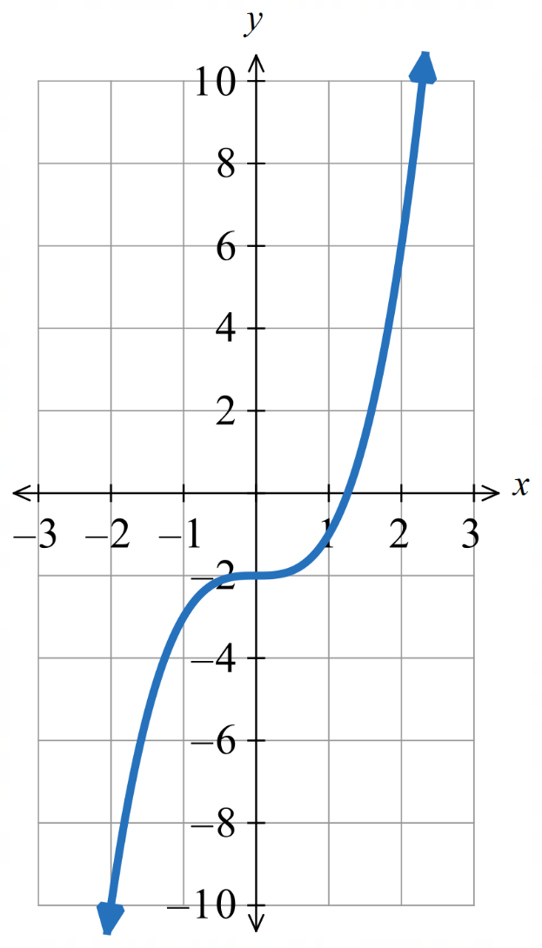 | Draw the graph of $y=-x^{3}+1$  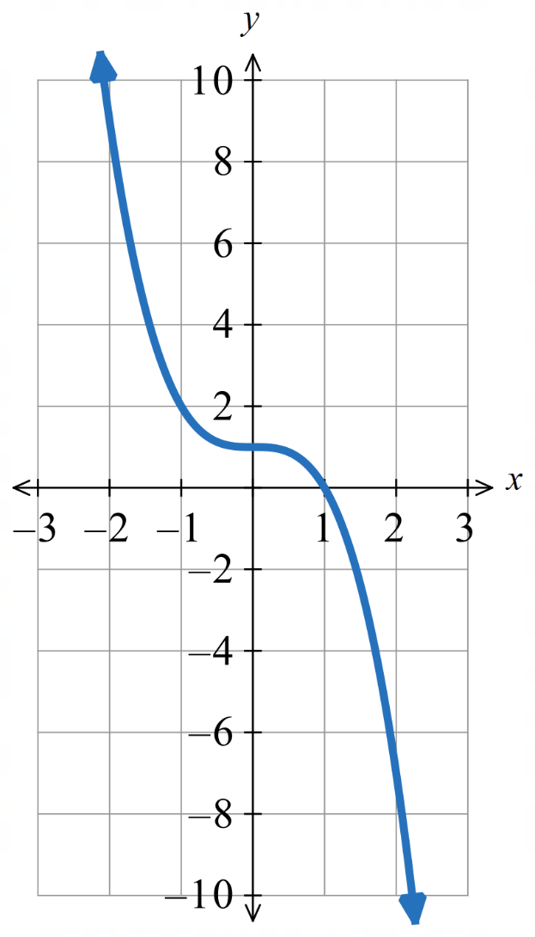
  $$x$$ | $$-2$$ | $$-1$$ | $$-\frac{1}{2}$$ | $$0$$ | $$\frac{1}{2}$$ | $$1$$ | $$2$$
  $$y$$
  $$x$$ | $$-2$$ | $$-1$$ | $$-\frac{1}{2}$$ | $$0$$ | $$\frac{1}{2}$$ | $$1$$ | $$2$$
  $$y$$

- Cubic Curve Transformations
For a cubic curve $y=k{\left(x-b\right)}^{3}+c$
The parameters $b,c,k$ affect the graph in predictable ways.
$k>0$, the curve is increasing.  $$y=1x^{3}$$  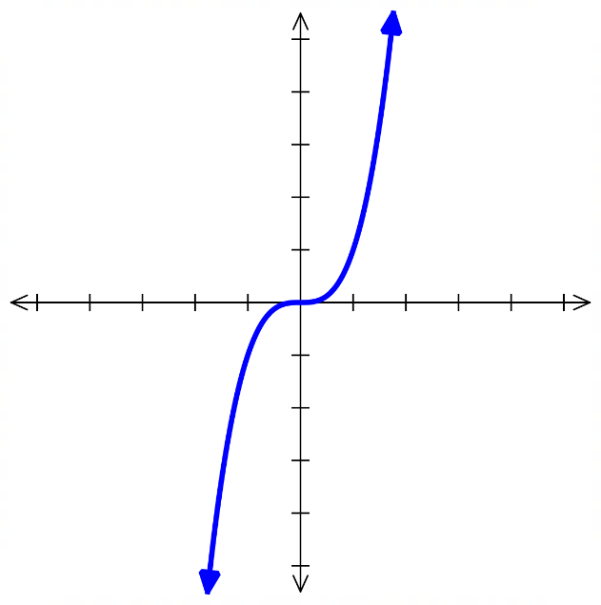 | $k<0$, the curve is decreasing  $$y=-1x^{3}$$  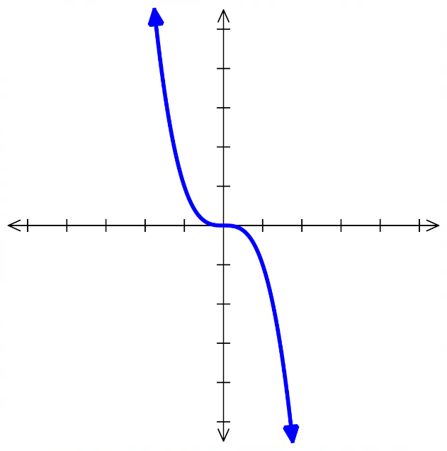
$b>0$, the curve is shifted ……………  $$y={\left(x-2\right)}^{3}$$  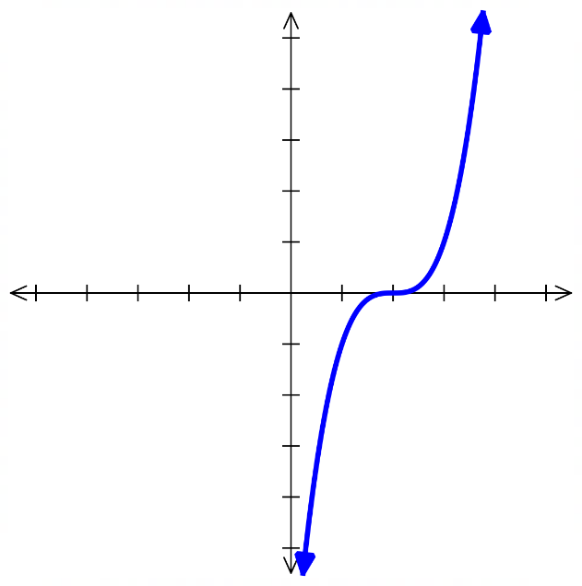 | $b<0$, the curve is shifted ……………  $$y={\left(x+2\right)}^{3}$$  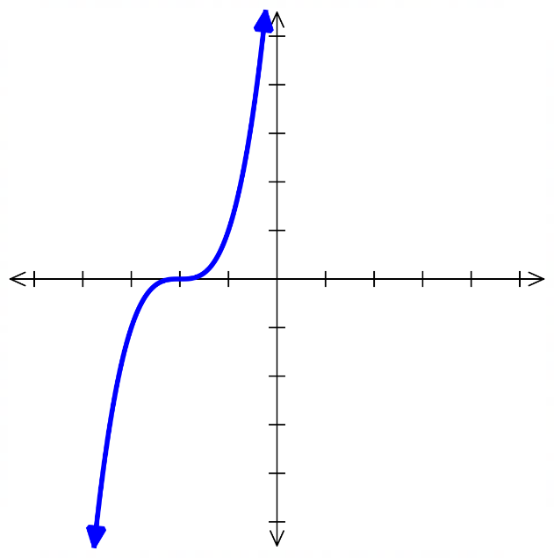
$c>0$, the curve is shifted ……………  $$y=x^{3}+2$$  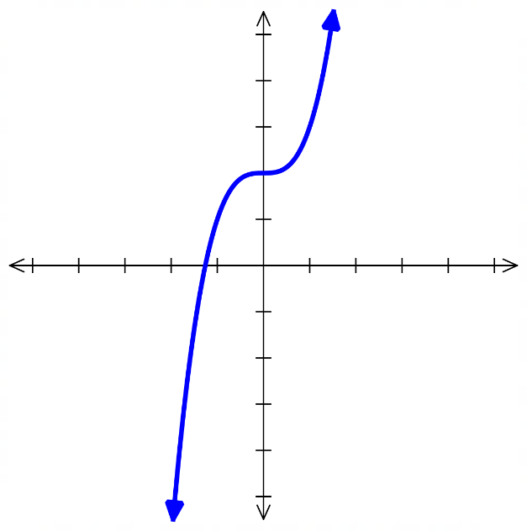 | $c<0$, the curve is shifted ……………  $$y=x^{3}-2$$  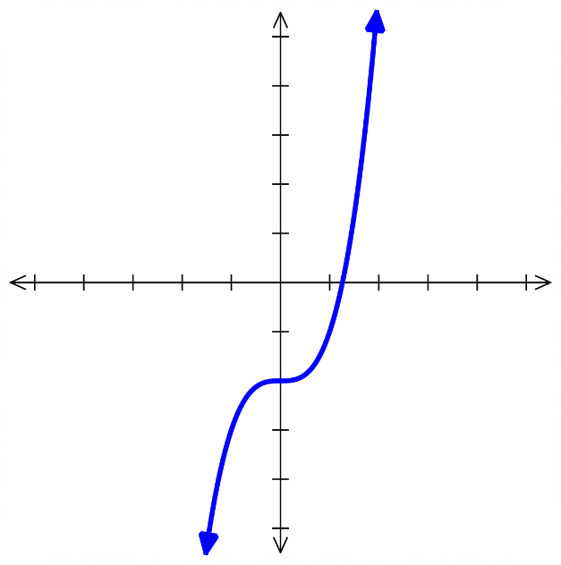
$\left|k\right|>1$, the curve gets narrower.  $$y=5x^{3}$$  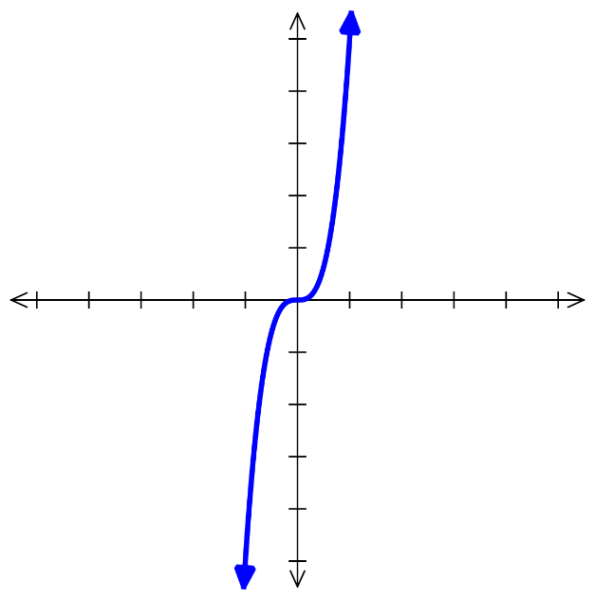 | $0<\left|k\right|<1$ the curve gets wider.  $$y=\frac{1}{5}x^{3}$$  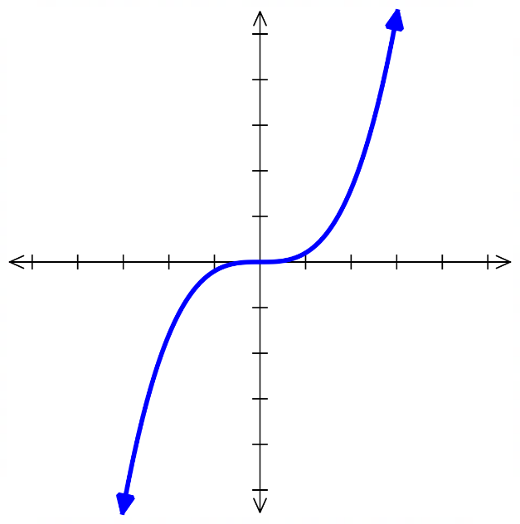
- Inflection Point Form of a Cubic Curve
The inflection point form of a cubic reveals its inflection point because it shows the graph’s horizontal and vertical shifts.

$$y=a{\left(x-h\right)}^{3}+k$$

Concavity inflection point $\left(h,k\right)$
To sketch a cubic curve:
- Determine the behaviour of curve by substituting $x→∞$.
- Find $y$-intercept by letting $x=0$.
- Find $x$-intercepts by letting $y=0$.
- Identify the point of inflection $\left(h,k\right)$.

- Example Success Criteria
Sketch $y=x^{3}-8$
1. Behaviour When $x→∞, y→∞$  2. $y$-int Let $x=0$  $y=0^{3}-8$  $=-8$  3. $x$-int Let $y=0$  $0=x^{3}-8$  $8=x^{3}$  $2=x$  4. Point of inflection at $(0,-8)$ | 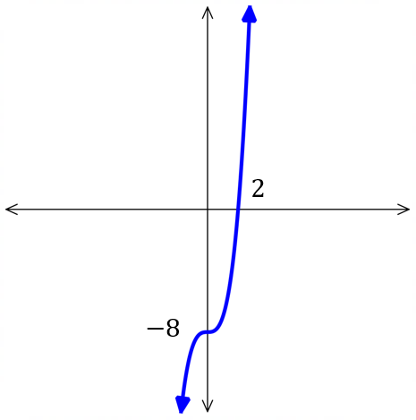

- Guided Practice
Sketch $y=-x^{3}+8$
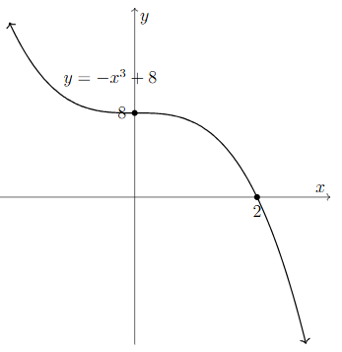

- Guided Practice
Sketch $y={\left(x-4\right)}^{3}$
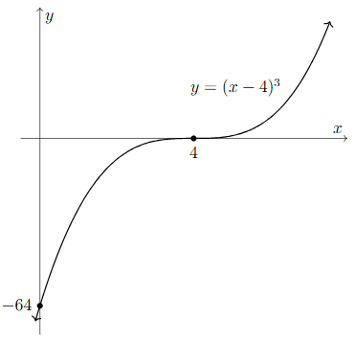

Sketch $y={\left(x+7\right)}^{3}-3$
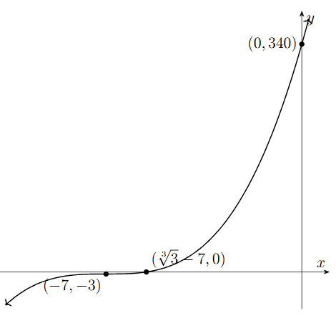

Sketch $y={-2\left(x-5\right)}^{3}+1$
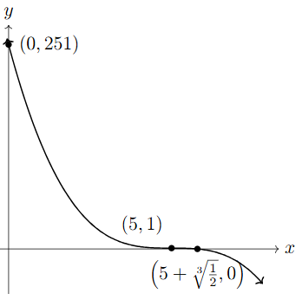

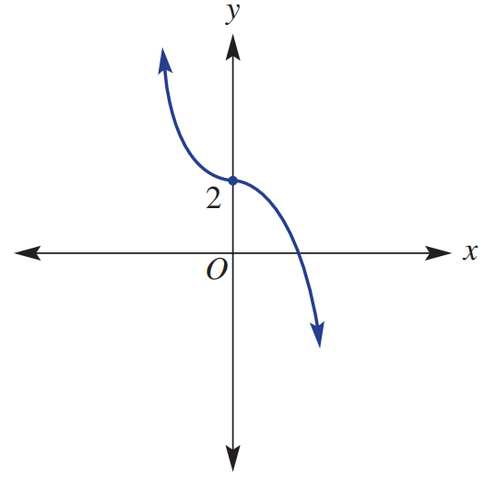
Foundation
- The graph of a cubic function is shown.
  - Identify the point of inflection.
$\left(0,2\right)$
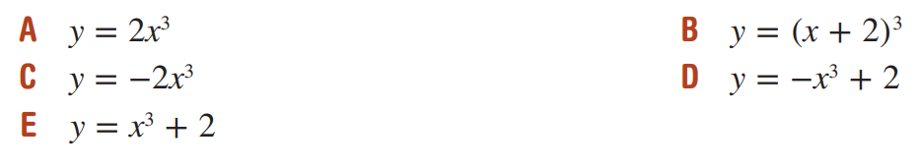
  - Circle a possible equation for this cubic equation.

D
- Draw a neat sketch of these equations.
Clearly label the $y$-intercept, $x$-intercept.
- $y={\left(x-2\right)}^{3}+7$  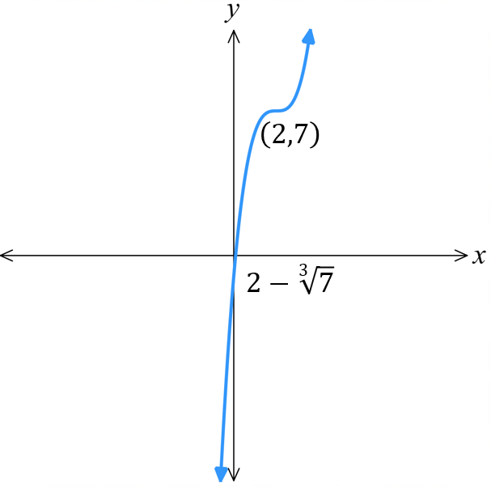 | - $y=-{\left(x-3\right)}^{3}$  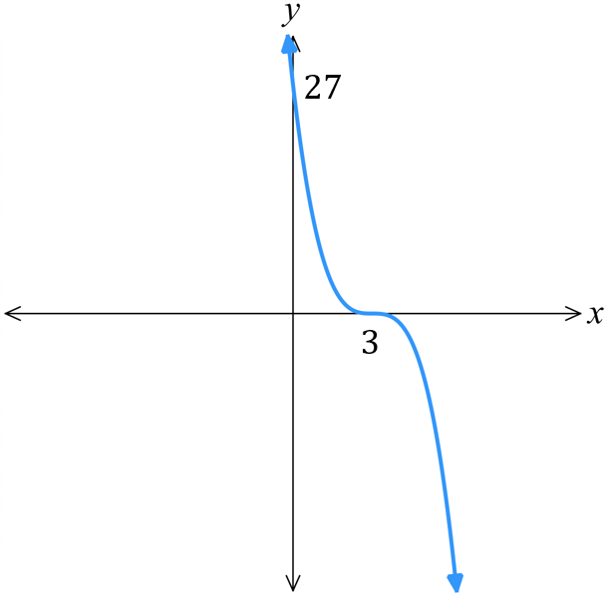
- $y=8x^{3}+12$  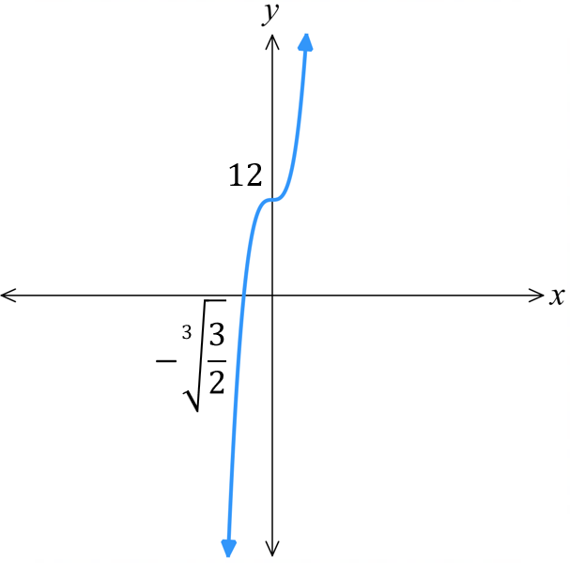 | - $y=-2{\left(x-3\right)}^{3}+8$  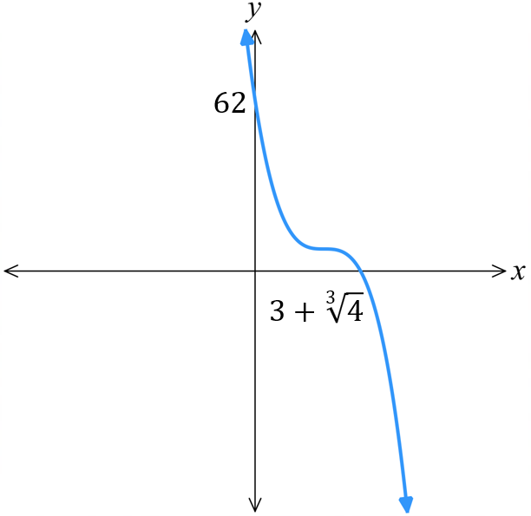
- $y=2{\left(x-1\right)}^{3}-16$  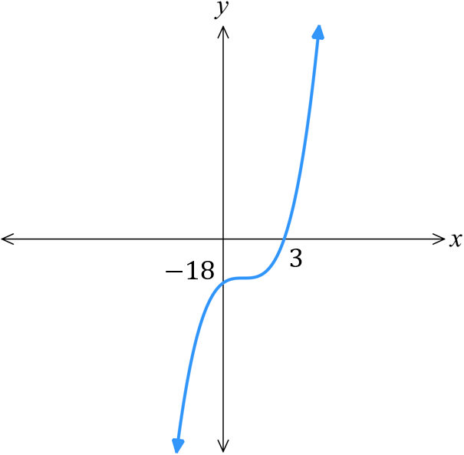 | - $y=-({x+1)}^{3}-5$  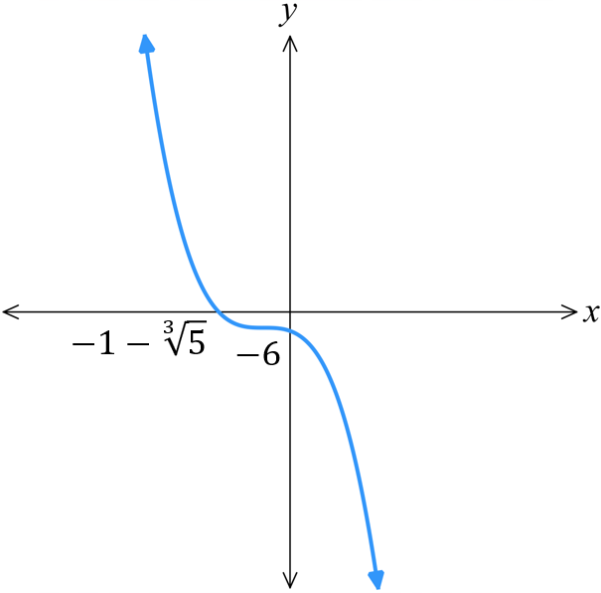

- The cubic curves are in the form $y=kx^{3}+c$. Find its equation.
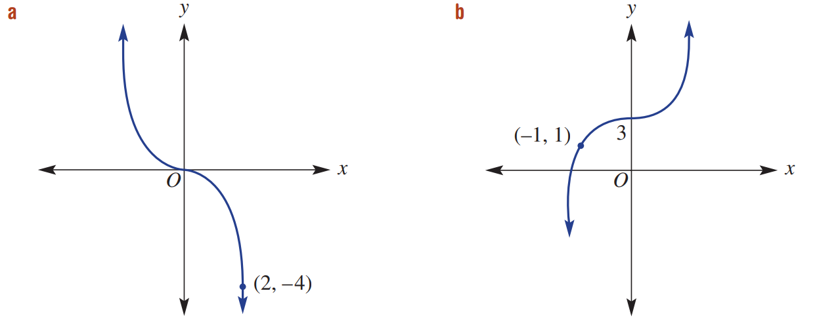  $$y=-\frac{x^{3}}{2}$$ | $$y=2x^{3}+3$$
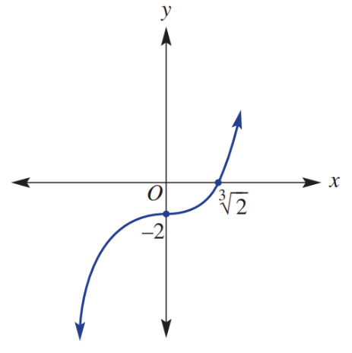  $$y=x^{3}-2$$ | 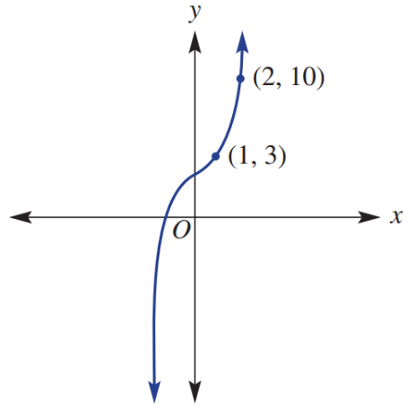  $$y=x^{3}+2$$

Power Curve Transformations

- Power Curve Transformations
For a power curve $y=k{\left(x-b\right)}^{n}+c$
The parameters $b,c,k,n$ affect the graph in predictable ways.
$n$ is even, curve has a turning point.
$n$ is odd, curve has inflection point.
As $n$ increases, the curve gets …………… but the turning/inflection point gets ………………
$y=x^{2}$ $y=x^{3}$ $y=x^{4}$ $y=x^{5}$
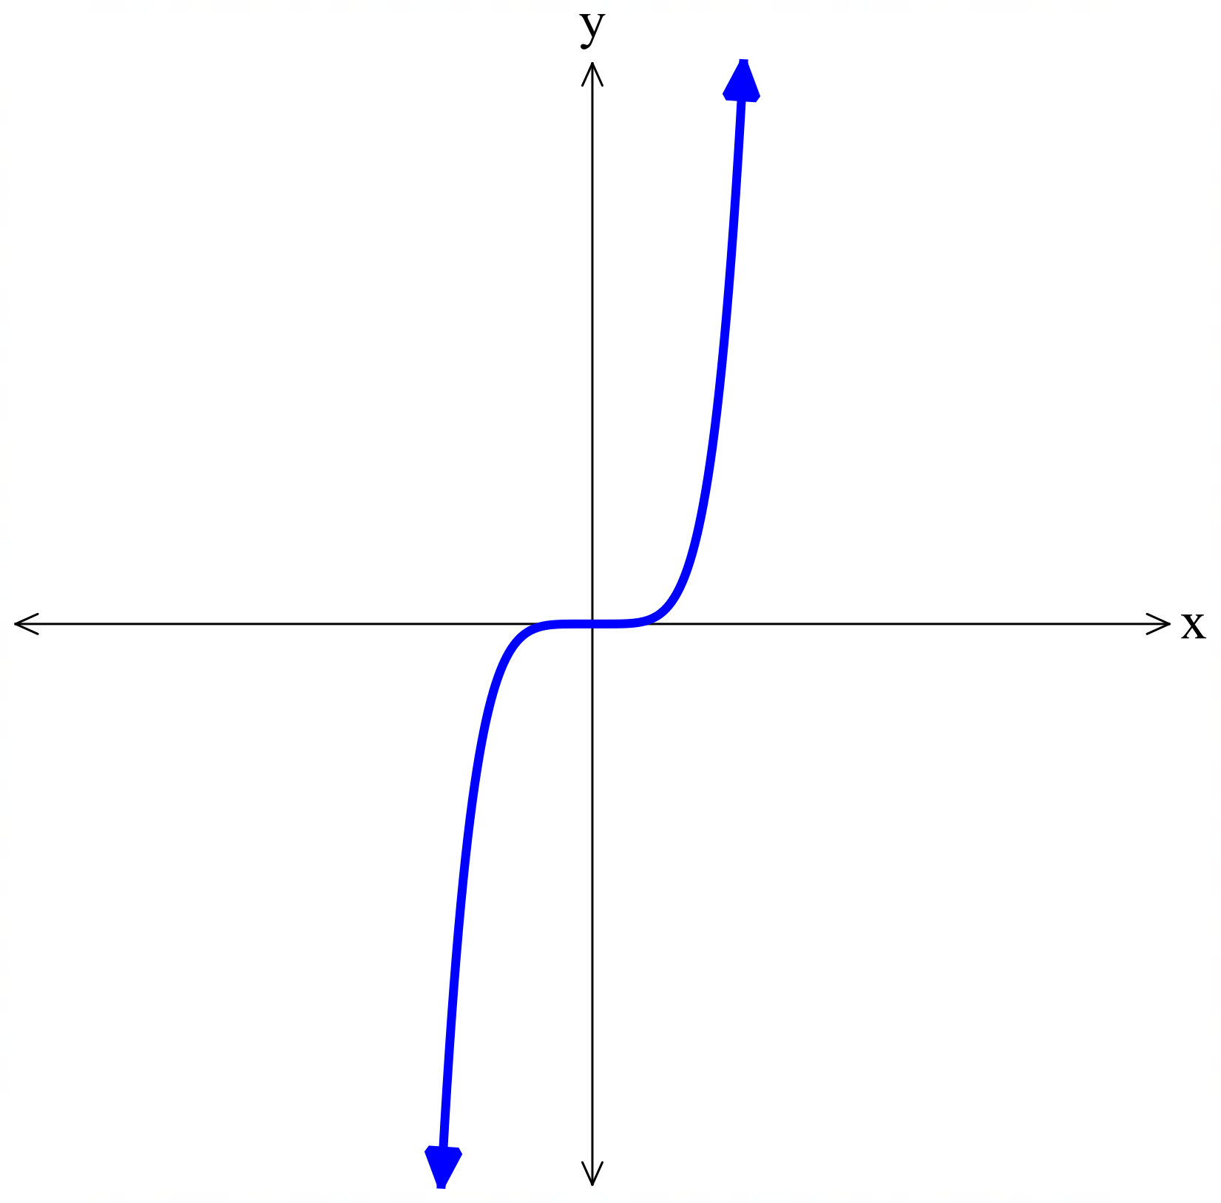
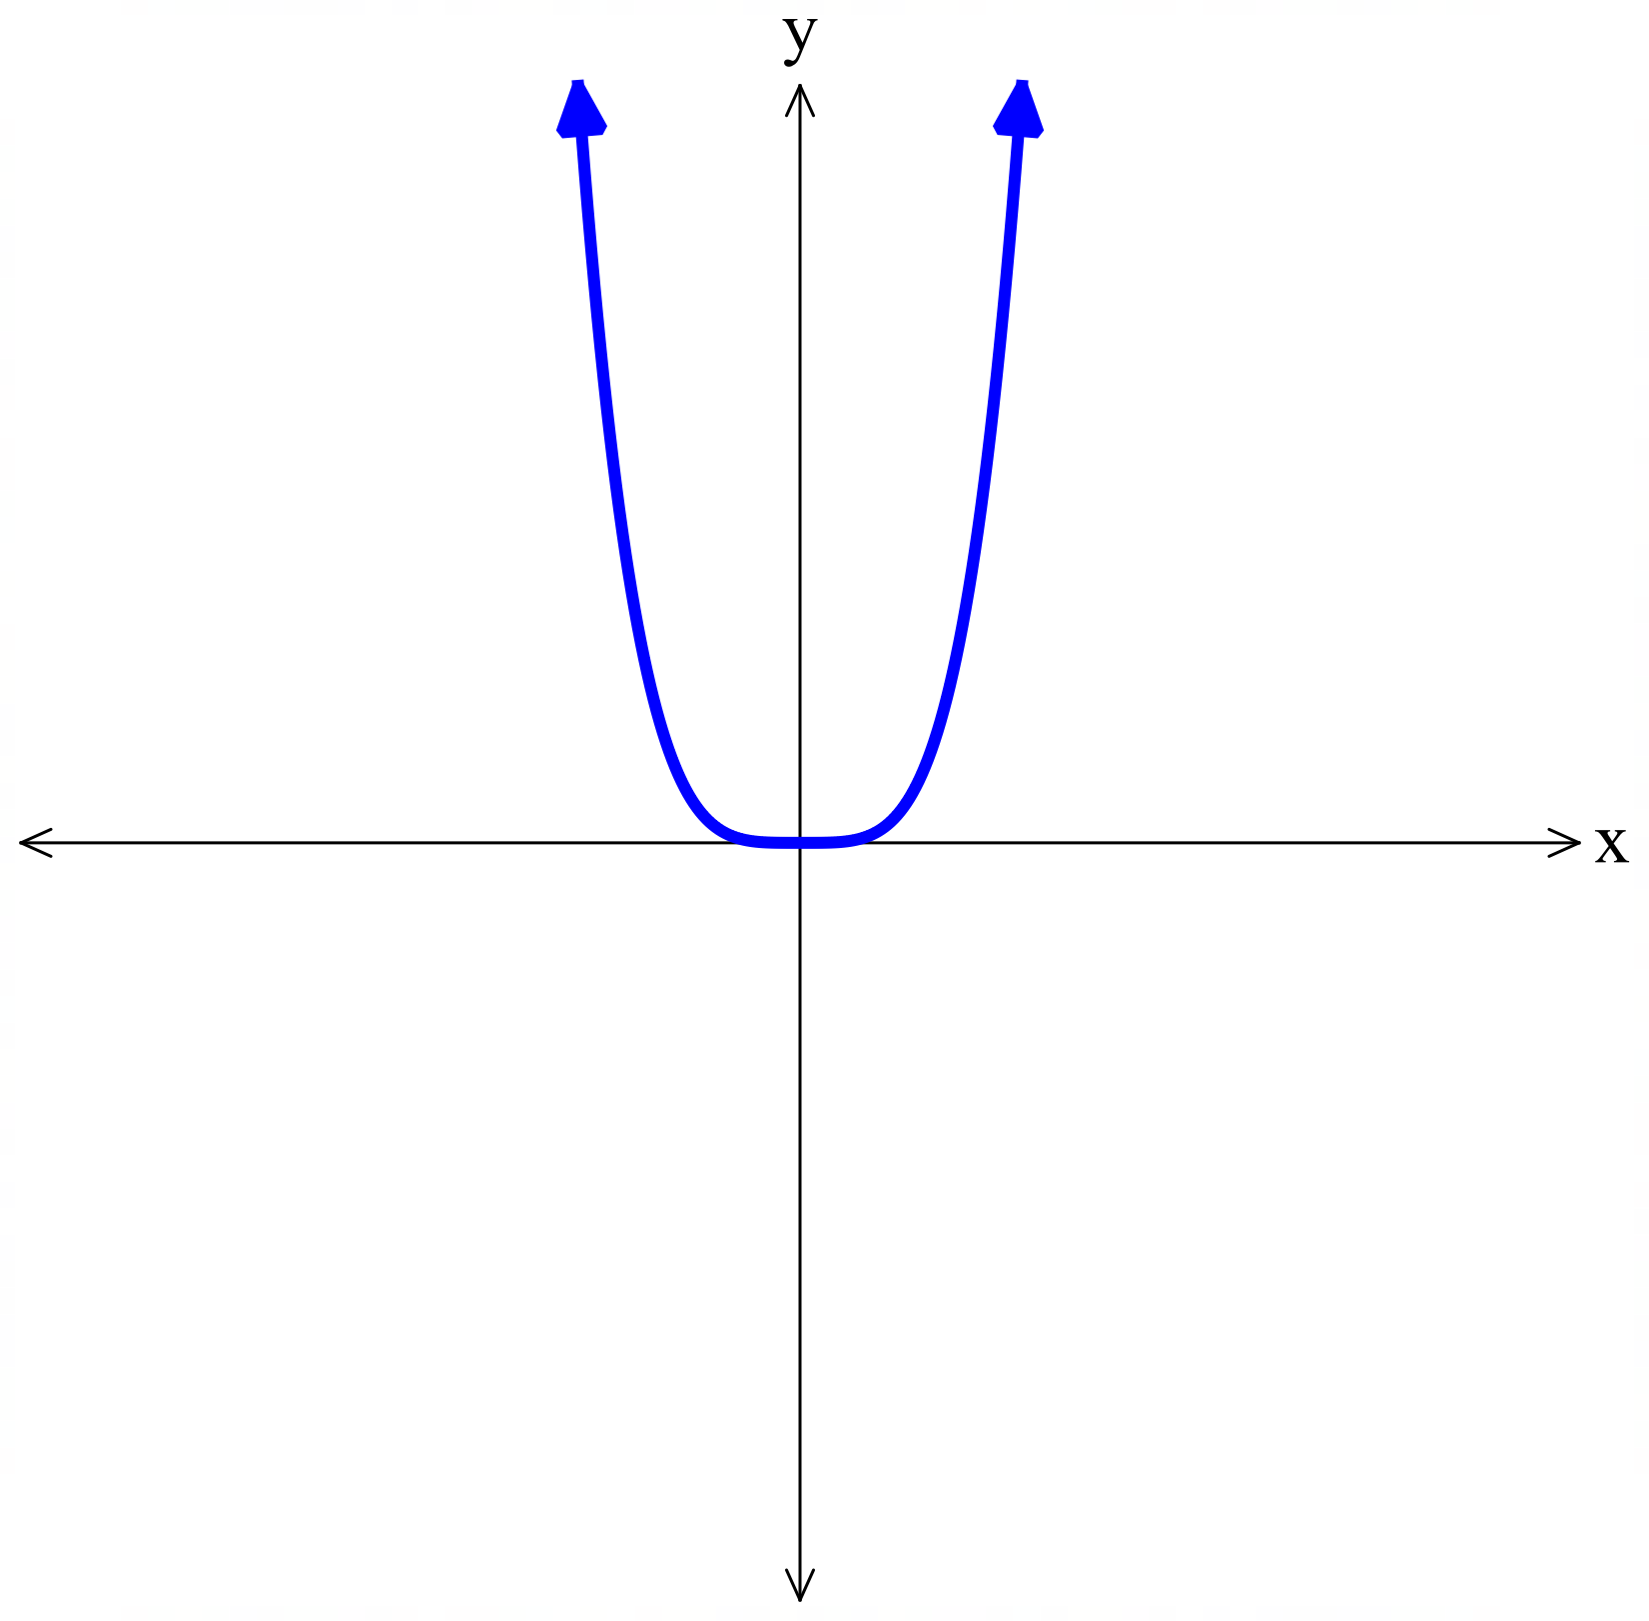
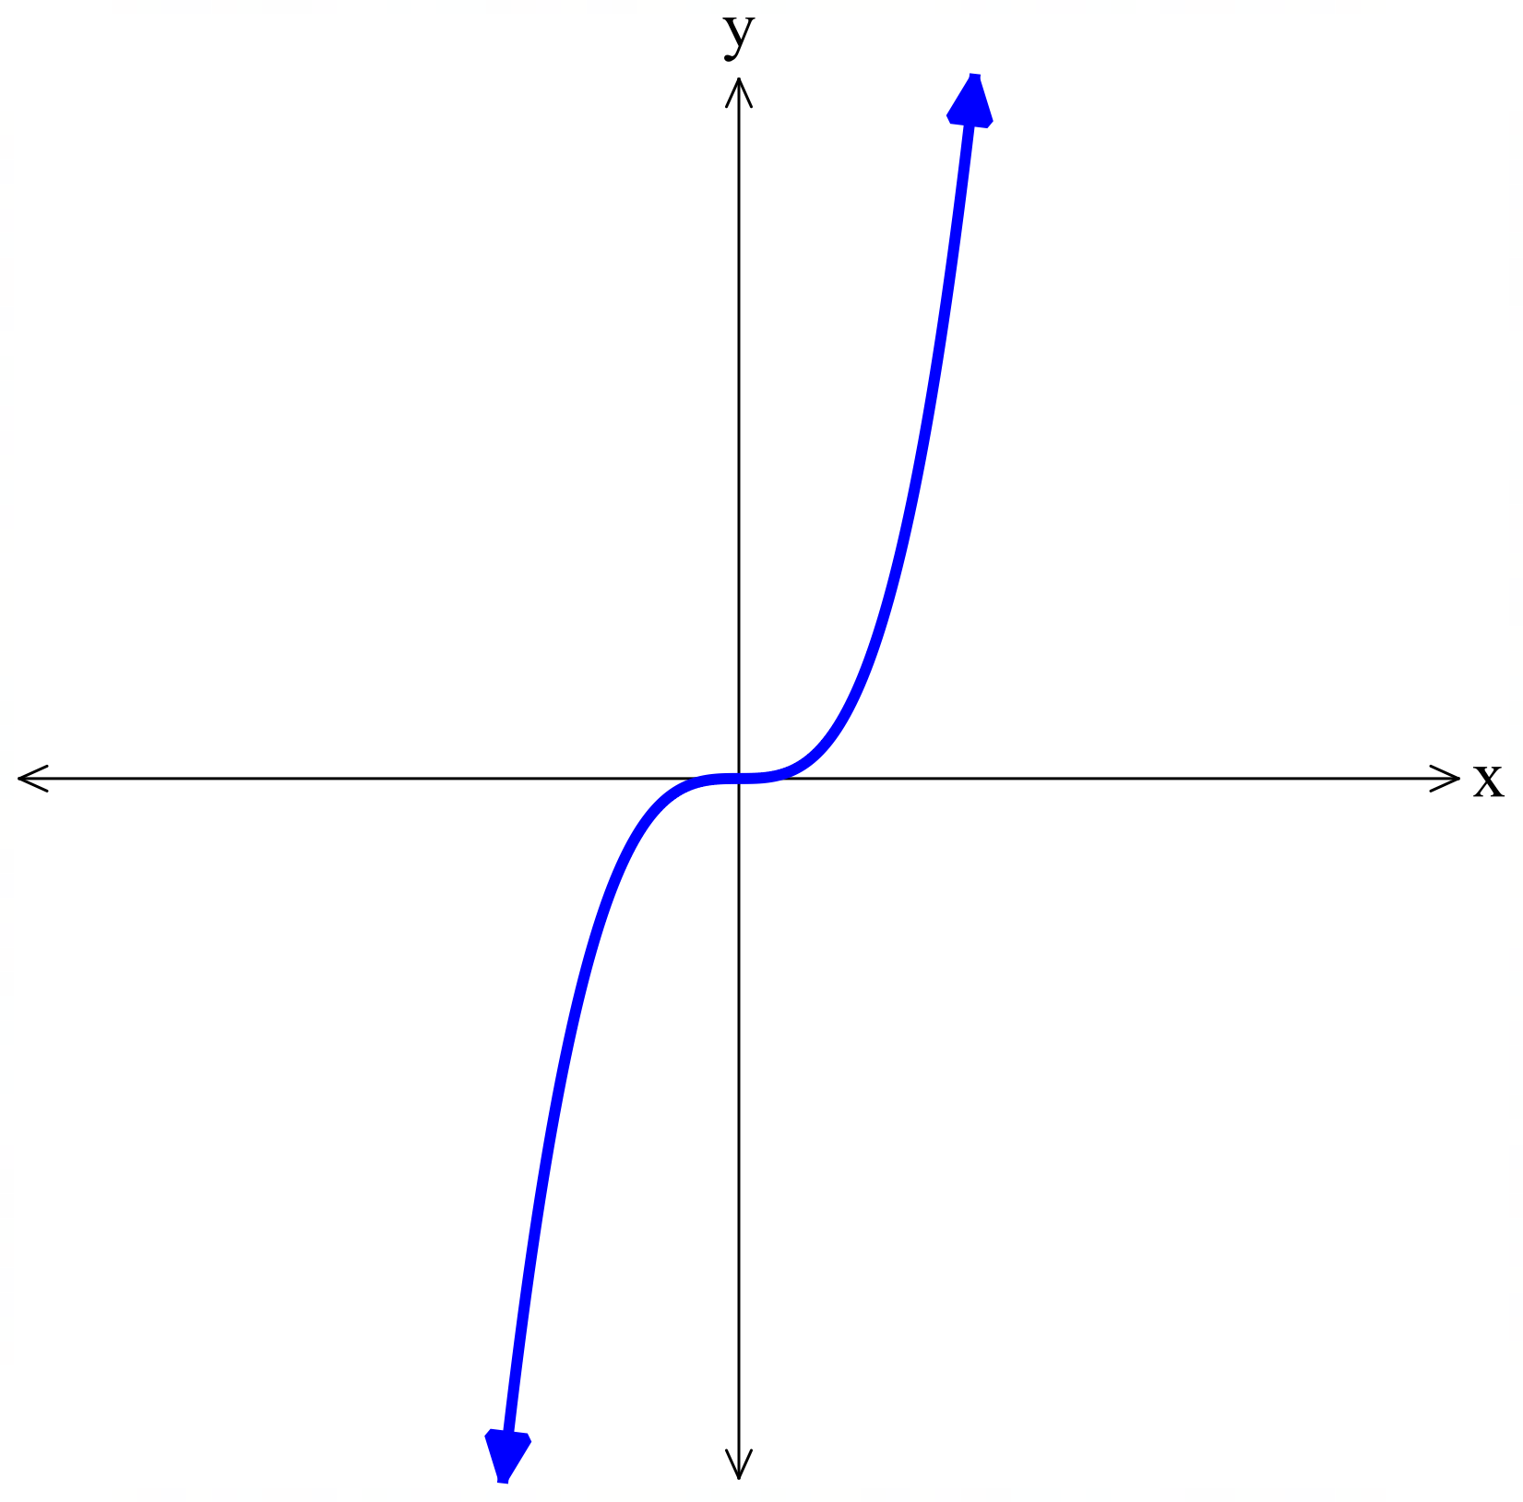
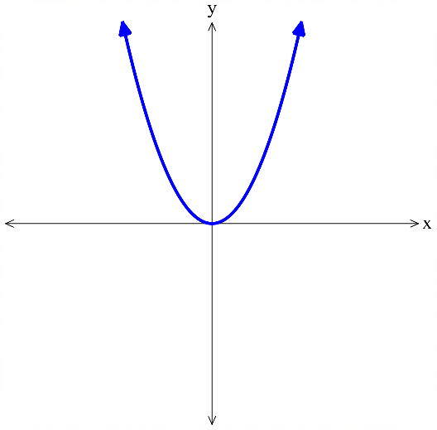

$b>0$, the curve is shifted ……………  $$y={\left(x-2\right)}^{3}$$ | $b<0$, the curve is shifted ……………  $$y={\left(x+2\right)}^{3}$$
$c>0$, the curve is shifted ……………  $$y=x^{3}+2$$ | $c<0$, the curve is shifted ……………  $$y=x^{3}-2$$
$\left|k\right|>1$, the curve gets narrower.  $$y=5x^{3}$$ | $0<\left|k\right|<1$ the curve gets wider.  $$y=\frac{1}{5}x^{3}$$

Foundation
- The graph of $y=x^{n}$ is given. State whether the power is even or odd.
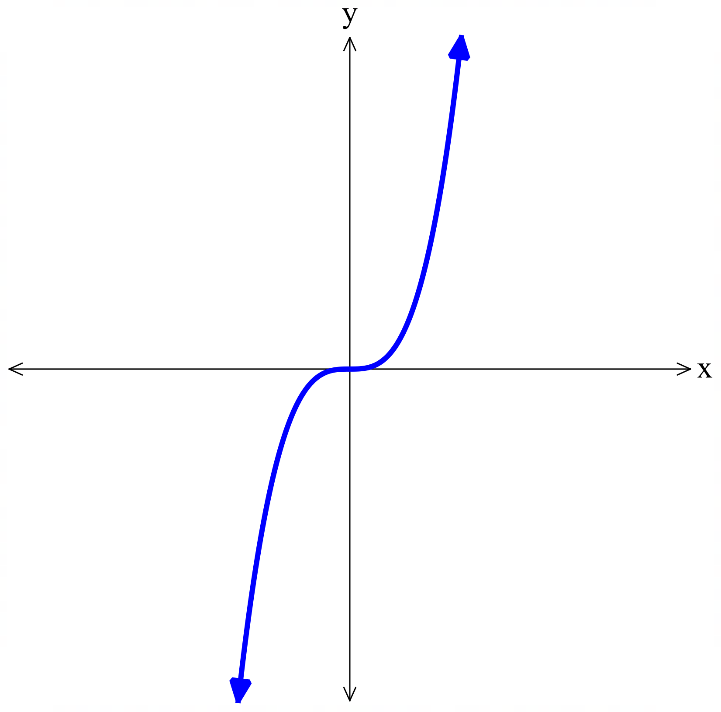  odd | 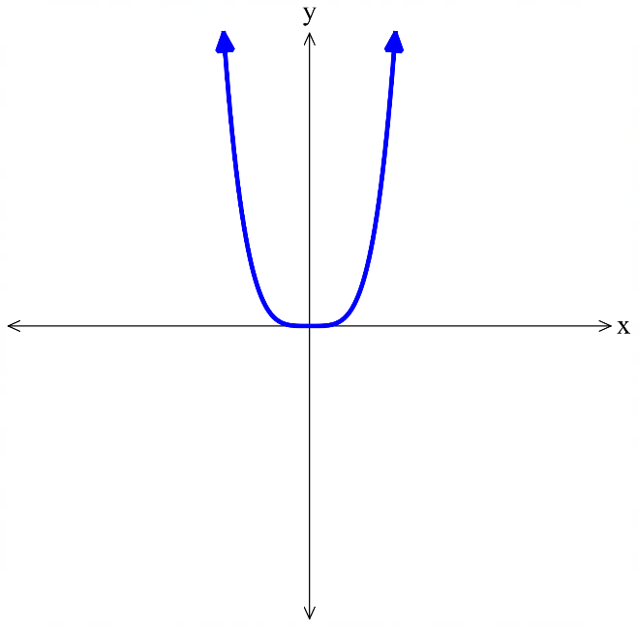  even | 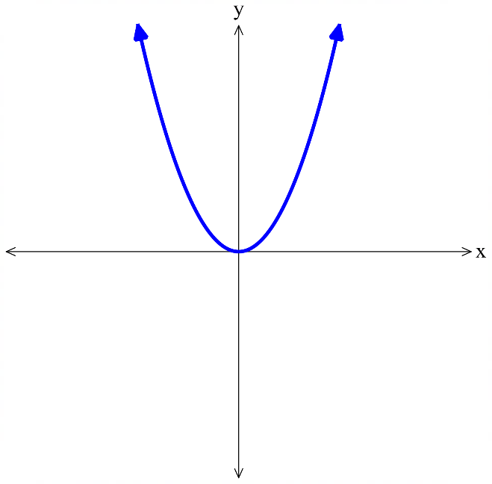  even
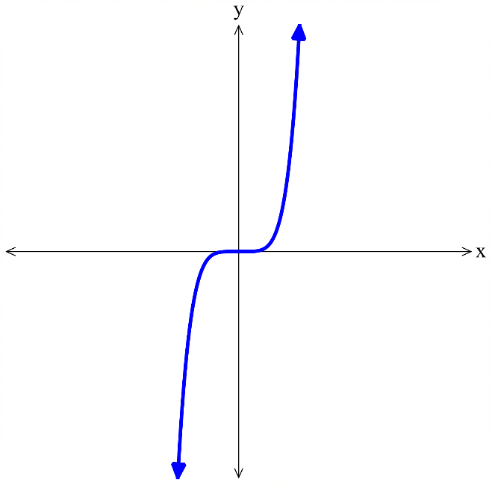  odd | 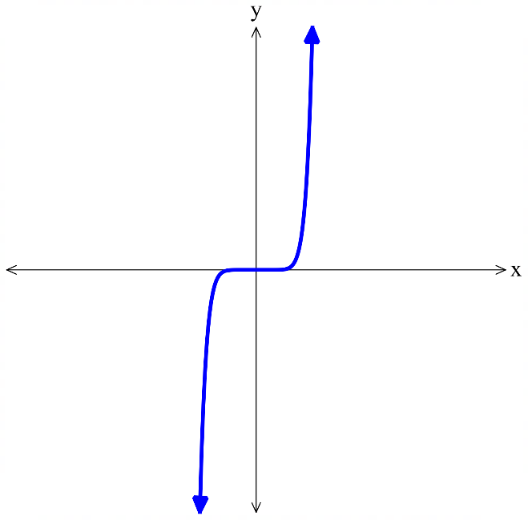  odd | 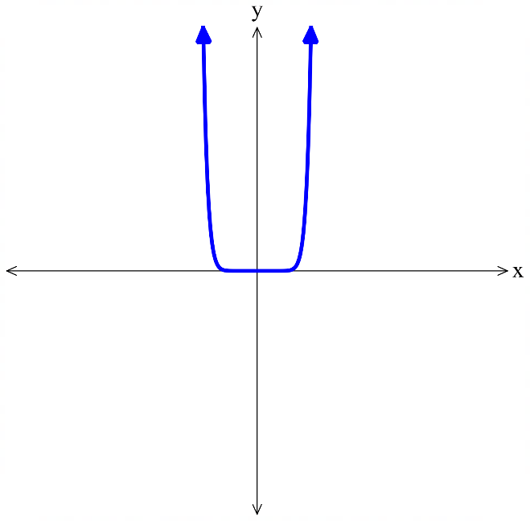  even

- Match each graph with its equation.
- $y=x^{4}$ | - $y=5x^{4}$ | - $y=\frac{1}{2}x^{4}$ | - $y=\frac{x^{4}}{6}$

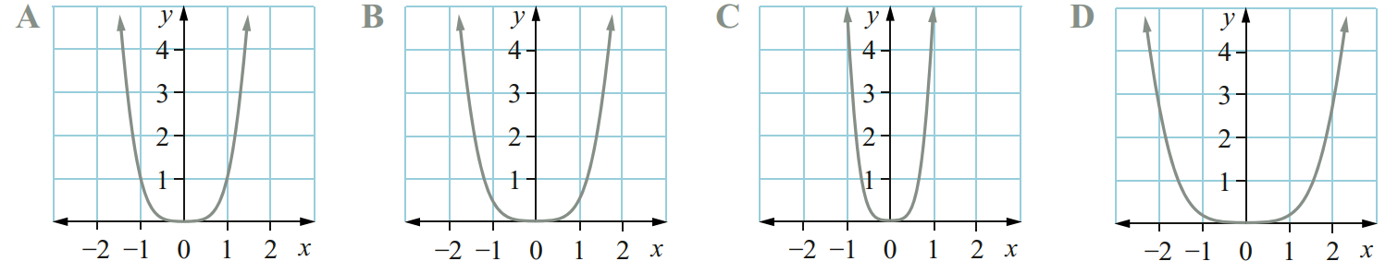

a – A, b – C, c – B, d - D
- Match each graph with its equation.
- $y=3{\left(x-1\right)}^{4}$ | - $y=3{\left(x+1\right)}^{4}$ | - $y=3{\left(x+3\right)}^{4}$ | - $y=3{\left(x-5\right)}^{4}$

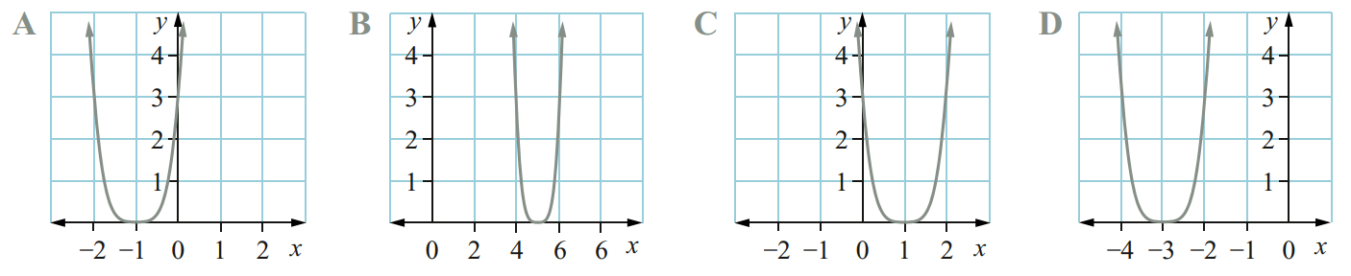

a – C, b – A, c – D, d – B
- Match each graph with its equation.
- $y=x^{4}-5$ | - $y=x^{4}+1$ | - $y=x^{4}-7$ | - $y=x^{4}+5$

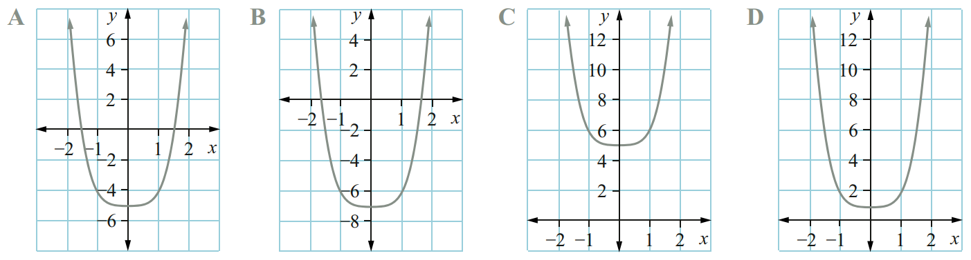

a – A, b – D, c – B, d – C

- Match each graph with its equation.
$y=4x^{2}$ $y=-4x^{2}$ $y=x^{3}-1$
$y=-x^{3}+1$ $y={\left(x+2\right)}^{6}$ $y=-{\left(x+2\right)}^{6}$
$$y=x^{3}-1$$ | 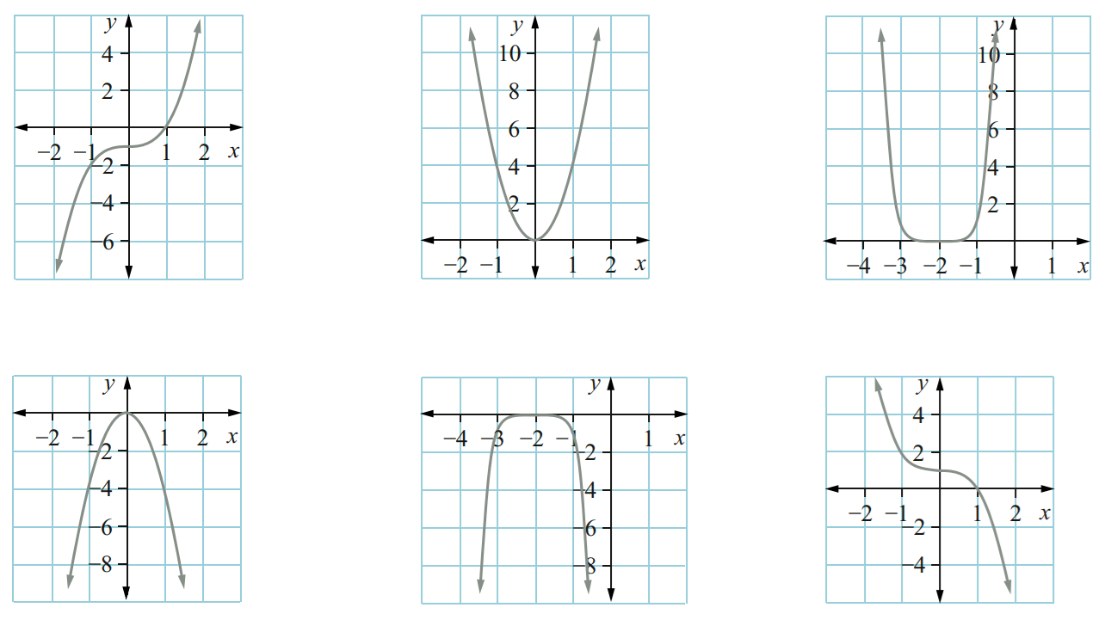  $$y=4x^{2}$$ | $$y={\left(x+2\right)}^{6}$$
$$-4x^{2}$$ | $$y=-{\left(x+2\right)}^{6}$$ | $$y=-x^{3}+1$$

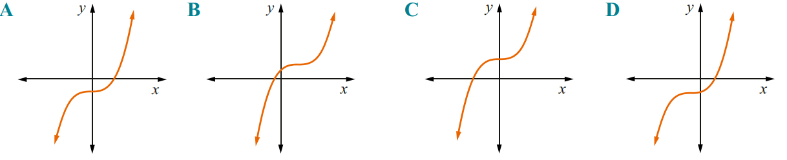
- Which of the following could be the graph of each function?
  - $y={\left(x+3\right)}^{3}-2$

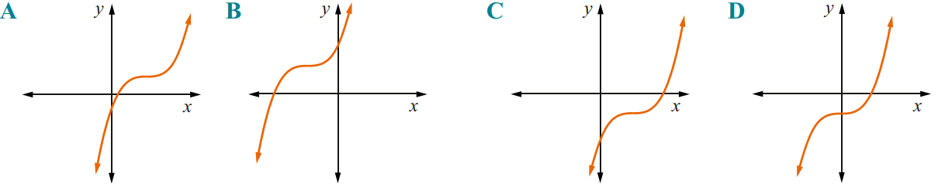
D
  - $y={\left(x+3\right)}^{3}+4$

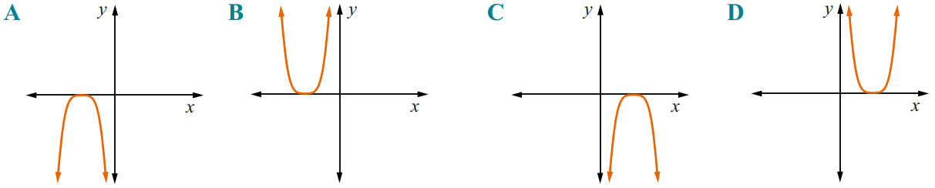
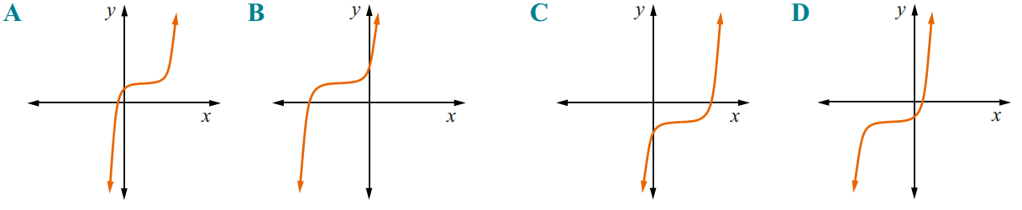
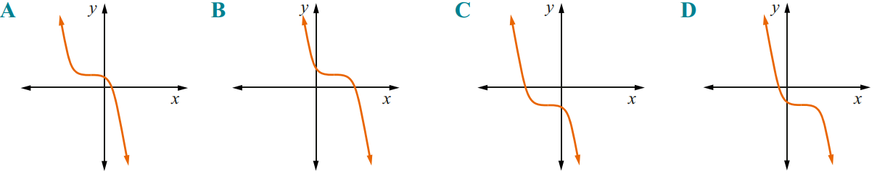
B
  - $y=-{\left(x-3\right)}^{4}$

C
  - $y={\left(x+3\right)}^{5}-2$

D
  - $y=-{\left(x+2\right)}^{3}+1$

A

Sketching Cubics in Factored Form

- Leading Term of a Cubic
For a cubic equation $y=ax^{3}+bx^{2}+cx+d$, $ax^{3}$ is called the leading term.
It has the biggest impact on the end behaviour of the curve.
The constant term, $d$, will tell us the $y$-intercept of the curve.

- Identify the leading term of a cubic
To find the leading term, multiply the highest power terms from each factor.
To find the constant term, multiply the constant terms of each factor.
$$y=\left(2x-3\right)\left(x-4\right)\left(x+5\right)$$  Leading term: $2x^{3}$  Constant term: $60$ | $$y=\left(3-2x\right)\left(x-4\right)\left(x+5\right)$$  Leading term: $-2x^{3}$  Constant term: $-60$
Find the leading term and constant term of these cubics.
- $y=\left(x+2\right)\left(x-1\right)\left(x-3\right)$ | - $y=-\left(x-2\right)\left(x-1\right)\left(x-3\right)$
- $y=x\left(x+5\right)\left(2x+3\right)$ | - $y=-3x\left(x-5\right)\left(2x+15\right)$
- $y=\left(3-x\right)\left(2+x\right)\left(x+5\right)$ | - $y=\left(2x-3\right)\left(3x+1\right)\left(7-x\right)$

- Sketching a Cubic Curve in Factored Form
$x$-intercepts

$$y=k\left(x-α\right)\left(x-β\right)\left(x-γ\right)$$
1. Find the leading term and determine the end behaviour as $x→∞$.
2. Find $x$ intercepts.
3. Find $y$ intercept.
Leading term positive | Leading term negative
As $x→∞$, $y→∞$ | 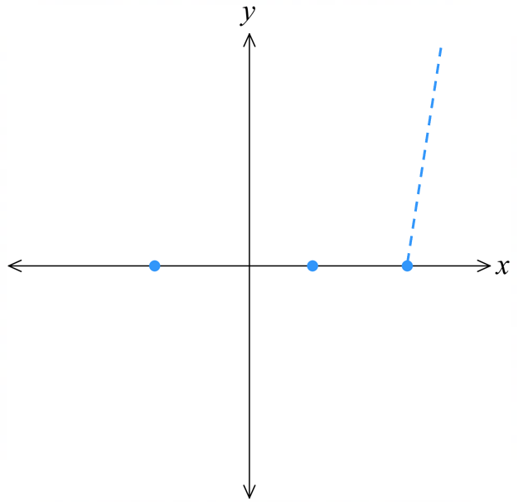  As $x→∞$, $y→-∞$  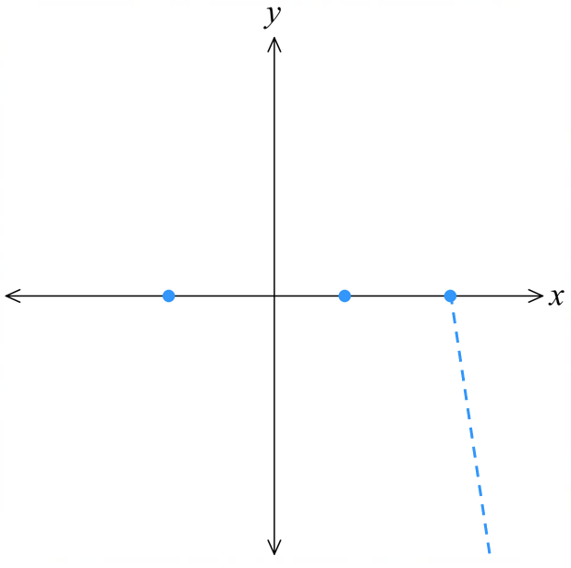

- Example Sketch cubic curves in factored form
Sketch $y=(x+2)(x-1)(x-3)$  1. The leading term is $x^{3}$,  so when $x→∞$, $y→∞$  2. Let $y=0$  $0=(x+2)(x-1)(x-3)$  $x=-2, 1, 3$  3. Let $x=0$  $y=(0+2)(0-1)(0-3)$  $=(2)\left(-1\right)(-3)$  $=6$ | 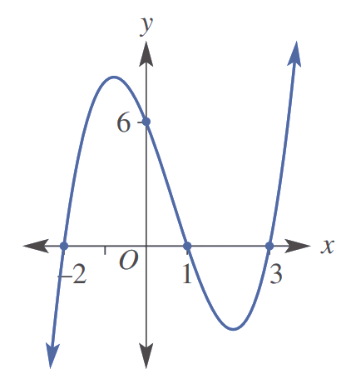

- Guided Practice
Sketch these cubic curves.
- $y=\left(x-4\right)\left(x+5\right)\left(x-3\right)$
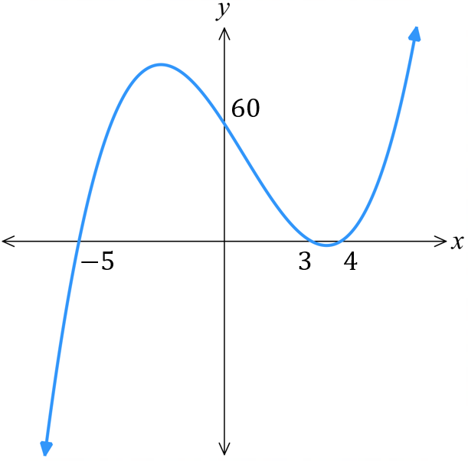
1. leading term & behaviour

2. $x$-intercepts

3. $y$-intercept

- $y=x\left(x-2\right)(x+3)$
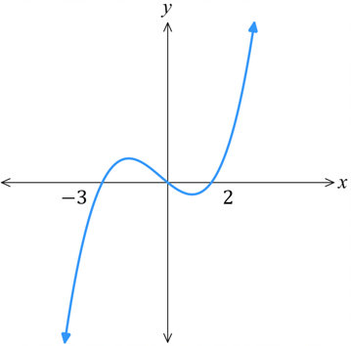

- $y=\left(x-4\right)\left(x+5\right)\left(x-3\right)$
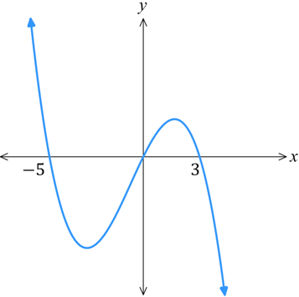

- $y=\left(3-x\right)(x+1)(2x+1)$
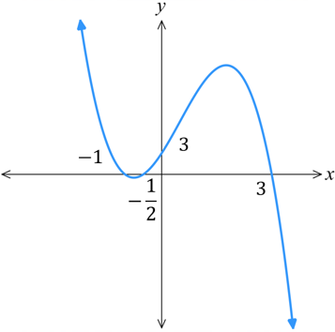

Foundation
- Sketch these cubic curves. Show the $x$ and $y$-intercepts.
- $y=x\left(x-1\right)\left(x-2\right)$  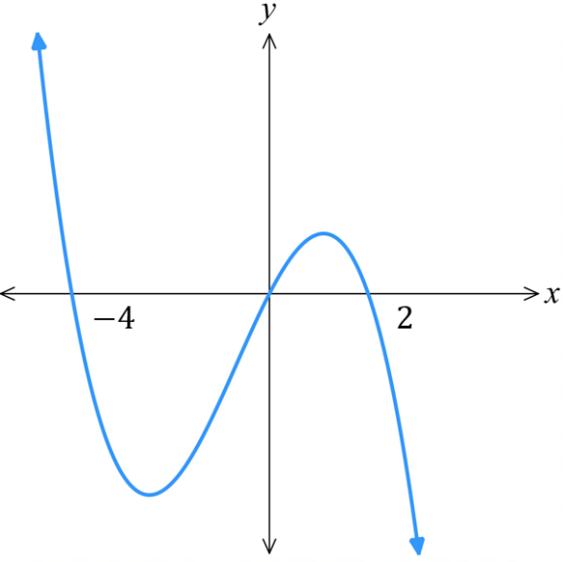  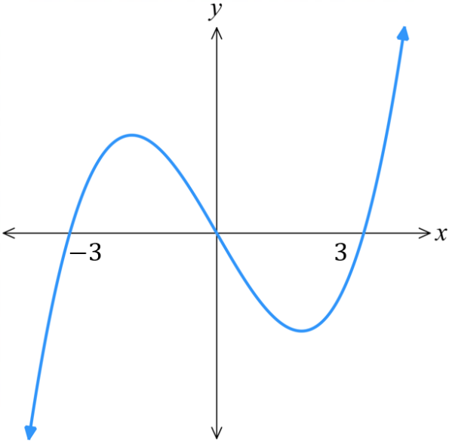  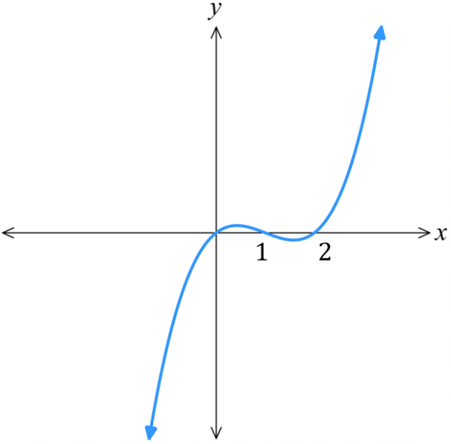  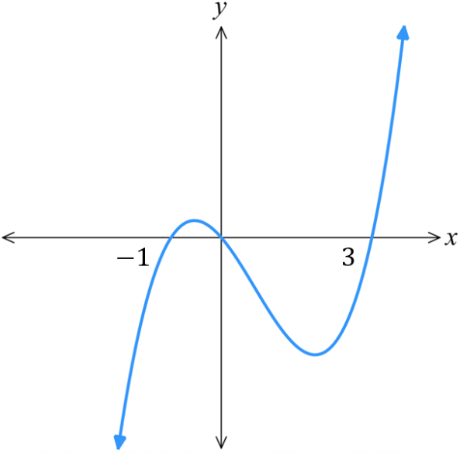 | - $y=x\left(x-3\right)\left(x+3\right)$
- $y=2x(x-3)(x+1)$ | - $y=-x(x-2)(x+4)$
- $y=-\left(x+4\right)\left(x-1\right)\left(x+5\right)$  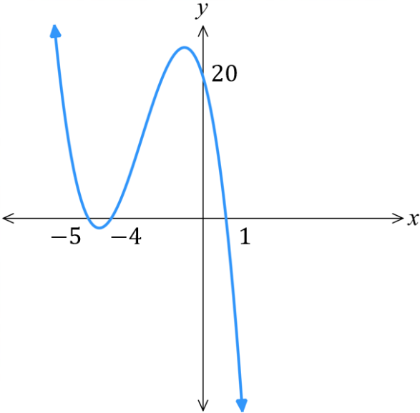 | - $y=3(x+2)(x-1)(x-3)$  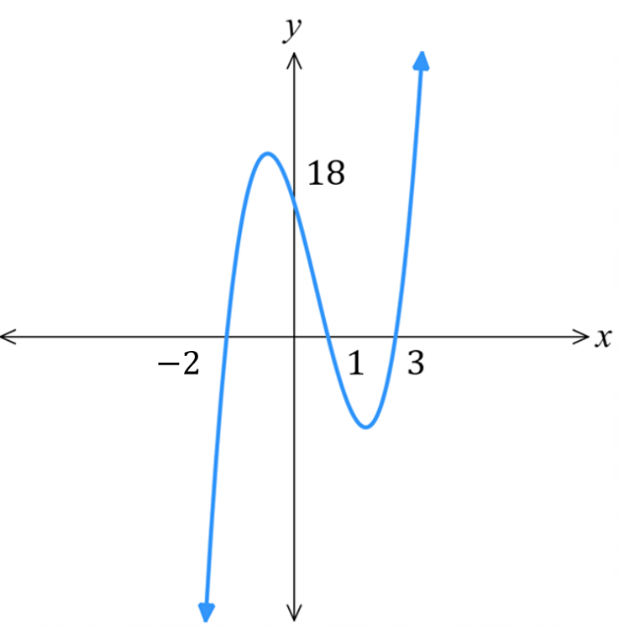

Development
- Sketch these cubic curves. Show the $x$ and $y$-intercepts.
- $y = (2x-1)(x+3)(x-2)$  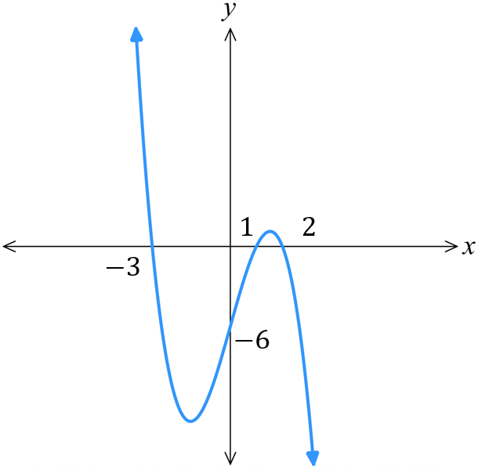  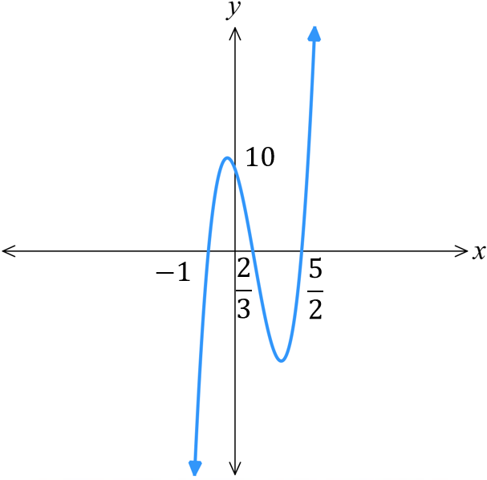  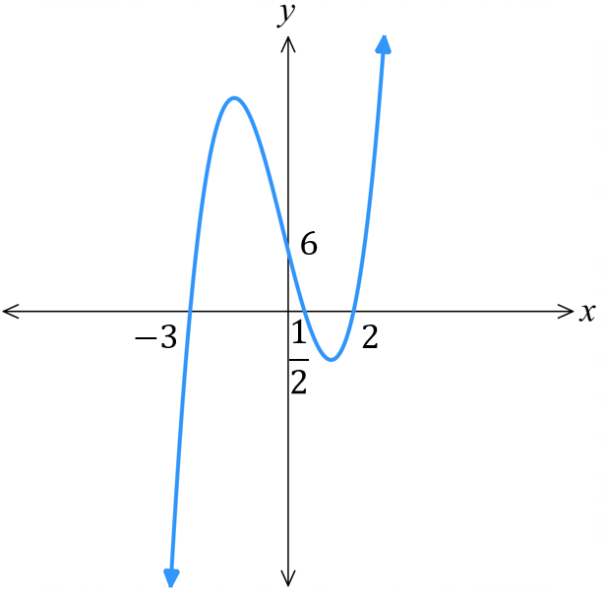  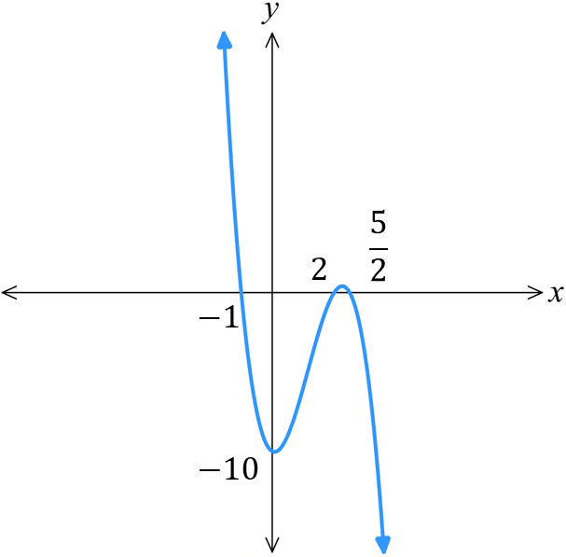 | - $y = (3x-2)(x+1)(2x-5)$
- $y = (1-x)(x+3)(x-2)$ | - $y = (2-x)(x+1)(2x-5)$
- $y = -2(3x+4)(2x-3)(1-x)$  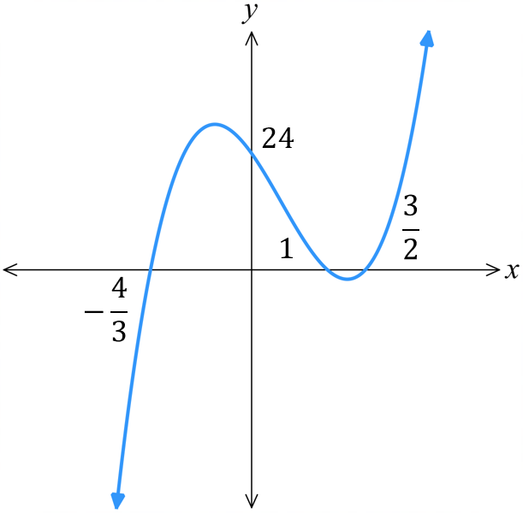 | - $y = -x(9-4x)(3-2x)$  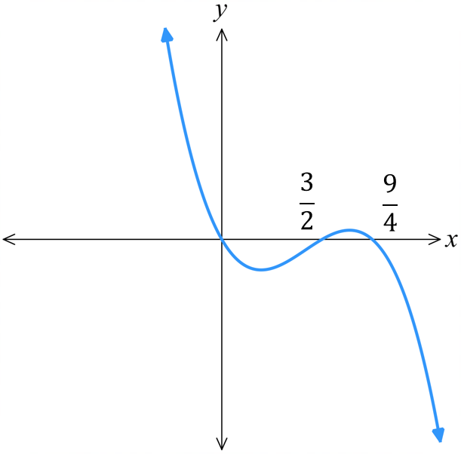

Mastery
- The following graphs are cubic curves. Find the equation using $y=k\left(x-α\right)\left(x-β\right)\left(x-γ\right)$.
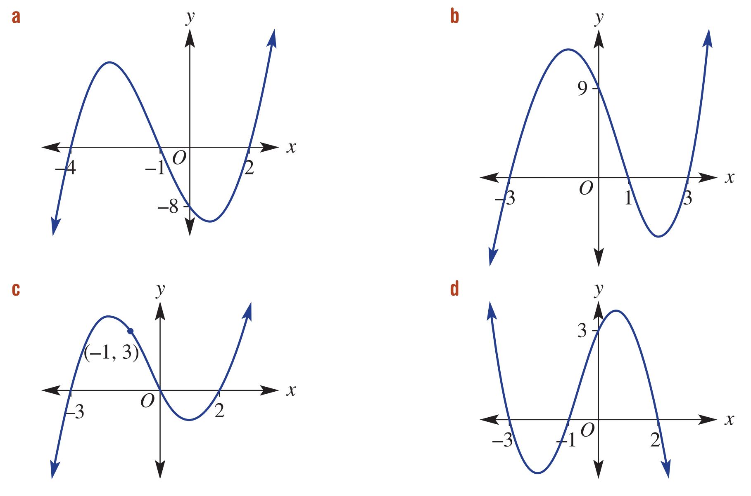  $$y=(x-2)(x+1)(x+4)$$ | $$y=(x+3)(x-1)(x-3)$$
$$y=\frac{1}{2}x(x-2)(x+3)$$ | $$y=-\frac{1}{2}(x+3)(x+1)(x-2)$$

- A cubic function is in the form $y=k\left(x-α\right)\left(x-β\right)\left(x-γ\right)$. Find its equation if:
  - it has $x$-intercepts 2, 3 and −5 and passes through the point (−2, –120).

$$y=-2(x-2)(x-3)(x+5)$$
  - it has $x$-intercepts −1, 4 and 6 and passes through the point (3, 96).

$$y=8(x+1)(x-4)(x-6)$$
  - it has $x$-intercepts 1 and 3, $y$-intercept −27 and $k$ = −3.

$$y=-3(x-1)(x-3)(x+3)$$

